7SENG013W Software Development Project

2023/24

Chiro360°

Chiropractic Practice Management System

Student: Tareq Mufleh Tareq Al-Batayneh (W19443854)

Supervisor: Hüseyin Dagdeviren

Date: 05/09/2024

MSc Software Engineering (Conversion)

School of Computer Science and Engineering

College of Design, Creative and Digital Industries

University of Westminster

**Abstract**

The Chiropractic Healthcare Management System is a comprehensive web application made to improve and streamline chiropractic healthcare practices' administrative and clinical procedures. The primary method by which chiropractors diagnose and treat musculoskeletal conditions is through manual adjustment and manipulation of the spine. This project is related to healthcare and focuses on chiropractic services specifically. This software's primary goal is to make patient management, appointment scheduling, SOAP note documentation, billing, and reporting easier. This will make chiropractic clinics' overall productivity and service quality better.

The web application is designed to run on any operating system that has access to a web browser and internet connectivity, ensuring broad accessibility and ease of use. The core of the application is developed using JavaScript for the front end, with React.js as the primary framework to ensure a responsive and user-friendly interface. The backend is created using Node.js and Express.js, providing a scalable server-side environment. Data management and storage are handled through PostgreSQL database, which offers reliability and performance for handling large volumes of patient records and clinical data.

Web Sockets are used to synchronize data in real time across all users, ensuring that application updates are immediately reflected. The system's collaborative aspects are enhanced by this feature, which makes it possible to share information seamlessly and keep up-to-date records. The application likewise integrates authentication, permissions, and access control components to guarantee information security and consistence with medical care guidelines. Enhancing the system's overall security and integrity, these measures ensure that only authorized personnel have access to specific functions and data.

By integrating these technologies, the Chiropractic Healthcare Management System aims to provide a seamless and efficient workflow for chiropractic practitioners, enhancing patient care and operational efficiency.

**Keywords**

* Healthcare
* Chiropractors
* Web Application
* PERN Stack
* Patient Management

**Declaration**

This report is submitted in partial fulfilment of the requirements for the MSc Software Engineering (Conversion) Degree at the University of Westminster.

This report has been prepared based on my own work. Where other published and unpublished source materials have been used, these have been acknowledged in the text of the report and included in the list of references.

Word Count: **XXXX**

Student Name: Tareq Mufleh Tareq Al-Batayneh (W19443854)

**Date of Submission: 05 September 2024**

**Acknowledgements**

I would like to express my deepest gratitude to those who have supported and guided me throughout the development of the Chiropractic Healthcare Management System.

Firstly, I extend my heartfelt thanks to my parents and brother for their unwavering emotional and financial support. Their encouragement and belief in my vision have been invaluable throughout this project and my entire course.

I am profoundly grateful to my cousin Kareem, a skilled DevOps engineer, for his expert technical guidance and assistance during challenging times. His insights and advice were instrumental in shaping the development of this system. Additionally, I appreciate the contributions of his wife Mariam, a chiropractor, whose practical feedback and understanding of the chiropractic field were crucial in ensuring the application's relevance and effectiveness.

I also want to thank Angela Yu for her outstanding online courses on Udemy related to web development, which provided me with essential skills and knowledge that complemented my studies. The knowledge gained from these courses was pivotal in the development of this project.

My appreciation extends to the University of Westminster for the comprehensive education and support provided through the MSc Software Engineering (Conversion) course. The academic and practical insights gained during the course have been fundamental to the successful completion of this project.

Special thanks to my supervisor, Hüseyin Dagdeviren, for his guidance, support, and critical and constructive feedback. His expertise and suggestions were invaluable in refining and enhancing the project.

Additionally, I would like to acknowledge my friends Ben, Marta, Ben, and Brad for their constant encouragement, collaboration, and support. Our shared experiences and problem-solving efforts have greatly contributed to my personal and academic growth.

Thank you all for your support, dedication, and invaluable contributions to this project.

**Contents**

Chapter 1 Introduction 10

1.1 Introduction 10

1.2 Project Aims and Objectives 11

Aim PA1 11

Objectives for PA1 11

Aim PA2 12

Objectives for PA2 12

1.3 Project Resources 12

1.3.1 Software Resources 13

1.3.2 Hardware Resources 14

1.4 Outline of the Report 14

Chapter 2 Requirements Analysis 15

2.1 Introduction 15

2.2 Review Criteria 15

Functionality 15

Scalability 15

Usability and User Experience 16

Security Access Controls: 16

Customizability 16

Reporting and Analytics 16

Cost-effectiveness 16

2.3 Systems to be Reviewed 16

2.4 Review of the Systems 17

2.4.1 ChiroHD 17

2.4.2 ChiroTouch 21

2.4.3 EZBIS 24

2.4.4 Jane 29

2.4.5 ChiroSpring 34

2.5 Conclusions and Comparisons of Systems 39

Functionality 39

Scalability 39

Usability and User Experience 40

Security Access Controls: 40

Customizability 40

Reporting and Analytics 41

Cost-effectiveness 41

System Review Results 42

Chapter 3 System Requirements 43

3.1 Introduction 43

3.2 System Stakeholder 43

3.2.1 Primary Stakeholders 44

3.2.2 Secondary Stakeholders 44

3.2.3 Tertiary Stakeholders 44

3.3 System Context 44

3.3.1 Patients 45

3.3.2 Clinic Owners 45

3.3.3 Chiropractors/Medical Staff 45

3.3.4 Administrative Staff 46

3.3.5 Insurance Companies 46

3.3.6 IT Support Staff 46

3.3.7 Marketing Teams 46

3.3.8 Regulatory Bodies 46

3.3.9 External Auditors 46

3.3.10 Software Developers/Vendors 46

3.3.11 Suppliers 47

3.4 System Requirements 47

3.4.1 Functional Requirements 47

3.4.2 Non-Functional Requirements 49

3.4.3 User Interface Requirements 50

Chapter 4 System Design 52

4.1 Introduction 52

4.2 Use Case Diagram 52

4.2.1 Call Agent 53

4.2.2 Administrative Staff 55

4.2.3 Medical Staff 57

4.2.4 System Administrator 58

4.2.5 Patient 59

4.3 Use Case Descriptions 60

4.3.1 Schedule Appointment 60

4.3.2 Reschedule Appointment 60

4.3.3 Cancel Appointment 61

4.3.4 Create Patient 61

4.3.5 Create SOAP Note 61

4.3.6 View Appointments 62

4.4 Sequence Diagram 64

4.4.1 User Login and Dashboard Display 64

4.4.2 Real-Time Data Update via Web Socket 65

4.5 Entity Relationship Diagram 65

4.6 GUI design 66

4.6.1 Login Page 66

4.6.2 Dashboard Home 67

4.6.3 Scheduling Page 67

4.6.4 SOAP Note Page 68

4.6.5 Patient Profile Page 68

4.6.6 System Settings Page 69

Chapter 5 Implementation 70

5.1 Introduction 70

5.2 System Architecture 70

5.3 Review of Technologies 71

5.4 Implementation Issues and Solutions 74

5.4.1 RESTful APIs for Frontend-Backend Communication 75

5.4.2 Real-Time Data Persistence: Web Sockets over Polling 76

5.4.3 Data Capping and Permission Based Data Fetching 77

5.5 Overview of Software Components 79

5.6 Conclusions 79

Chapter 6 Testing 80

6.1 Unit Testing 80

6.2 Integration Testing 80

6.3 End to End Testing 80

6.4 Black Box Testing 80

6.5 Outstanding Bugs 80

Chapter 7 Conclusions 81

7.1 Introduction and Summary 81

7.2 Review of Project Aims and Objectives 81

7.3 Review of Requirements 81

7.3.1 Functional Requirements 81

7.3.2 Non-Functional Requirements 81

7.3.3 User Interface Requirements 81

7.4 Further Work and Improvements 81

7.5 Conclusion 81

Bibliography 82

**List of Figures**

Figure 2.1 ChrioHD Appointment Scheduling

Figure 2.2 ChrioHD Electronic Health Records (EHR)

Figure 2.3 ChrioHD SOAP Notes

Figure 2.4 ChrioHD SOAP Notes

Figure 2.5 ChrioHD Multilocation Support

Figure 2.6 ChrioHD Reporting

Figure 2.7 ChiroTouch Scheduling

Figure 2.8 ChiroTouch Electronic Health Records (EHR)

Figure 2.9 ChiroTouch SOAP Notes

Figure 2.10 ChiroTouch Billing

Figure 2.11 Reporting

Figure 2.12 EZBIS Features

Figure 2.13 EZBIS Scheduling

Figure 2.14 EZBIS Electronic Health Records (EHR)

Figure 2.15 EZBIS Electronic Health Records (EHR)

Figure 2.16 EZBIS SOAP Notes

Figure 2.16 EZBIS SOAP Notes

Figure 2.17 Jane Scheduling

Figure 2.18 Jane Electronic Health Record (EHR)

Figure 2.19 Jane SOAP Notes

Figure 2.20 Jane Billing

Figure 2.21 Jane Security Options

Figure 2.22 Jane Treatment Templates

Figure 2.23 Jane Reporting

Figure 2.24 Jane Pricing

Figure 2.25 ChiroSpring Scheduling

Figure 2.26 ChiroSpring Electronic Health Record (EHR)

Figure 2.27 ChiroSpring SOAP Notes

Figure 2.28 ChiroSpring SOAP Notes

Figure 2.29 ChiroSpring Billing

Figure 2.30 ChiroSpring Reporting

Figure 3.1 Stakeholder Diagram

Figure 3.2 Context Diagram

Figure 4.1 Chiro360° Use Case Diagram

Figure 4.2 Chiro360° Call Agent Simple Use Case Diagram

Figure 4.3 Chiro360° Call Agent Use Case Diagram with Relationships

Figure 4.4 Chiro360° Administrative Staff Simple Use Case Diagram

Figure 4.5 Chiro360° Administrative Staff Use Case Diagram with Relationships

Figure 4.6 Chiro360° Medical Staff Simple Use Case Diagram

Figure 4.7 Chiro360° Medical Staff Use Case Diagram with Relationships

Figure 4.8 Chiro360° System Administrator Use Case Diagram

Figure 4.9 Chiro360° Patient Simple Use Case Diagram

Figure 4.10 Chiro360° Patient Use Case Diagram with Relationships

Figure 4.11 Chiro360° User Login and Dashboard Display Sequence Diagram

Figure 4.12 Chiro360° Real-Time Data Update via Web Socket Sequence Diagram

Figure 4.13 Chiro360° Entity Relationship Diagram

Figure 4.14 Chiro360° Login Wireframe

Figure 4.15 Chiro360° Dashboard Wireframe

Figure 4.16 Chiro360° Scheduling Wireframe

Figure 4.17 Chiro360° SOAP Notes Wireframe

Figure 4.18 Chiro360° Patient Profile Wireframe

Figure 4.19 Chiro360° System Settings Wireframe

Figure 5.1 Chiro360° System Architecture

Figure 5.2 StackOverflow Top Programming Languages

Figure 5.3 StackOverflow Top Web Frameworks

Figure 5.4 GitHub Most Used Programming Langauges

Figure 5.5 StackOverflow Top Databases

**List of Tables**

Table 2.1 Comparison of Functional Review Criteria

Table 2.2 Comparison of Scalability Review Criteria

Table 2.3 Comparison of UI/UX Review Criteria

Table 2.4 Comparison of Security Access Controls Review Criteria

Table 2.5 Comparison of Customizability Review Criteria

Table 2.6 Comparison of Reporting & Analytics Review Criteria

Table 2.7 Comparison of Cost-effectivness Review Criteria

Table 2.8 Comparison of Systems Review Criteria

# Chapter 1 Introduction

## Introduction

In today's dynamic healthcare environment, effective management of medical practices is crucial for delivering high-quality patient care. Information systems (IS) play a vital role in healthcare by enhancing operational efficiency and supporting clinical decisions. Among the various disciplines within healthcare, chiropractic care stands out as a holistic approach to treating musculoskeletal disorders, primarily cantered around the spine. Chiropractors employ manual manipulation and other therapeutic techniques to alleviate pain, improve mobility, and enhance overall well-being. This hands-on approach to healing, traditionally conducted in person, emphasizes personalized treatments tailored to each patient's unique needs.

Given the importance of efficient practice management in delivering optimal care experiences, this project focuses specifically on developing a Chiropractic Practice Management System for small to medium-sized enterprises (SMEs) in the United States. This decision is grounded in recognizing the distinct challenges faced by chiropractic practitioners in managing their practices effectively. Through extensive literature review and client engagement, valuable insights were gained into the specific pain points experienced by chiropractic practices. Existing practice management solutions often lack the specialized features needed to accommodate the unique workflows of chiropractic care, leading to inefficiencies. For instance, Walker et al. (2018) found that many systems fail to provide adequate support for the specific documentation and billing requirements of chiropractic treatments. Administrative tasks, such as scheduling, billing, and patient record management, often consume a significant portion of practitioners' time, detracting from their ability to focus on patient care (Christensen & Kollasch, 2005; Whedon et al., 2015).

One crucial aspect of a specialized chiropractic practice management system is detailed documentation and SOAP notes (Subjective, Objective, Assessment, and Plan). Chiropractors use these notes to document patient encounters comprehensively, and a system should provide templates and tools that streamline the creation of SOAP notes, ensuring that all relevant patient information is captured accurately and efficiently (Walker et al., 2018). Additionally, chiropractic care often involves long-term treatment plans with multiple visits. Therefore, the system should facilitate the creation, tracking, and modification of these plans, including predefined treatment protocols and customizable progress tracking tools (Leach et al., 2013).

Efficient scheduling is another critical need due to the hands-on nature of chiropractic care. The system should support advanced scheduling features such as recurring appointments, automated reminders, waitlists, and real-time calendar syncing to minimize no-shows and optimize practitioner availability (Mior & Barnsley, 2010). Integration with diagnostic tools is also essential, as chiropractors frequently use tools like X-rays and posture analysis software. A specialized practice management system should integrate seamlessly with these tools, allowing easy access to diagnostic results and their incorporation into patient records (Walker et al., 2018).

Furthermore, customizable billing and coding features are vital since chiropractic billing involves specific codes and procedures distinct from other medical fields. Customizable billing means the system should offer billing templates that can be adjusted to fit the specific needs of the practice, automated claim generation, and error-checking features to streamline the financial aspects of the practice and ensure compliance with insurance requirements (Christensen & Kollasch, 2005). Patient education resources are also critical; the system should include a library of educational materials and tools to create personalized education plans, ensuring patients are well-informed and engaged in their care (Leach et al., 2013).

To demonstrate the effectiveness of treatments, chiropractors need tools to measure and document patient outcomes. Therefore, the system should include standardized assessment tools and reporting features that help track patient progress and outcomes over time (Mior & Barnsley, 2010). Given the regulatory environment surrounding healthcare data in the United States, the system must ensure compliance with standards such as HIPAA. This includes features for secure data storage, access controls, and audit trails to protect patient information (Walker et al., 2018).

By focusing efforts on developing a tailored Chiropractic Practice Management System, the solution aims to bridge these gaps or enhance current systems and equip chiropractors with a comprehensive toolset to enhance practice efficiency and elevate patient care delivery. The system will offer features such as automated scheduling, integrated billing, detailed reporting, and seamless EHR integration. These functionalities are designed to reduce administrative burdens and enhance the overall efficiency of chiropractic practices, allowing practitioners to concentrate on their primary role of delivering patient care.

## Project Aims and Objectives

The project aims to develop a comprehensive Chiropractic Practice Management System that not only meets industry standards but also addresses existing gaps in the market. The system will prioritize security and compliance with healthcare regulations, ensuring it is both functional and reliable for chiropractic practitioners, administrative staff, and patients.

### Aim PA1

Develop a comprehensive system incorporating all the standard features found in existing chiropractic management systems to meet industry standards and address gaps in existing systems to provide enhanced functionality and user experience.

### Objectives for PA1

* PO1.1: Conduct a detailed analysis of existing chiropractic management systems, such as ChiroHD, ChiroTouch, Jane, SimplePractice, and EZBIS, to compile a comprehensive list of standard features.
* PO1.2: Engage with a chiropractic practitioner to gather detailed requirements and insights from the perspectives of chiropractors, administrative staff, and patients.
* PO1.3: Design and implement key features such as appointment scheduling, patient electronic health records (EHR), SOAP notes, and reporting to ensure the system meets industry standards.
* PO1.4: Develop a user-friendly interface that enhances usability and accessibility for all users, ensuring ease of use and efficiency.
* PO1.5: Perform a gap analysis by comparing existing systems and identifying areas where they fall short in meeting user needs or industry standards.
* PO1.6: Design and implement innovative features to address identified gaps, such as improved billing and insurance management, patient portal functionalities, and multi-location management.
* PO1.7: Continuously test and refine these features based on feedback from the practitioner and other research, ensuring they effectively address user needs.

### Aim PA2

Ensure the system is secure and compliant with relevant healthcare regulations, particularly regarding patient data security and privacy.

### Objectives for PA2

* PO2.1: Review and understand relevant healthcare regulations, including HIPAA, to ensure the system complies with all necessary security and privacy standards.
* PO2.2: Integrate robust security measures into the system architecture, including data encryption, access controls, and regular security audits.
* PO2.3: Implement comprehensive user authentication and authorization mechanisms to protect patient data from unauthorized access.
* PO2.4: Provide thorough documentation and training materials to ensure users understand and adhere to security protocols, enhancing overall system security and compliance.

By achieving these aims and objectives, the Chiropractic Practice Management System will not only match industry standards but also provide unique improvements, ensuring it is secure, functional, and highly effective for chiropractic practices.

## 1.3 Project Resources

The development of the Chiropractic Healthcare Management System required a range of software and hardware resources to ensure the successful completion of the project. Below is an outline of the key resources utilized:

### 1.3.1 Software Resources

#### 1.3.1.1 Development Tools

* Visual Studio Code: The primary Integrated Development Environment (IDE) used for writing, debugging, and testing code efficiently.
* Postman: Tool used for testing and verifying API endpoints, ensuring the correct functioning of backend services.
* Git: Version control system utilized for managing code changes, with GitHub as the repository for collaboration and version tracking.
* Astah: The UML modelling tool used for designing system architecture, use case and entity relationship diagrams
* Draw.io: Used to model diagrams such as wireframes and ERDs
* Google Chrome: The primary web browser used for testing and debugging the web application.

#### 1.3.1.2 Backend Tools

* Node.js: JavaScript runtime used to execute server-side code and build scalable backend services.
* Express.js: Web application framework for Node.js, used to create RESTful APIs and manage server operations such as routing, authentication, sessions, cookies, WebSockets, database manipulation, and logging.
* PostgreSQL & pgAdmin: Relational database management system used for storing and managing the web application’s data. PostgreSQL is the core database system, while pgAdmin serves as the graphical interface for database administration and query management.
* Dependencies:
  + axios: A promise-based HTTP client used to make requests from the frontend to the backend APIs, facilitating communication between different parts of the application.
  + bcrypt: A library used for hashing passwords, ensuring secure storage of user credentials in the database.
  + body-parser: Middleware used to parse incoming request bodies in a middleware before handling them, particularly useful for parsing JSON data.
  + cors: Middleware to enable Cross-Origin Resource Sharing, allowing the backend to handle requests from different domains.
  + dotenv: Module used to load environment variables from a .env file into process.env, helping manage configuration settings securely.
  + express-session: Middleware used to manage user sessions, storing session data on the server securely.
  + morgan: HTTP request logger middleware for Node.js, used for logging requests to the server for monitoring and debugging purposes.
  + passport: Authentication middleware for Node.js, used to implement secure login mechanisms and manage user authentication.
  + passport-local: Passport strategy for authenticating using a username and password, providing local login capabilities.
  + path: A Node.js module used to work with file and directory paths, ensuring correct file handling across different operating systems.
  + pg: Node.js client for PostgreSQL, used to interact with the PostgreSQL database from the Node.js environment.
  + url: Node.js module used for URL resolution and parsing, helping manage and manipulate URLs effectively.
  + ws: A WebSocket library for Node.js, enabling real-time, bi-directional communication between the server and clients.

#### 1.3.1.2 Frontend Tools

* React.js: JavaScript library used to develop the user interface, ensuring a responsive and dynamic user experience.
* JSX (JavaScript XML): A syntax extension for JavaScript used in conjunction with React to structure components and elements.
* Material-UI: React component library used for implementing a consistent and visually appealing user interface.
* EJS (Embedded JavaScript): Templating engine used for generating HTML markup with embedded JavaScript logic.
* Axios: HTTP client used to make requests from the frontend to the backend APIs.
* HTML5 & CSS3: Fundamental web technologies used for structuring and styling the application interface.

### 1.3.2 Hardware Resources

* MacBook Pro M3 Max: The primary development machine, equipped with an Apple M3 Max chip, 36GB RAM, and 1TB SSD. This high-performance laptop was used for development, testing, and local hosting.

## 1.4 Outline of the Report

This report begins with an analysis of existing systems and user feedback in Chapter 2 to establish the requirements for the Chiropractic Healthcare Management System. Chapter 3 outlines the system's stakeholders, context, and detailed requirements. In Chapter 4, the system design is presented through various diagrams, including use case, system architecture, and entity relationship diagrams, along with the GUI design. Chapter 5 discusses the implementation process, including the system architecture, technologies used, and solutions to implementation challenges. The testing methodologies and results are covered in Chapter 6, highlighting the types of tests conducted and any outstanding issues. Finally, Chapter 7 concludes the report by reviewing the project’s objectives, reflecting on the outcomes, and suggesting areas for further improvement.

# Chapter 2 Requirements Analysis

## 2.1 Introduction

This chapter provides a comprehensive analysis of several existing chiropractic practice management systems. The goal of this analysis is to identify features, functionalities, and user interface elements that could be incorporated into the development of the proposed Chiropractic Practice Management System. Additionally, by critically evaluating these systems, the aim is to identify any gaps or areas where existing solutions fall short. This will allow for the extraction of the most effective features, the avoidance of potential shortcomings, and the creation of a more efficient and user-friendly solution tailored to the specific needs of chiropractic practices.

## 2.2 Review Criteria

In this section, a set of review criteria has been established to evaluate the various chiropractic practice management systems under consideration. These criteria were developed using a framework adapted from a comprehensive software evaluation guide available at (Testsigma, 2023), The framework provides a structured approach to assessing the key aspects of software systems, ensuring that all critical areas are covered. The selected criteria encompass functionality, scalability, usability, security, customizability, and cost-effectiveness, with a specific focus on features that are essential for chiropractic practices.

### Functionality

1. Appointment Scheduling: Evaluate the system's ability to handle booking, cancellations, recurring appointments, automated reminders, and waitlist management.
2. Electronic Health Records (EHR): Assess the system's support for storing, updating, and accessing patient health records, including medical history and treatment plans.
3. SOAP Notes: Determine the system's ability to facilitate the creation, storage, and retrieval of SOAP (Subjective, Objective, Assessment, Plan) notes during patient visits.
4. Billing and Coding: Examine the system’s capability to manage chiropractic-specific billing codes, generate invoices, and process insurance claims.
5. Patient Portal: Review features that allow patients to access their records, schedule appointments, and communicate with the practice online.

### Scalability

1. User Load Management: Assess how well the system can scale to accommodate an increasing number of users (patients, practitioners, and admin staff).
2. Multi-Location Support: Evaluate the ability to manage multiple practice locations within a single system, if applicable.

### Usability and User Experience

1. Interface Design, Navigation Efficiency, and Learning Curve: Evaluate the overall user experience, focusing on the intuitiveness and accessibility of the interface, ease of navigation, and the learning curve for new users.

### Security Access Controls:

1. Assess the effectiveness of user authentication and authorization mechanisms to protect patient data.
2. Compliance: Ensure the system meets HIPAA requirements or other relevant healthcare regulations, focusing on data security and privacy.

### Customizability

1. Treatment Protocols: Assess how easily the system allows for the customization of treatment plans and progress tracking.
2. System Settings for Functional Modules: Evaluate the flexibility in customizing system settings across all functional modules, ensuring the system can be tailored to meet specific practice needs.

### Reporting and Analytics

1. Custom Reports and Real-Time Analytics: Examine the system’s ability to generate custom reports and provide real-time data analytics, including data visualization tools for tracking patient outcomes, financial performance, and other metrics.

### Cost-effectiveness

1. Total Cost of Ownership: Assess the overall costs, including initial purchase, licensing, maintenance, and upgrades, to determine the cost-effectiveness of the system.

## 2.3 Systems to be Reviewed

Based on the review criteria, five software systems will be compared for their suitability for chiropractic practices in the U.S., serving as a guide to identifying the project’s software requirements. The systems under review are ChrioHD, ChiroTouch, Jane, ChiroSpring, and EZBIS. ChrioHD, ChiroTouch, ChiroSpring and EZBIS were selected for their specialized focus on chiropractic practices. They are among the most well-known and widely used systems in the field, offering essential features such as billing, patient management, and scheduling, and are designed to be HIPAA compliant. EZBIS primarily caters to small to medium-sized clinics, while ChiroSpring, ChrioHD and ChiroTouch are scalable and suitable for small to large practices. Jane was chosen for its versatility and global applicability, providing features like online booking and patient management, and complying with both HIPAA and GDPR. It is well-suited for small to medium-sized clinics. These systems were selected for their extensive use, diverse features, relevance to chiropractic practices, and suitability for different clinic sizes and compliance with relevant data protection regulations.

## 2.4 Review of the Systems

### 2.4.1 ChiroHD

#### Overview

ChiroHD is a chiropractic practice management software designed to streamline operations through comprehensive features, including scheduling, EHR management, billing, and more. The software is built to address key operational needs of chiropractic practices with a focus on efficiency, usability, and automation (ChiroHD, 2024)

#### Review Based on Criteria

##### RC1: Appointment Scheduling:

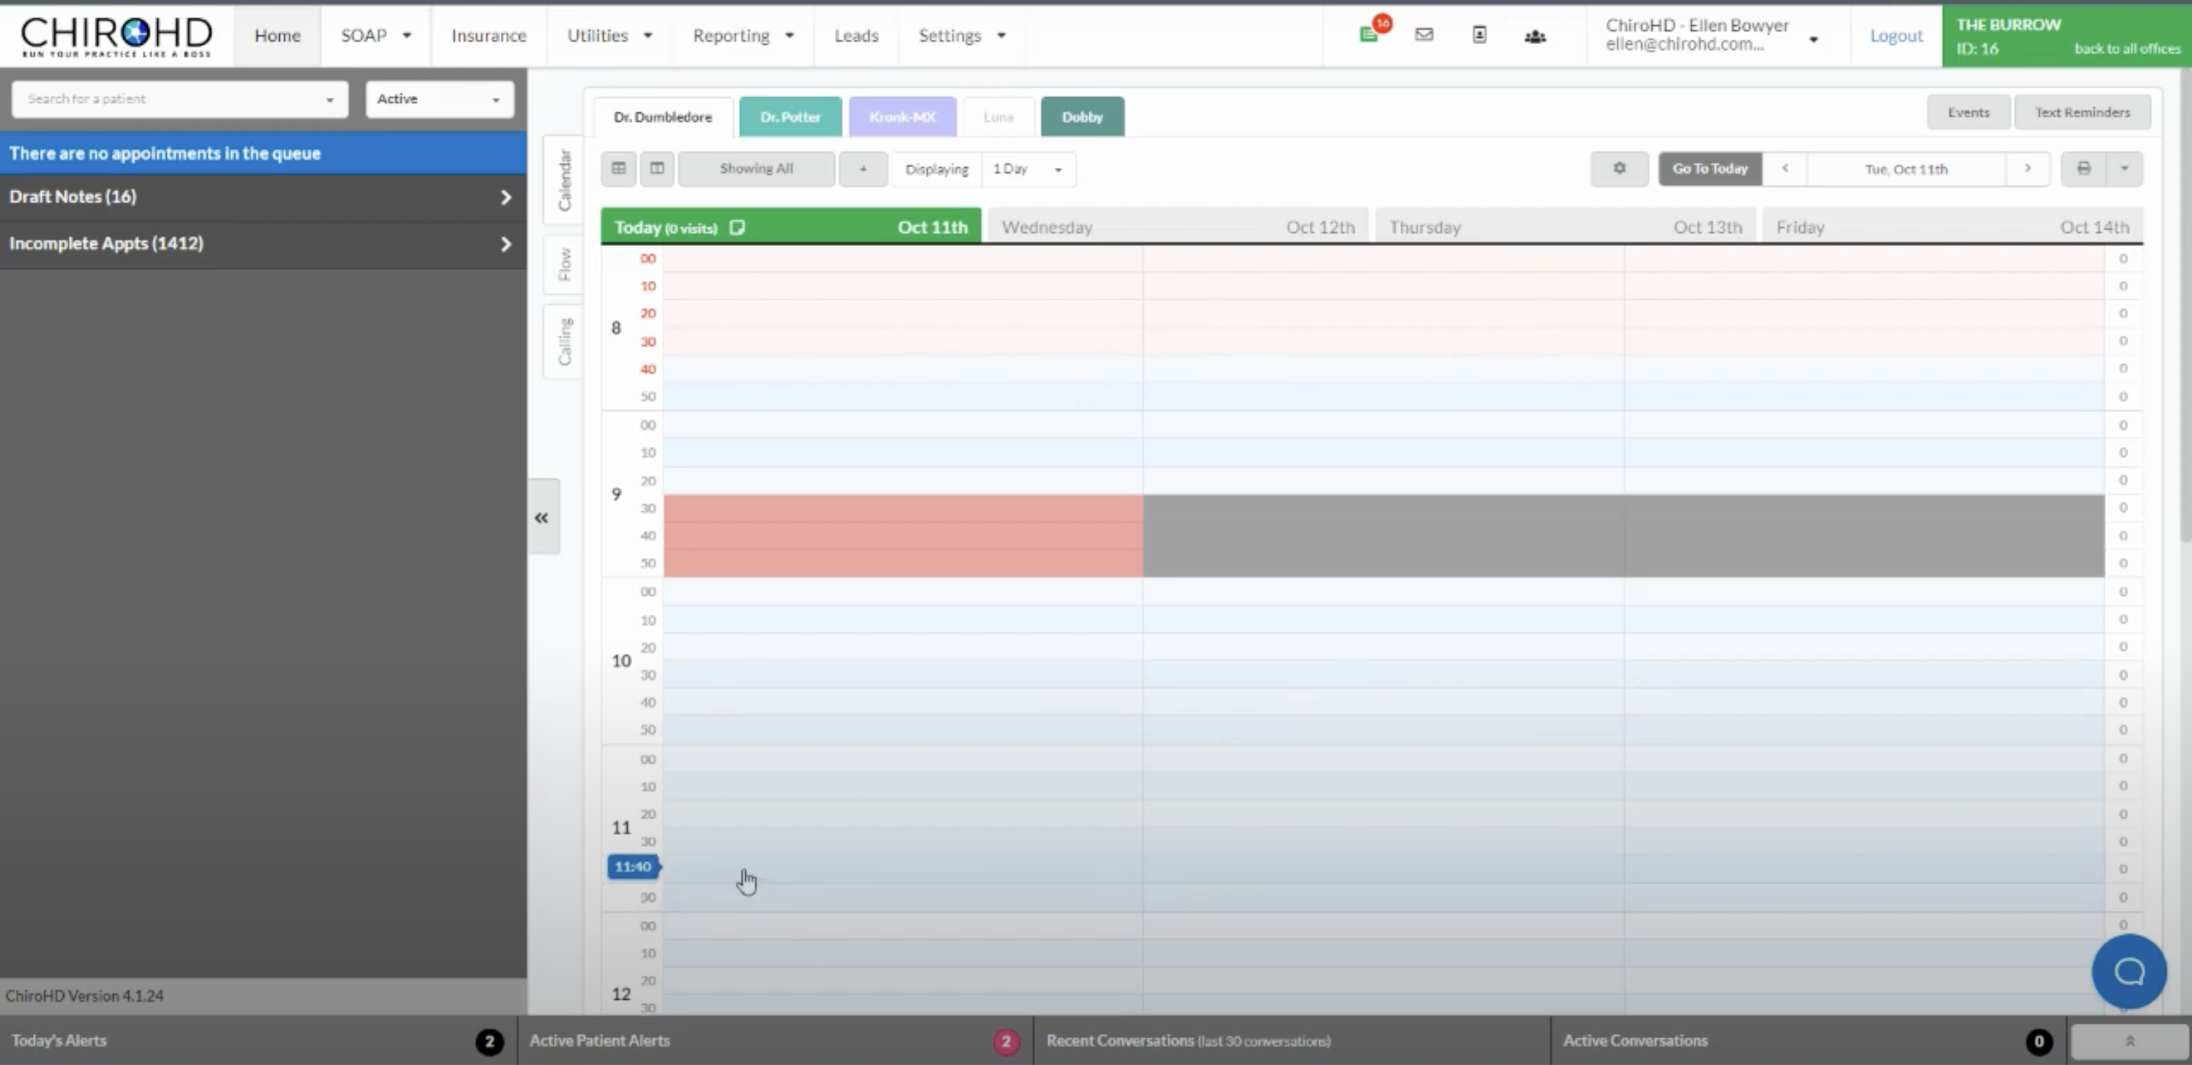

*Figure 2.1 ChrioHD Appointment Scheduling*

ChiroHD offers a straightforward scheduling system with color-coded blocks for managing appointments. The system allows easy rescheduling, cancellations, and integrates appointment reminders, making it easier for staff and patients to manage schedules effectively. However, the feature for automated patient engagement, such as follow-ups or customized notifications, is not as robust as other systems.

##### RC2: Electronic Health Records (EHR):

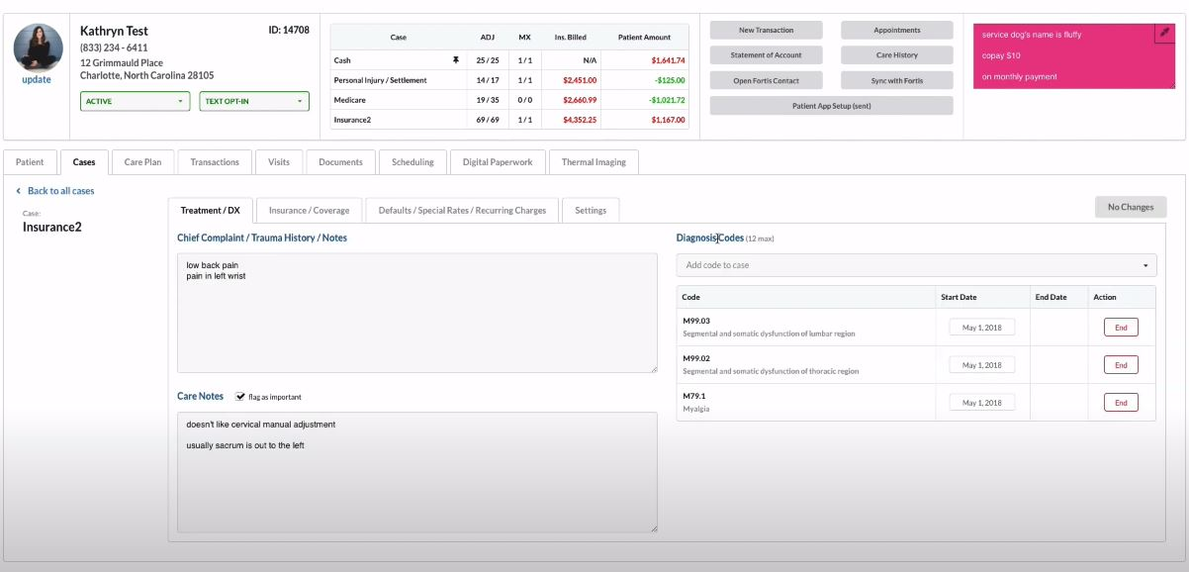

*Figure 2.2 ChrioHD Electronic Health Records (EHR)*

The EHR module within ChiroHD supports a detailed capture of patient records, including comprehensive visit histories, diagnosis details, and treatment notes. The interface is clean, with segmented views allowing practitioners to easily navigate between patient records. Integration with other diagnostic tools is also possible.

##### RC3: SOAP Notes:

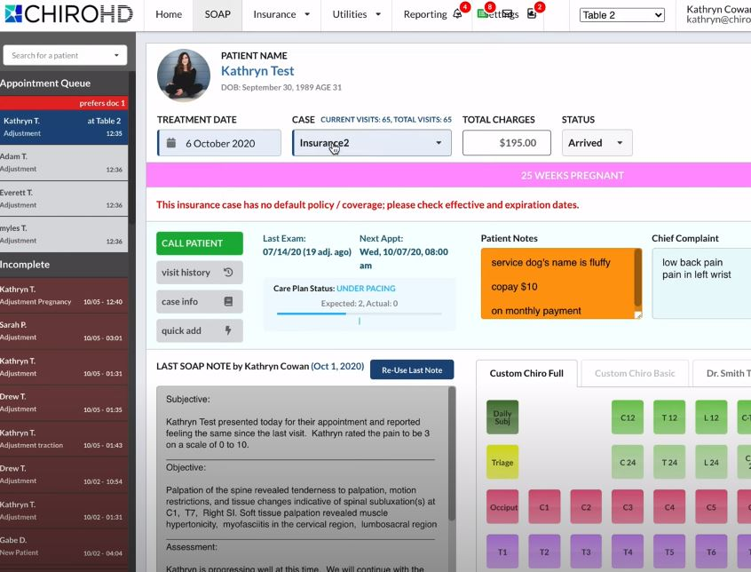

*Figure 2.3 ChrioHD SOAP Notes*

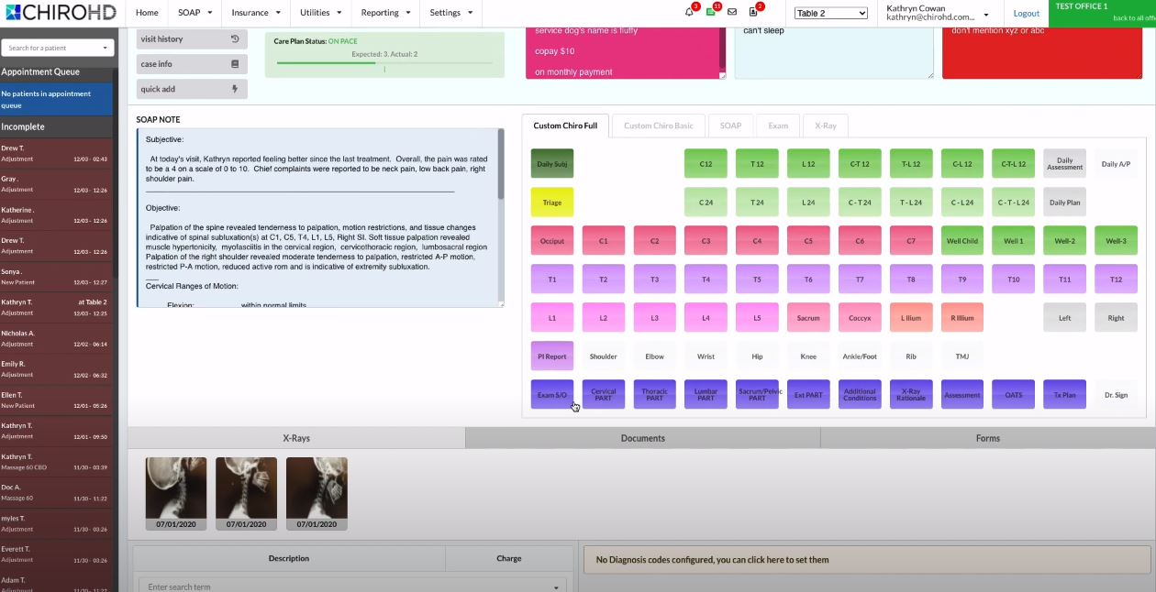

*Figure 2.4 ChrioHD SOAP Notes*

ChiroHD provides a well-structured SOAP notes feature that covers the essential elements. The system offers basic templates and allows some level of customization, although more flexibility could enhance its usability for diverse chiropractic workflows.

##### RC4: Billing and Coding:

The software supports billing processes and includes features for generating invoices, processing payments, and managing insurance claims. Automatic coding features streamline the documentation process, ensuring accuracy in claim submissions.

##### RC5: Patient Portal:

A dedicated patient portal is available, enabling patients to access their health records, manage appointments, and view billing information. However, the user experience could benefit from additional customization options.

##### RC6: User Load Management:

ChiroHD performs well under high user loads, supporting multi-practitioner environments with ease. However, specific scalability information under heavy traffic scenarios is not clearly documented.

##### RC7: Multi-Location Support:

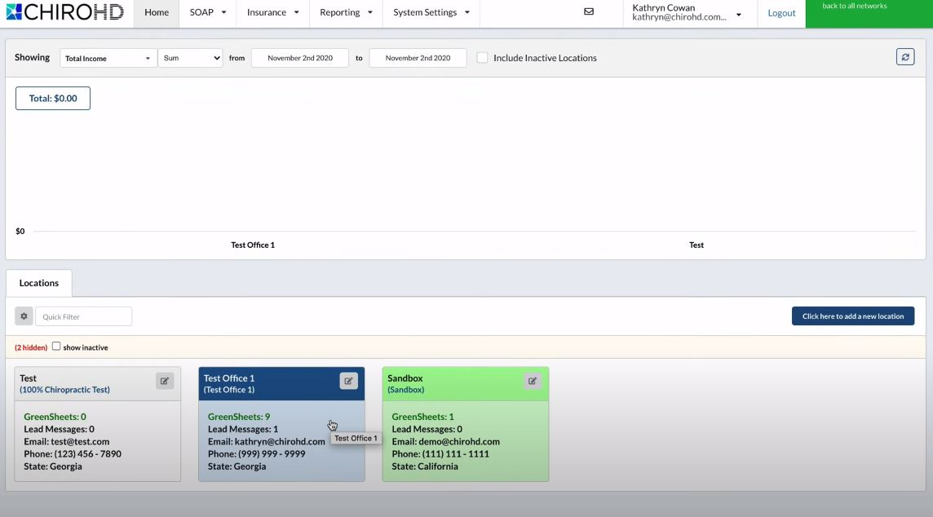

*Figure 2.5 ChrioHD Multilocation Support*

ChiroHD supports multiple location management, allowing practices with several branches to maintain separate yet integrated databases, facilitating centralized reporting and management.

##### RC8: Interface Design, Navigation Efficiency, and Learning Curve:

The software interface is generally intuitive, with straightforward navigation paths. However, the design feels slightly outdated compared to more modern practice management solutions. The learning curve is moderate, and new users can adapt with a few training sessions.

##### RC9: Security Access Controls:

ChiroHD offers robust access controls, allowing role-based permissions to ensure that sensitive data is only available to authorized users. Security measures meet standard compliance requirements.

##### RC10: Compliance:

The system is compliant with HIPAA regulations, ensuring the safe storage and handling of patient data, which is crucial in healthcare practice management.

##### RC11: Treatment Protocols:

ChiroHD offers features to create, track, and modify treatment protocols. These are integrated with patient records, allowing practitioners to maintain a consistent care plan throughout treatment.

##### RC12: System Settings for Functional Modules:

The system includes configurable modules, allowing practices to customize the workflow to suit their unique needs. However, some advanced settings might require additional technical support.

##### RC13: Custom Reports and Real-Time Analytics:

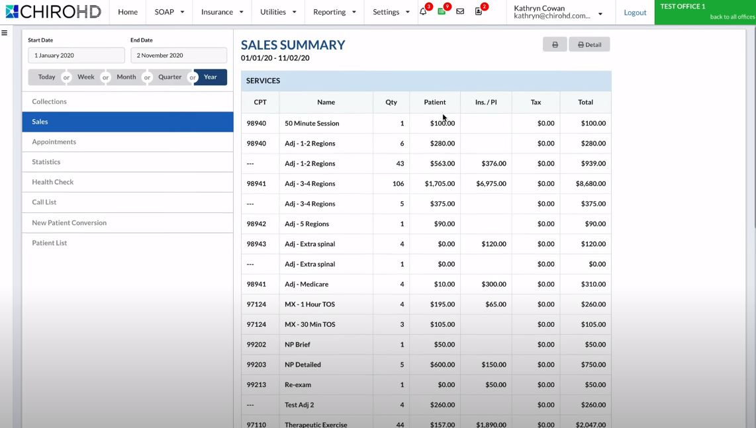

*Figure 2.6 ChrioHD Reporting*

Customizable reporting features are available, offering insights into practice performance, financials, and patient care metrics. Real-time analytics helps in monitoring key indicators but can be improved with more visual dashboards.

##### RC14: Total Cost of Ownership:

ChiroHD is priced at 300 USD per month, offering value for all practice sizes. The total cost includes a subscription fee that is relatively high compared to other systems in the market.

#### Conclusions

ChiroHD is a robust chiropractic practice management system, ideal for clinics seeking a well-rounded solution. While it excels in core areas like scheduling and EHR, some features, such as patient engagement and interface design, could benefit from enhancements to compete with more modern offerings, such as AI aided automation.

### 2.4.2 ChiroTouch

#### Overview

ChiroTouch is a widely used chiropractic practice management system known for its comprehensive range of features tailored to the needs of chiropractors. It focuses on improving practice efficiency and patient care through its all-in-one solution (ChiroTouch, 2024).

#### Review Based on Criteria

##### RC1: Appointment Scheduling:

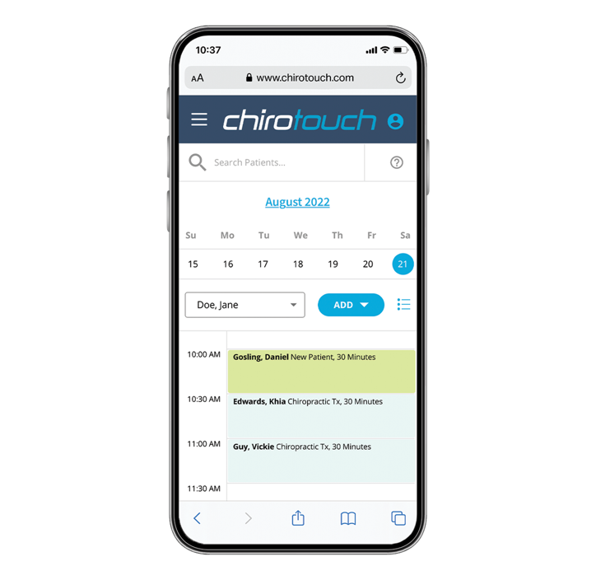

*Figure 2.7 ChiroTouch Scheduling*

ChiroTouch offers an advanced scheduling system with features like automated reminders, recurring appointments, and waitlist management. The interface is user-friendly and offers robust customization options.

##### RC2: Electronic Health Records (EHR):

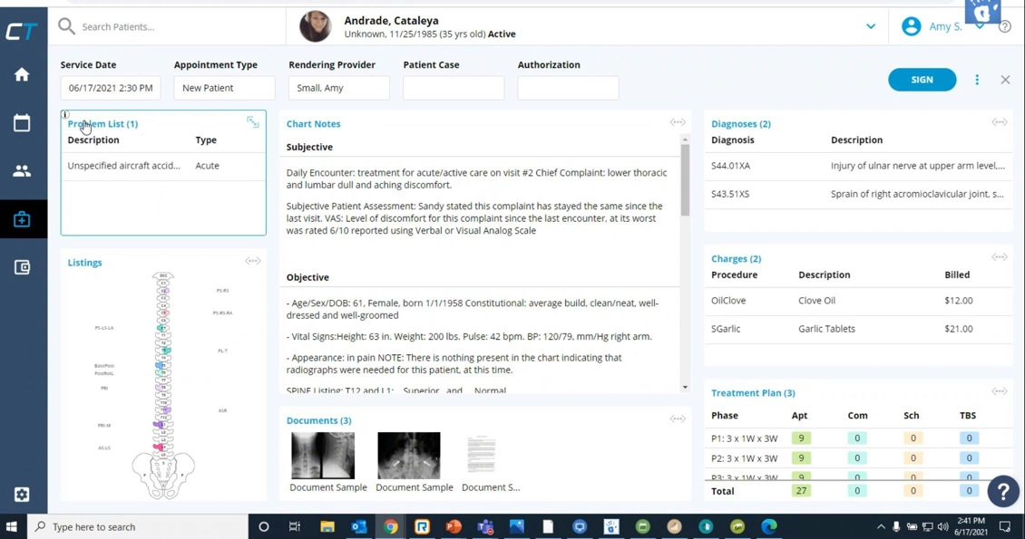

*Figure 2.8 ChiroTouch Electronic Health Records (EHR)*

The EHR module in ChiroTouch is comprehensive, offering in-depth patient records, integration with diagnostic tools, and advanced filtering options. The records are easily accessible and well-organized, supporting both clinical and administrative needs.

##### RC3: SOAP Notes:



*Figure 2.9 ChiroTouch SOAP Notes*

ChiroTouch excels in SOAP notes management with customizable templates that allow practitioners to document patient encounters in a highly personalized manner. The notes are integrated seamlessly with the broader patient record system, enhancing documentation efficiency.

##### RC4: Billing and Coding:

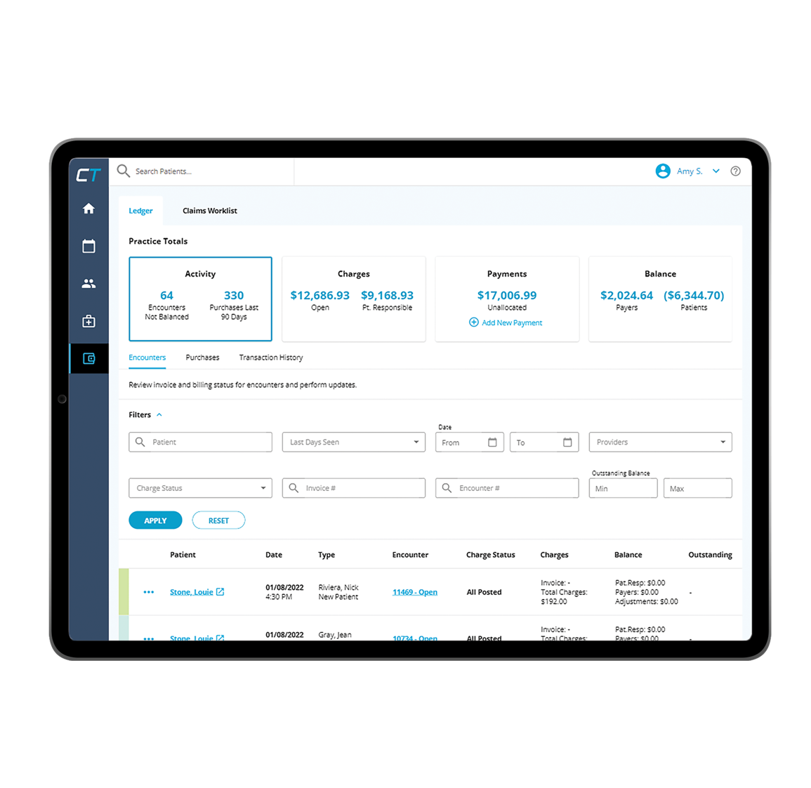

*Figure 2.10 ChiroTouch Billing*

Billing features are extensive, supporting insurance claims, payment processing, and financial reporting. The coding tools are sophisticated, enabling accurate documentation for insurance submissions.

##### RC5: Patient Portal:

A fully featured patient portal is provided, allowing patients to manage appointments, access health records, and engage with their care plans. The portal is customizable, improving the patient experience significantly.

##### RC6: User Load Management:

ChiroTouch is highly scalable, supporting large practices with multiple users without performance degradation. The system handles peak loads effectively.

##### RC7: Multi-Location Support:

Multi-location support is built-in, enabling practices to manage multiple branches with centralized control over scheduling, billing, and patient records.

##### RC8: Interface Design, Navigation Efficiency, and Learning Curve:

The interface is modern and intuitive, reducing the learning curve for new users. Navigation is streamlined, with clearly defined modules that make it easy for practitioners and administrative staff to use the system efficiently.

##### RC9: Security Access Controls:

ChiroTouch employs advanced security protocols, including role-based access control and data encryption, ensuring compliance with regulatory standards like HIPAA.

##### RC10: Compliance:

The system is fully HIPAA-compliant and incorporates features for secure data management and audit trails, essential for maintaining legal and regulatory standards in healthcare.

##### RC11: Treatment Protocols:

Treatment protocols in ChiroTouch are highly customizable, allowing practitioners to develop and adapt care plans that suit individual patient needs. Protocols are integrated with the patient management workflow.

##### RC12: System Settings for Functional Modules:

ChiroTouch offers extensive configuration options, allowing practices to tailor the software modules according to their operational requirements.

##### RC13: Custom Reports and Real-Time Analytics:

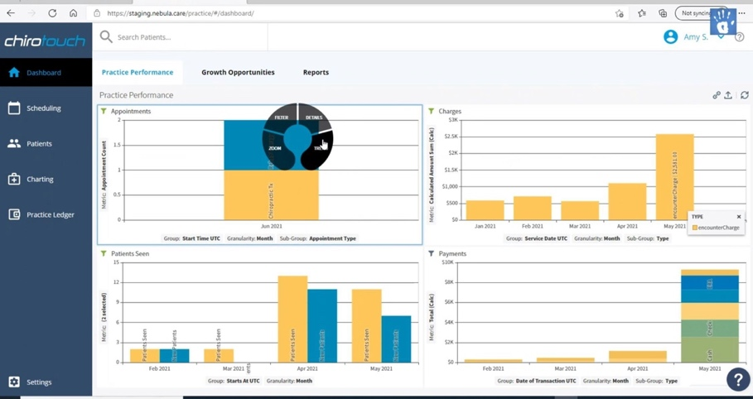

*Figure 2.11 Reporting*

ChiroTouch provides detailed reporting and analytics capabilities, offering insights into practice operations, financials, and patient outcomes. Real-time data monitoring is available through dashboards and customizable reports.

##### RC14: Total Cost of Ownership:

ChiroTouch is competitively priced at approximately $150 USD per month. Given its extensive feature set, the system offers excellent value for small to medium-sized practices. Despite its affordability, ChiroTouch does not compromise on functionality, making it a strong contender among chiropractic practice management solutions.

#### Conclusions

ChiroTouch is a premium chiropractic practice management solution offering a wide range of advanced features. It is best suited for small to medium-sized practices with complex needs. The system’s strength lies in its depth of functionality, particularly in areas like billing, reporting, and compliance, making it a comprehensive choice with competitive pricing.

### 2.4.3 EZBIS

#### Overview

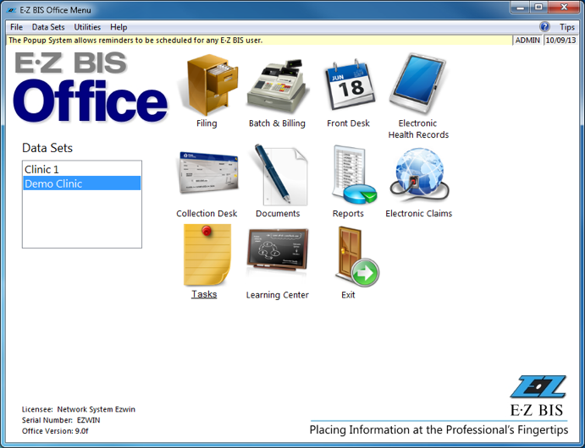

*Figure 2.12 EZBIS Features*

EZBIS Office is a versatile, modular software suite designed for chiropractic practice management. It includes key features like electronic health records (EHR), patient scheduling, and billing, tailored to streamline operations in chiropractic offices (EZBIS, 2024).

#### Review Based on Criteria

##### RC1: Appointment Scheduling:

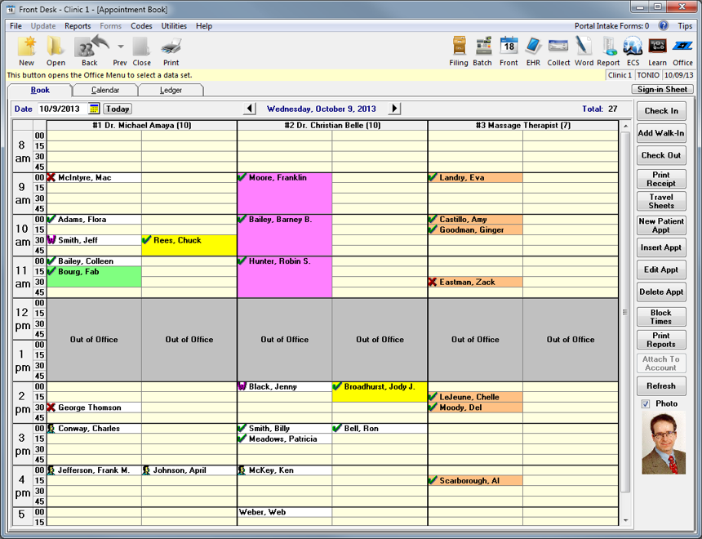

*Figure 2.13 EZBIS Scheduling*

EZBIS Office provides a robust scheduling application through its EZBIS FrontDesk module. The user-friendly interface offers clear visibility of daily appointments, including the status of missed or kept appointments. The system's automation enhances flexibility for office staff, and the recent addition of online self-scheduling allows patients to book their own appointments, which are then automatically integrated into the EZBIS appointment book. However, while the system is strong in core scheduling functionalities, it lacks advanced patient engagement features such as automated reminders.

##### RC2: Electronic Health Records (EHR):

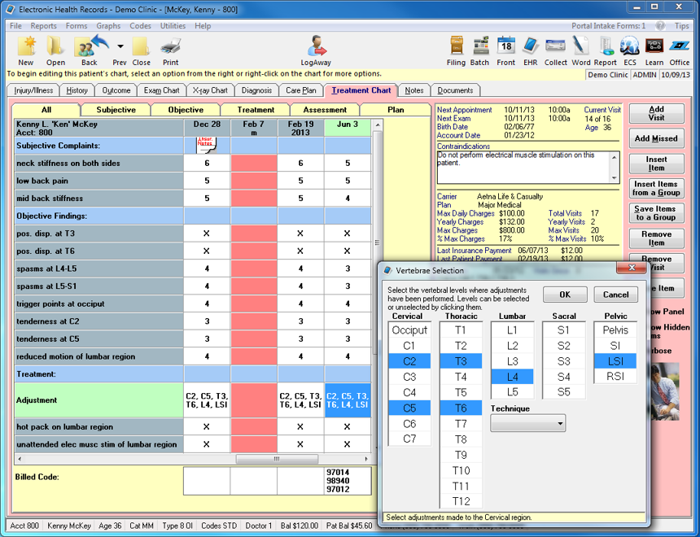

*Figure 2.14 EZBIS Electronic Health Records (EHR)*

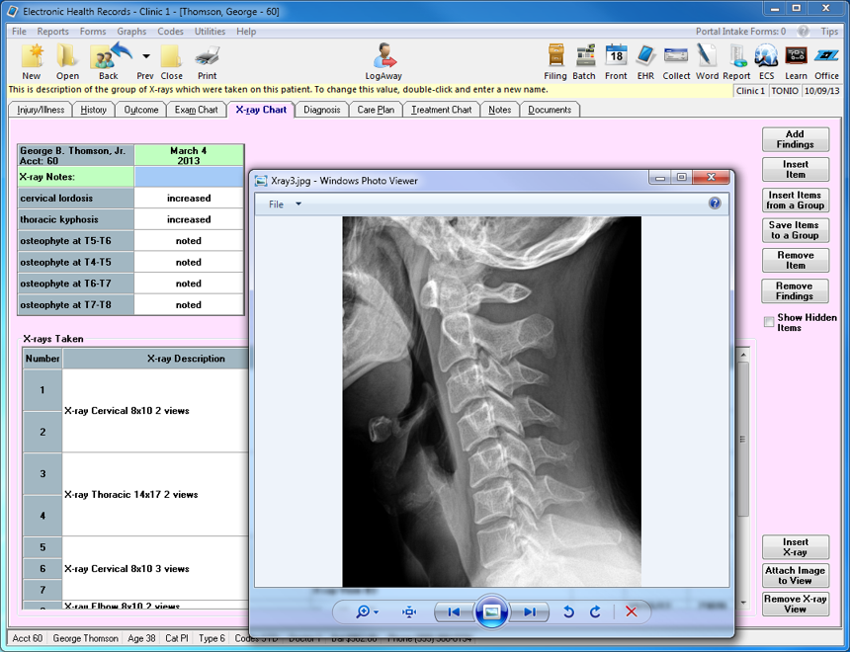

*Figure 2.15 EZBIS Electronic Health Records (EHR)*

The EHR module in EZBIS Office is comprehensive, covering detailed patient records, visit history, SOAP notes, and case plans. It is integrated with other modules, allowing seamless access to patient information across the system. The EHR is customizable to some extent, enabling practices to tailor it to their specific needs.

##### RC3: SOAP Notes:

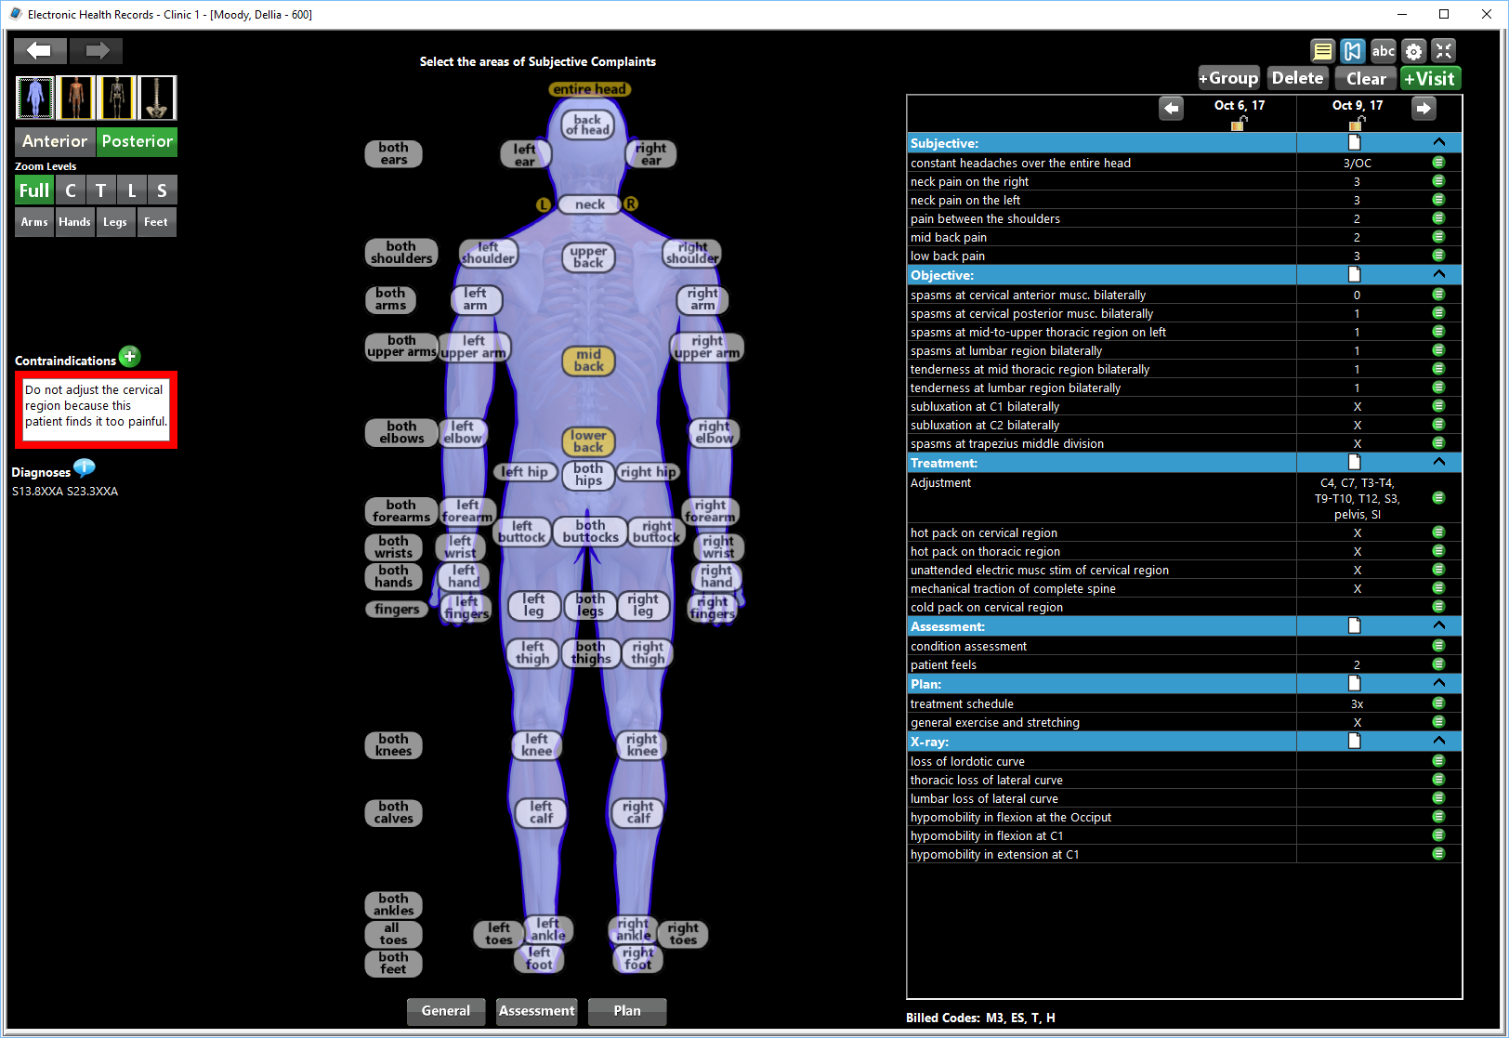

*Figure 2.16 EZBIS SOAP Notes*

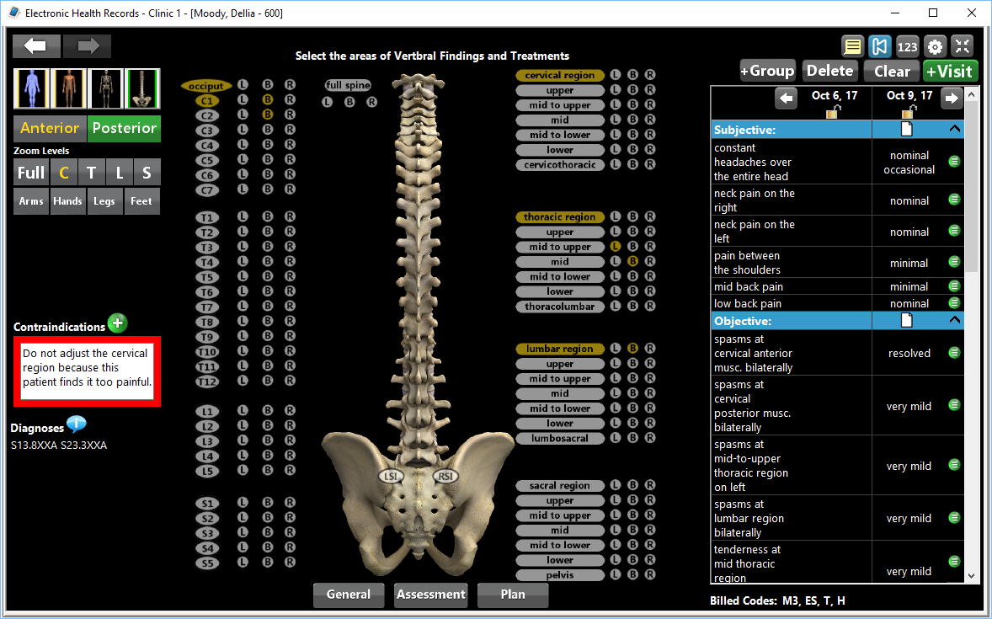

*Figure 2.16 EZBIS SOAP Notes*

EZBIS supports the creation of SOAP notes with a clear and detailed workflow. The system visually organizes this information effectively, covering the entire skeletal system. However, while the template provided is thorough, it does not offer customization options, which may be a limitation for practices with specific documentation preferences.

##### RC4: Billing and Coding:

EZBIS Office excels in billing and coding with its EZBIS Billing module. The batch entry feature allows for the rapid input of multiple transactions on a single screen, saving time for office staff. The system also automatically posts insurance payments, simplifying the billing process. Pre-built reports support the management of billing, collections, and patient information. However, while the system is effective for basic billing, it may lack the depth needed for more complex insurance processing.

##### RC5: Patient Portal:

EZBIS Office does not have a dedicated patient portal. Instead, it provides an option for clinics to create custom forms on their websites, enabling patients to schedule appointments online. These appointments are then directly integrated into the EZBIS system. While functional, this workaround does not offer the comprehensive features typically found in a full-fledged patient portal.

##### RC6: User Load Management:

EZBIS Office does not provide sufficient information regarding its ability to manage a high volume of users or large-scale operations. This could be a potential concern for larger practices that require robust user load management.

##### RC7: Multi-Location Support:

EZBIS Office supports multi-location practices, allowing each location to maintain its own database and analytics. This feature is beneficial for practices operating in multiple locations, though it may not offer the seamless integration found in more advanced systems.

##### RC8: Interface Design, Navigation Efficiency, and Learning Curve:

The user interface of EZBIS is somewhat outdated and cluttered, with limited use of modern design principles such as white space. Navigation can be challenging due to the dense presentation of information on screen, which may lead to a steeper learning curve for new users.

##### RC9: Security Access Controls:

EZBIS Office provides security access controls through authentication capabilities and user-specific permission sets. These features help ensure that sensitive data is protected, whether the software is deployed in the cloud or on-premises.

##### RC10: Compliance:

EZBIS is HIPAA compliant

##### RC11: Treatment Protocols:

The software allows the creation of case plans within the patient's EHR. However, details on the flow and customizability of treatment protocols are limited, which could be a drawback for practices that require more tailored treatment management options.

##### RC12: System Settings for Functional Modules:

EZBIS seems to be lacking behind in terms of customizable modules and users are forced to rely on the templates provided by the system

##### RC13: Custom Reports and Real-Time Analytics:

EZBIS offers reporting capabilities with the ability to produce custom reports and export them to the required format

##### RC14: Total Cost of Ownership:

EZBIS Office is a subscription-based service with a monthly fee of $225. While it is one of the more expensive options, its modular nature allows practices to pay for only what they need. However, given its higher cost, practices may find better value in other systems that offer more advanced features for the same or lower price.

#### Conclusions

EZBIS Office provides a comprehensive, modular chiropractic practice management solution with strengths in appointment scheduling, EHR, and billing. However, its outdated interface and limited patient engagement features may hinder usability and modern practice needs. While it offers flexibility and robust billing tools, its higher cost and lack of customization in key areas might lead practices to consider other options for better value and functionality.

### 2.4.4 Jane

#### Overview

Jane is a versatile practice management software designed to streamline operations for clinics of all sizes. It offers robust features such as online booking, comprehensive EHR management, customizable SOAP notes, and integrated billing and insurance processing. With a user-friendly interface, real-time reporting, and strong security measures including HIPAA compliance, Jane ensures efficient scheduling, secure patient data management, and seamless billing. The platform supports multi-location practices and provides extensive customization options, making it a comprehensive solution for modern healthcare practices (Jane, 2024).

#### Review Based on Criteria

##### RC1: Appointment Scheduling:

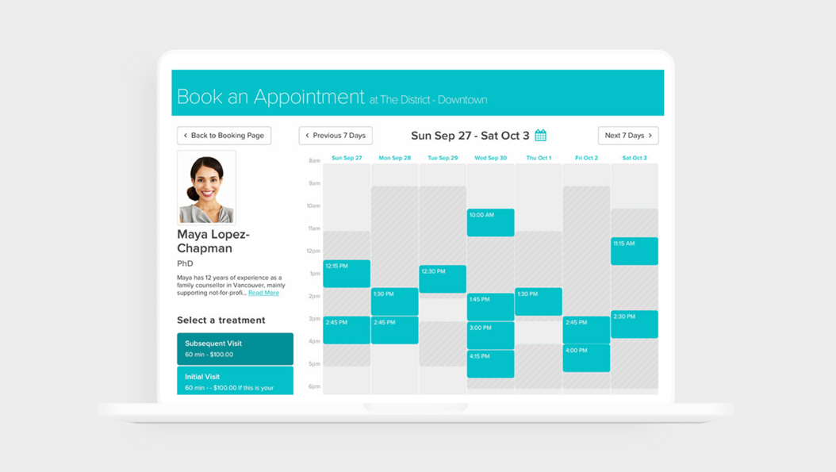

*Figure 2.17 Jane Scheduling*

Jane provides comprehensive online booking with clinic-friendly customization, including brand colours and services. It also offers staff and admin scheduling with features to view services, rooms, resources, waitlists, and payment statuses. It integrates online appointments with a HIPAA-compliant telehealth option, it excels in handling booking, cancellations, recurring appointments, and waitlist management. Automated reminders are also available.

##### RC2: Electronic Health Records (EHR):

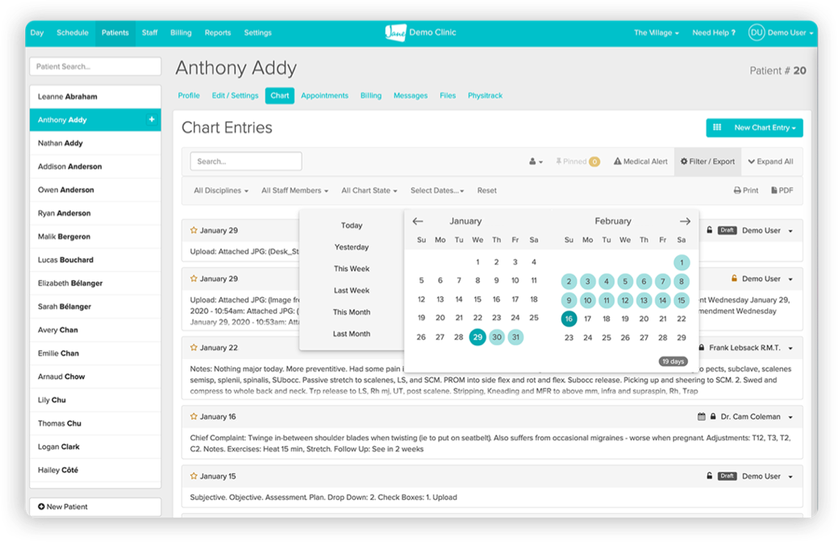

*Figure 2.18 Jane Electronic Health Record (EHR)*

Jane includes a template library with charts, forms, SOAP notes, and surveys. It allows for secure documentation from intake to final treatment. it supports the storage, updating, and access of patient health records effectively, covering medical history and treatment plans.

##### RC3: SOAP Notes:

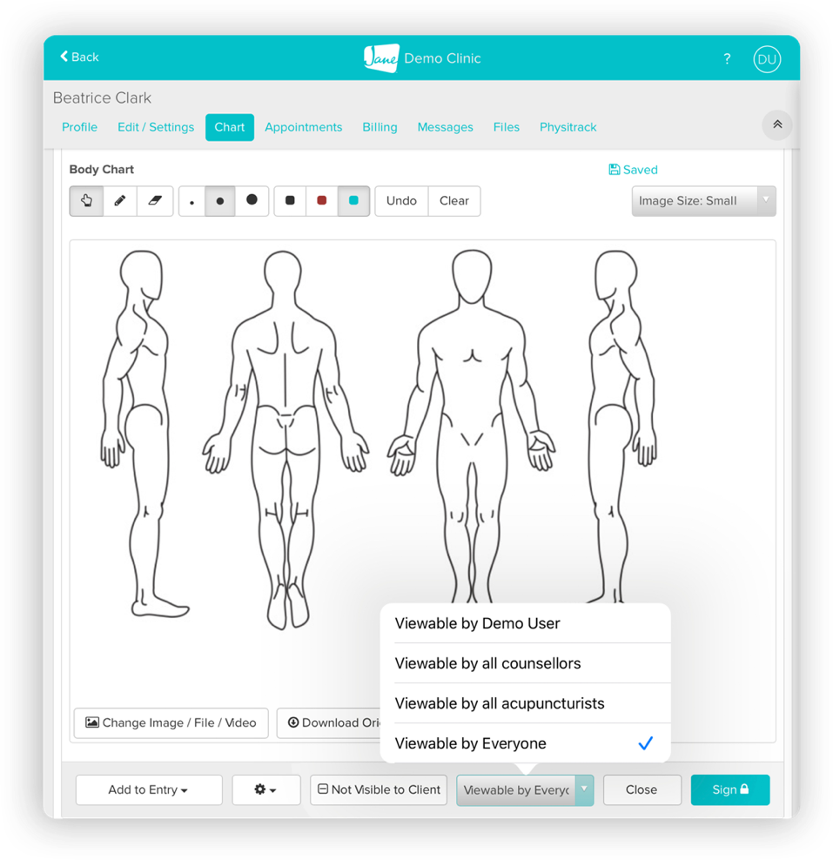

*Figure 2.19 Jane SOAP Notes*

Jane offers customizable SOAP notes and a library of templates for various documentation needs. The system supports the creation, storage, and retrieval of SOAP notes.

##### RC4: Billing and Coding:

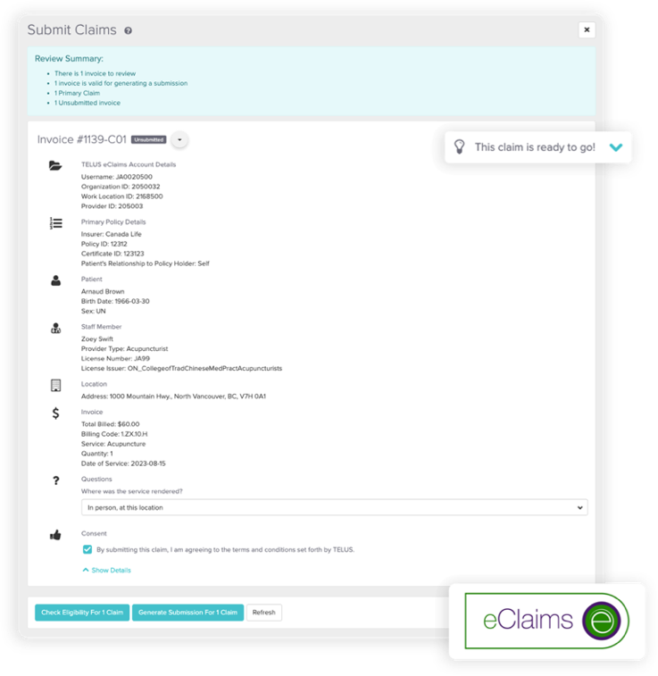

*Figure 2.20 Jane Billing*

Jane provides integrated billing and insurance management, including automatic calculations for billing and support for various international regions. It handles chiropractic-specific billing codes, generates invoices, and processes insurance claims effectively.

##### RC5: Patient Portal:

Jane’s online booking system and integrated website editor allow for patient access to records and appointment scheduling. Communication features such as reminders and online booking are also available depending on the subscription tier. but communication features need further clarification.

##### RC6: User Load Management:

Jane is designed to manage both solo practitioners and multi-location clinics. The system is well-equipped to handle an increasing number of users, including patients and staff. However, this depends on the number of licenses and subscription chosen.

##### RC7: Multi-Location Support:

Jane supports multi-location clinics with features for scheduling and management across different locations.

##### RC8: Interface Design, Navigation Efficiency, and Learning Curve:

Jane’s UI is simple and modern making it easy to use. It also offers unlimited support and a thorough onboarding process.

##### RC9: Security Access Controls:

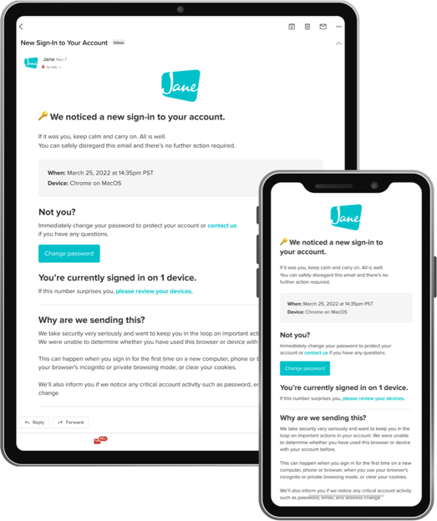

*Figure 2.21 Jane Security Options*

Jane includes security features such as 2FA, owner controls and access levels in addition to authentication, session logs and secure digital consent forms.

##### RC10: Compliance:

Jane meets necessary healthcare regulations and ensures data security and privacy. It is HIPAA, GDPR & PIPEDA compliant.

##### RC11: Treatment Protocols:

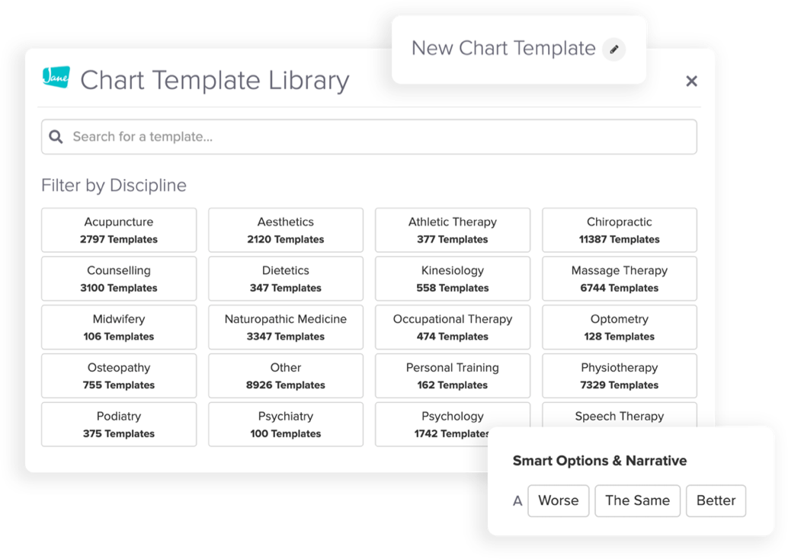

*Figure 2.22 Jane Treatment Templates*

The system allows customization of treatment plans and progress tracking through its flexible documentation and template options.

##### RC12: System Settings for Functional Modules:

Jane provides customization options across various functional modules, including billing, scheduling, and documentation. The system can be tailored to meet specific practice needs effectively.

##### RC13: Custom Reports and Real-Time Analytics:

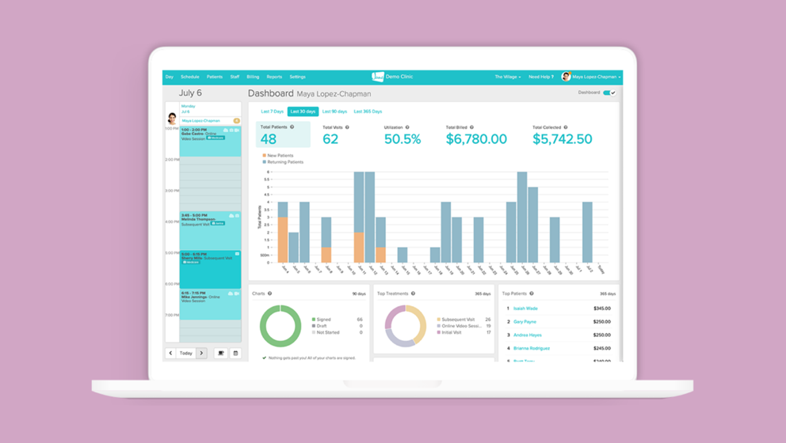

*Figure 2.23 Jane Reporting*

Jane offers real-time business insights and a full set of reports, eliminating the need for external tools like Excel. The system provides robust reporting and real-time analytics, including data visualization tools.

##### RC14: Total Cost of Ownership:

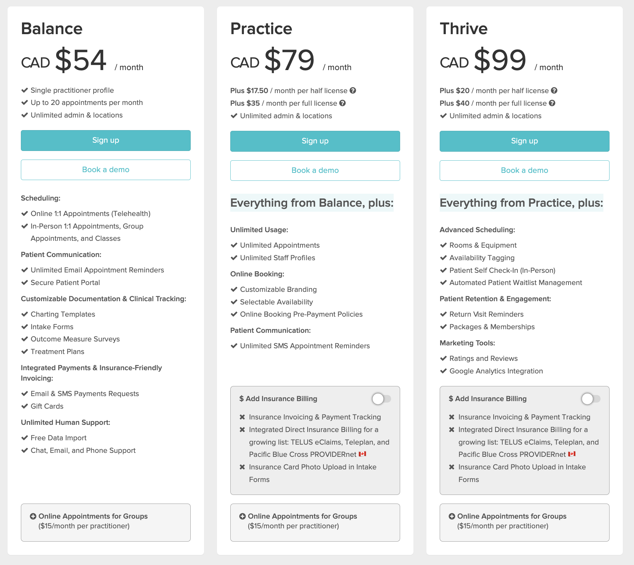

*Figure 2.24 Jane Pricing*

Jane is available on a monthly subscription starting from 54 CAD and up to 100 CAD adding features such as insurance billing, marketing tools, patient portal, and advanced scheduling features along the way. However, the base price includes all the core features. In the end it depends on the size of the clinic and its specific needs.

#### Conclusions

Overall, Jane appears to be a comprehensive solution with strong functionality across various criteria, including appointment scheduling, EHR management, billing, and security. Its scalability and customizability make it suitable for both small to medium sized practices. However, for large practices that require more customisability Jane may be lacking as it caters to a wider range of practices and doesn’t focus on Chiropractors in specific

### 2.4.5 ChiroSpring

#### Overview

ChiroSpring is a comprehensive cloud-based software designed to simplify and enhance the management of chiropractic practices. It offers a range of features including integrated billing, customizable SOAP notes, and online scheduling to streamline administrative tasks. With tools for managing payments, automated reminders, and online intake forms, ChiroSpring aims to improve patient engagement and operational efficiency. The platform also includes GrowthHub for patient acquisition and SEO tools to boost online visibility. ChiroSpring’s user-friendly interface and robust functionality make it a powerful choice for modern chiropractic care (ChiroSpring, 2024).

#### Review Based on Criteria

##### RC1: Appointment Scheduling:

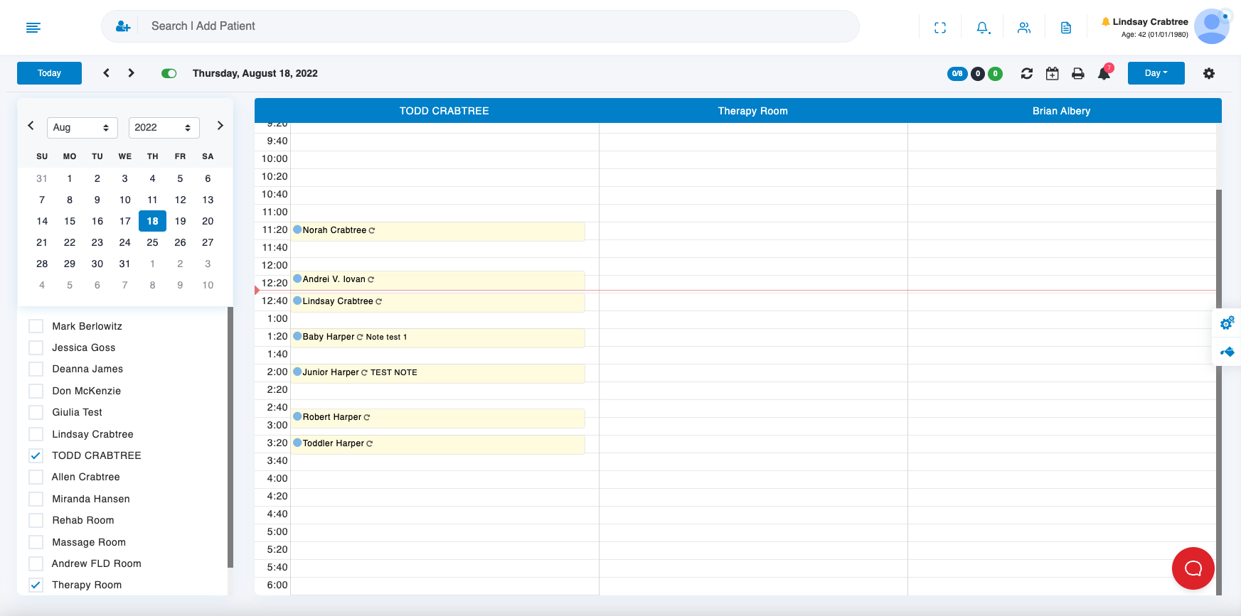

*Figure 2.25 ChiroSpring Scheduling*

ChiroSpring provides online appointment scheduling with customizable options, automatic new patient creation, and 24/7 booking capabilities.

##### RC2: Electronic Health Records (EHR):

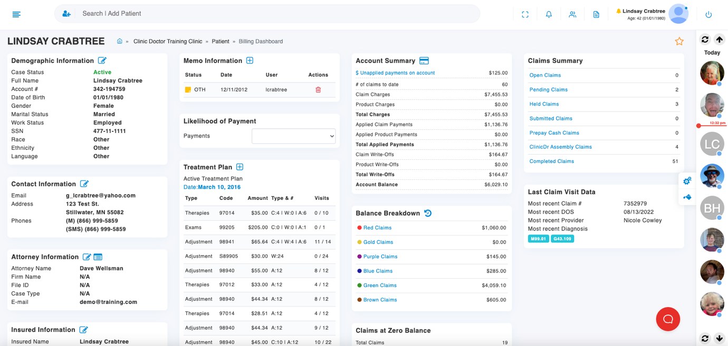

*Figure 2.26 ChiroSpring Electronic Health Record (EHR)*

The platform allows for customizable and audit-proof SOAP notes with built-in macros, with full EHR capabilities, such as storing and updating patient health records.

##### RC3: SOAP Notes:

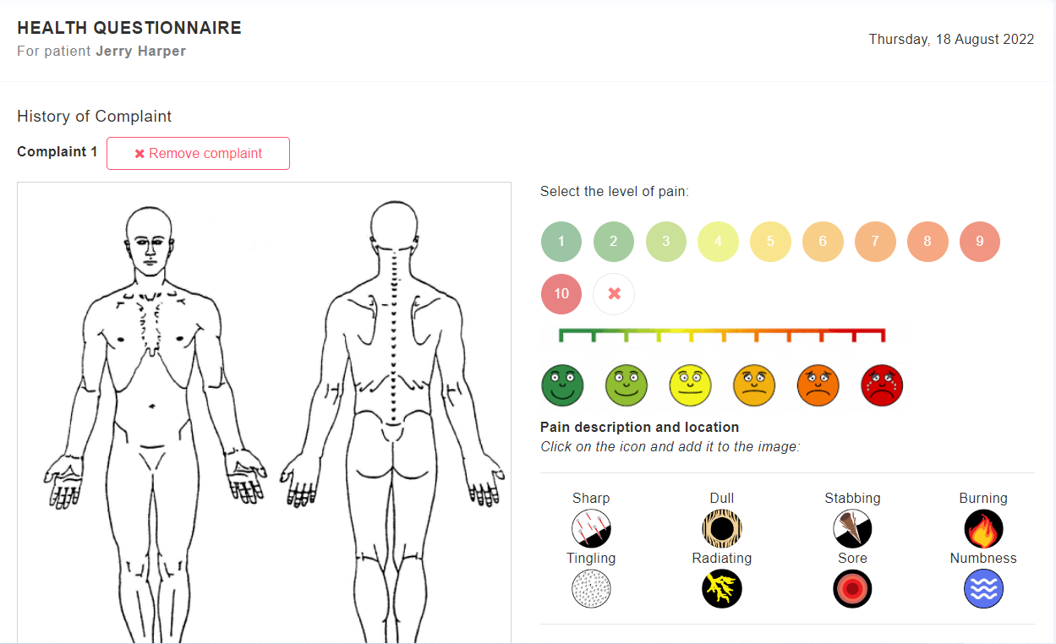

*Figure 2.27 ChiroSpring SOAP Notes*

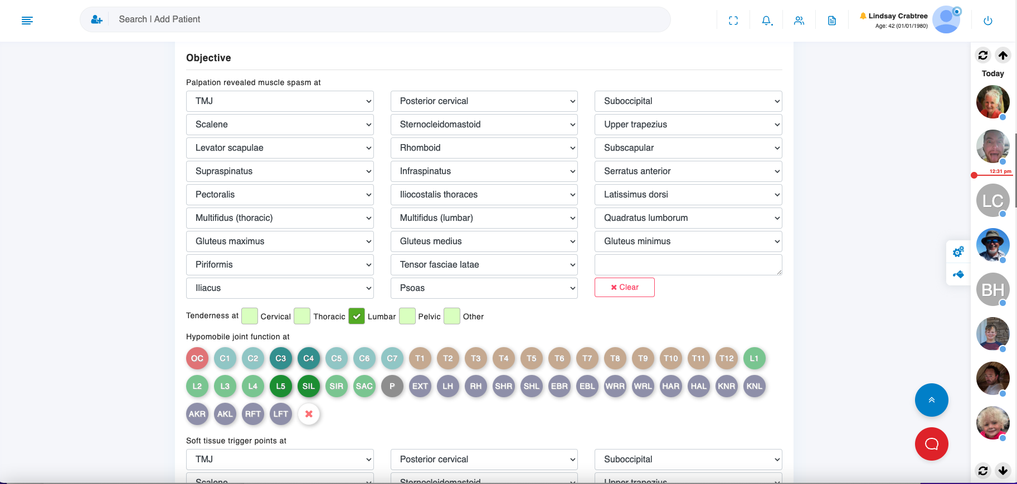

*Figure 2.28 ChiroSpring SOAP Notes*

ChiroSpring offers fully customizable SOAP notes with 50+ templates and built-in macros for compliance, it excels in facilitating the creation, storage, and retrieval of SOAP notes.

##### RC4: Billing and Coding:

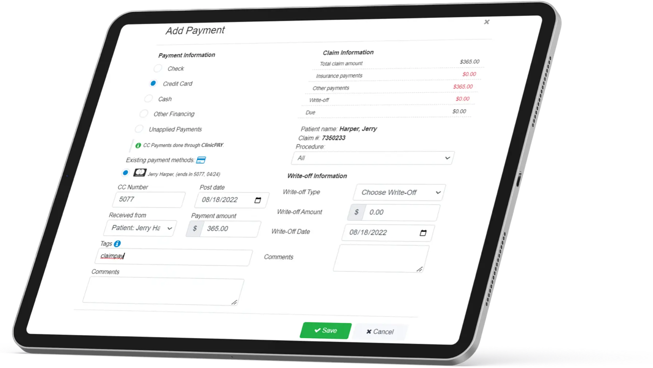

*Figure 2.29 ChiroSpring Billing*

ChiroSpring includes integrated billing with advanced claim scrubbing, auto posting ERAs, and automatic claim creation. It effectively manages chiropractic-specific billing codes, generates invoices, and handles insurance claims.

##### RC5: Patient Portal:

ChiroSpring provides online intake forms and scheduling, but a full-featured patient portal is not explicitly detailed.

##### RC6: User Load Management:

The system appears scalable and suitable for increasing numbers of users and practice locations.

##### RC7: Multi-Location Support:

Designed to accommodate various practice sizes, including multi-location setups.

##### RC8: Interface Design, Navigation Efficiency, and Learning Curve:

The UI allows for customized views depending on the needs of the clinic with access to training videos and a 24/7 available help desk.

##### RC9: Security Access Controls:

ChiroSpring is a cloud-based application with authentication and access controls are put in place for users restricting access to sensitive patient information.

##### RC10: Compliance:

HIPAA Compliant

##### RC11: Treatment Protocols:

ChiroSpring offers customizable SOAP notes and online intake forms, allowing for customization of treatment documentation but does not provide extensive details on treatment plans or progress tracking.

##### RC12: System Settings for Functional Modules:

ChiroSpring enables customization of scheduling and billing modules, but lacks comprehensive details on all system settings.

##### RC13: Custom Reports and Real-Time Analytics:

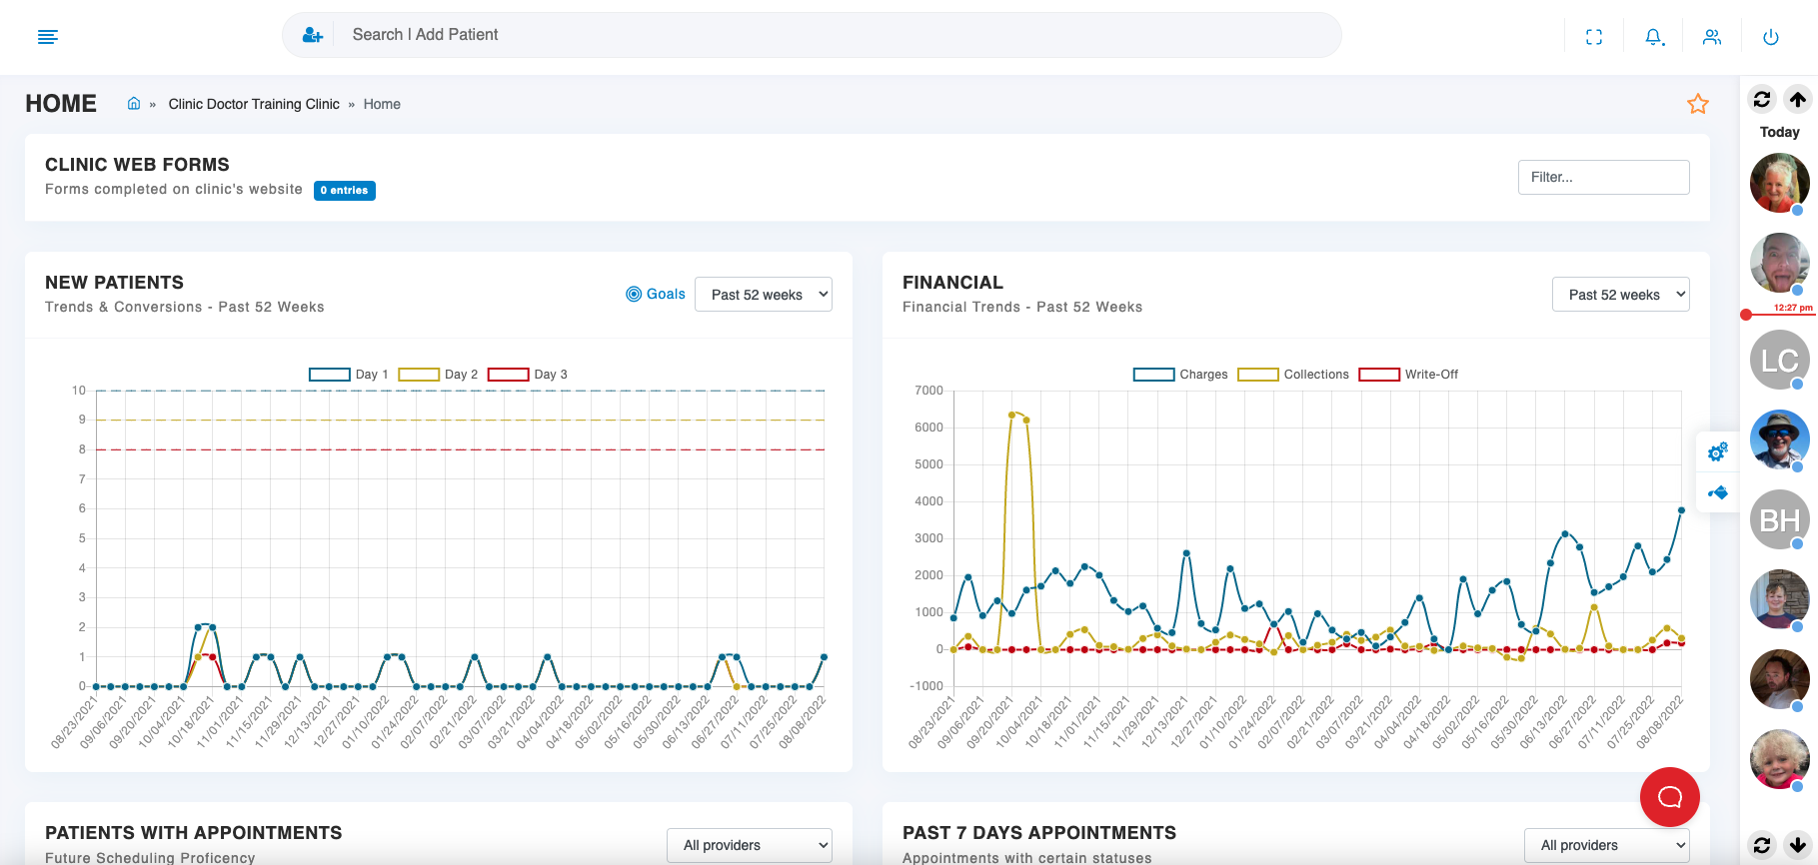

*Figure 2.30 ChiroSpring Reporting*

ChiroSpring provides dashboards for accessing patient information, billing, and engagement. The system offers real-time insights and reporting through dashboards but does not specify custom reporting features or advanced data analytics.

##### RC14: Total Cost of Ownership:

Chirospring is available on a monthly subscription starting from 149 USD and up to 400 USD adding features such as AI data scrubbing for insurance claims, marketing tools, patient subscription functionality, and advanced engagement features along the way. Depending on the clinic size the subscription plans are balanced and priced accordingly.

#### Conclusions

ChiroSpring offers a refined and highly customizable application, distinguished by advanced features like AI-driven data scrubbing, setting it apart from other systems. While the learning curve may be steeper compared to some alternatives, it is a robust solution that effectively caters to practices of all sizes.

## 2.5 Conclusions and Comparisons of Systems

### Functionality

|  |  |  |  |  |  |
| --- | --- | --- | --- | --- | --- |
| **Review Criteria** | **ChiroHD** | **ChiroTouch** | **EZBIS** | **Jane** | **ChiroSpring** |
| Appointment Scheduling | 5 | 3 | 3 | 4 | 4 |
| Electronic Health Record | 5 | 4 | 4 | 3 | 5 |
| SOAP Notes | 4 | 4 | 5 | 3 | 5 |
| Billing & Coding | 4 | 4 | 3 | 4 | 5 |
| Patient Portal | 4 | 4 | 1 | 3 | 3 |
| Total Score  out of 25 | 22 | 19 | 16 | 17 | 22 |

*Table 2.1 Comparison of Functional Review Criteria*

After reviewing the different chiropractic software systems, several key insights and comparisons emerge. ChiroHD and ChiroSpring stand out for their superior functionality, each scoring 22 out of 25. Both systems offer comprehensive features across appointment scheduling, electronic health records, SOAP notes, and billing and coding. They also excel in patient portal functionality, making them robust choices for practices requiring a full range of capabilities. In contrast, EZBIS lags behind with a score of 16, particularly struggling in patient portal and billing functionalities.

### Scalability

|  |  |  |  |  |  |
| --- | --- | --- | --- | --- | --- |
| **Review Criteria** | **ChiroHD** | **ChiroTouch** | **EZBIS** | **Jane** | **ChiroSpring** |
| User Load Management | 4 | 4 | 4 | 4 | 4 |
| Multilocation Support | 4 | 4 | 2 | 4 | 4 |
| Total Score  out of 10 | 8 | 8 | 6 | 8 | 8 |

Table 2.2 Comparison of Scalability Review Criteria

In terms of scalability, ChiroHD, ChiroTouch, Jane and ChiroSpring all perform exceptionally well, each scoring 8 out of 10. These systems effectively manage user loads and support multiple locations, which is crucial for growing or multi-site practices. EZBIS, with a score of 6, falls short in multi-location support, potentially limiting its scalability for larger operations.

### Usability and User Experience

|  |  |  |  |  |  |
| --- | --- | --- | --- | --- | --- |
| **Review Criteria** | **ChiroHD** | **ChiroTouch** | **EZBIS** | **Jane** | **ChiroSpring** |
| User Interface | 3 | 5 | 2 | 5 | 5 |
| Navigation | 4 | 4 | 3 | 5 | 4 |
| Ease of Use | 4 | 4 | 3 | 5 | 4 |
| Total Score  out of 15 | 11 | 13 | 8 | 15 | 13 |

Table 2.3 Comparison of UI/UX Review Criteria

When evaluating usability and user experience, Jane emerges as the top performer, scoring a perfect 15 out of 15. It offers an intuitive user interface, seamless navigation, and overall ease of use, which greatly enhances the user experience. ChiroTouch and ChiroSpring also provide strong usability features but are slightly less intuitive than Jane. On the other hand, EZBIS scores the lowest in this category, reflecting challenges with its user interface and ease of use.

### Security Access Controls:

|  |  |  |  |  |  |
| --- | --- | --- | --- | --- | --- |
| **Review Criteria** | **ChiroHD** | **ChiroTouch** | **EZBIS** | **Jane** | **ChiroSpring** |
| User Authentication & Authorization | 5 | 5 | 5 | 5 | 5 |
| Access Controls | 5 | 5 | 2 | 2 | 5 |
| Total Score  out of 10 | 10 | 10 | 7 | 7 | 10 |

Table 2.4 Comparison of Security Access Controls Review Criteria

Security access controls are well-handled by ChiroHD, ChiroTouch, and ChiroSpring, each achieving a perfect score of 10 out of 10. These systems provide robust user authentication and access controls, ensuring a high level of data security. EZBIS and Jane have room for improvement in access controls, which could pose potential security risks.

### Customizability

|  |  |  |  |  |  |
| --- | --- | --- | --- | --- | --- |
| **Review Criteria** | **ChiroHD** | **ChiroTouch** | **EZBIS** | **Jane** | **ChiroSpring** |
| Treatment Plan | 5 | 4 | 3 | 2 | 5 |
| System Settings for functional modules | 5 | 4 | 2 | 3 | 5 |
| Total Score  out of 10 | 10 | 8 | 5 | 5 | 10 |

Table 2.5 Comparison of Customizability Review Criteria

In terms of customizability, ChiroHD & ChiroSpring excel with a top score of 10 out of 10, offering extensive customization options for treatment plans and system settings. ChiroTouch follows closely behind with a score of 8, providing good customization options but not as comprehensive as ChiroHD & ChiroSpring. EZBIS and Jane score lower, indicating less flexibility in adapting to specific practice needs.

### Reporting and Analytics

|  |  |  |  |  |  |
| --- | --- | --- | --- | --- | --- |
| **Review Criteria** | **ChiroHD** | **ChiroTouch** | **EZBIS** | **Jane** | **ChiroSpring** |
| Custom Reports | 4 | 4 | 3 | 3 | 5 |
| Real time Analytics | 5 | 5 | 2 | 3 | 5 |
| Total Score  out of 10 | 9 | 9 | 5 | 6 | 10 |

Table 2.6 Comparison of Reporting & Analytics Review Criteria

For reporting and analytics, ChiroSpring is the leader with a perfect score of 10 out of 10, offering advanced custom reporting and real-time analytics. ChiroHD and ChiroTouch also perform well but are not as strong as ChiroSpring in providing robust reporting capabilities. EZBIS scores the lowest in this category, which could limit its effectiveness in data-driven decision-making.

### Cost-effectiveness

|  |  |  |  |  |  |
| --- | --- | --- | --- | --- | --- |
| **Review Criteria** | **ChiroHD** | **ChiroTouch** | **EZBIS** | **Jane** | **ChiroSpring** |
| Cost of Ownership | 3 | 4 | 2 | 4 | 5 |
| Total Score  out of 5 | 3 | 4 | 2 | 4 | 5 |

Table 2.7 Comparison of Cost-effectivness Review Criteria

Cost-effectiveness is a highlight for ChiroSpring, which scores 5 out of 5, offering excellent value for its features and capabilities. ChiroTouch is also cost-effective but at a slightly higher price point. EZBIS is the least cost-effective, offering the least value relative to its cost.

### System Review Results

|  |  |  |  |  |  |
| --- | --- | --- | --- | --- | --- |
| **Review Criteria** | **ChiroHD** | **ChiroTouch** | **EZBIS** | **Jane** | **ChiroSpring** |
| Functionality | 22 | 19 | 16 | 17 | 22 |
| Scalability | 8 | 8 | 6 | 8 | 8 |
| Usability & User Experience | 11 | 13 | 8 | 15 | 13 |
| Security Access Control | 10 | 10 | 7 | 7 | 10 |
| Customizability | 10 | 8 | 5 | 5 | 10 |
| Reporting & Analytics | 9 | 9 | 5 | 6 | 10 |
| Cost Effectiveness | 3 | 4 | 2 | 4 | 5 |
| Total Score  out of 85 | 73 | 71 | 49 | 62 | 78 |

Table 2.8 Comparison of Systems Review Criteria

Overall, ChiroSpring emerges as the best system due to its high scores in functionality, customizability, reporting and analytics, and cost-effectiveness. Despite its lower usability and user experience score, its comprehensive feature set and excellent value make it the top choice for most chiropractic practices. In developing or selecting a system, it would be prudent to incorporate the strengths of ChiroSpring and consider improvements based on the weaknesses identified in other systems, particularly in user interface design and cost-effectiveness.

# Chapter 3 System Requirements

## 3.1 Introduction

This section outlines the detailed system requirements essential for the successful implementation of the chiropractic practice management system. It begins with a stakeholder diagram and context diagram to visually represent the interactions and data flows between the system and its external entities. Following this, the system requirements are categorized into functional, non-functional, and user interface requirements, providing a comprehensive and precise specification of what the system must achieve. This thorough analysis reflects a deep understanding of stakeholders' needs and business objectives, setting a robust foundation for the subsequent development phases. The requirements are meticulously documented and traceable, ensuring alignment with best practices in software engineering and supporting a seamless transition to the design and implementation stages.

## 3.2 System Stakeholder

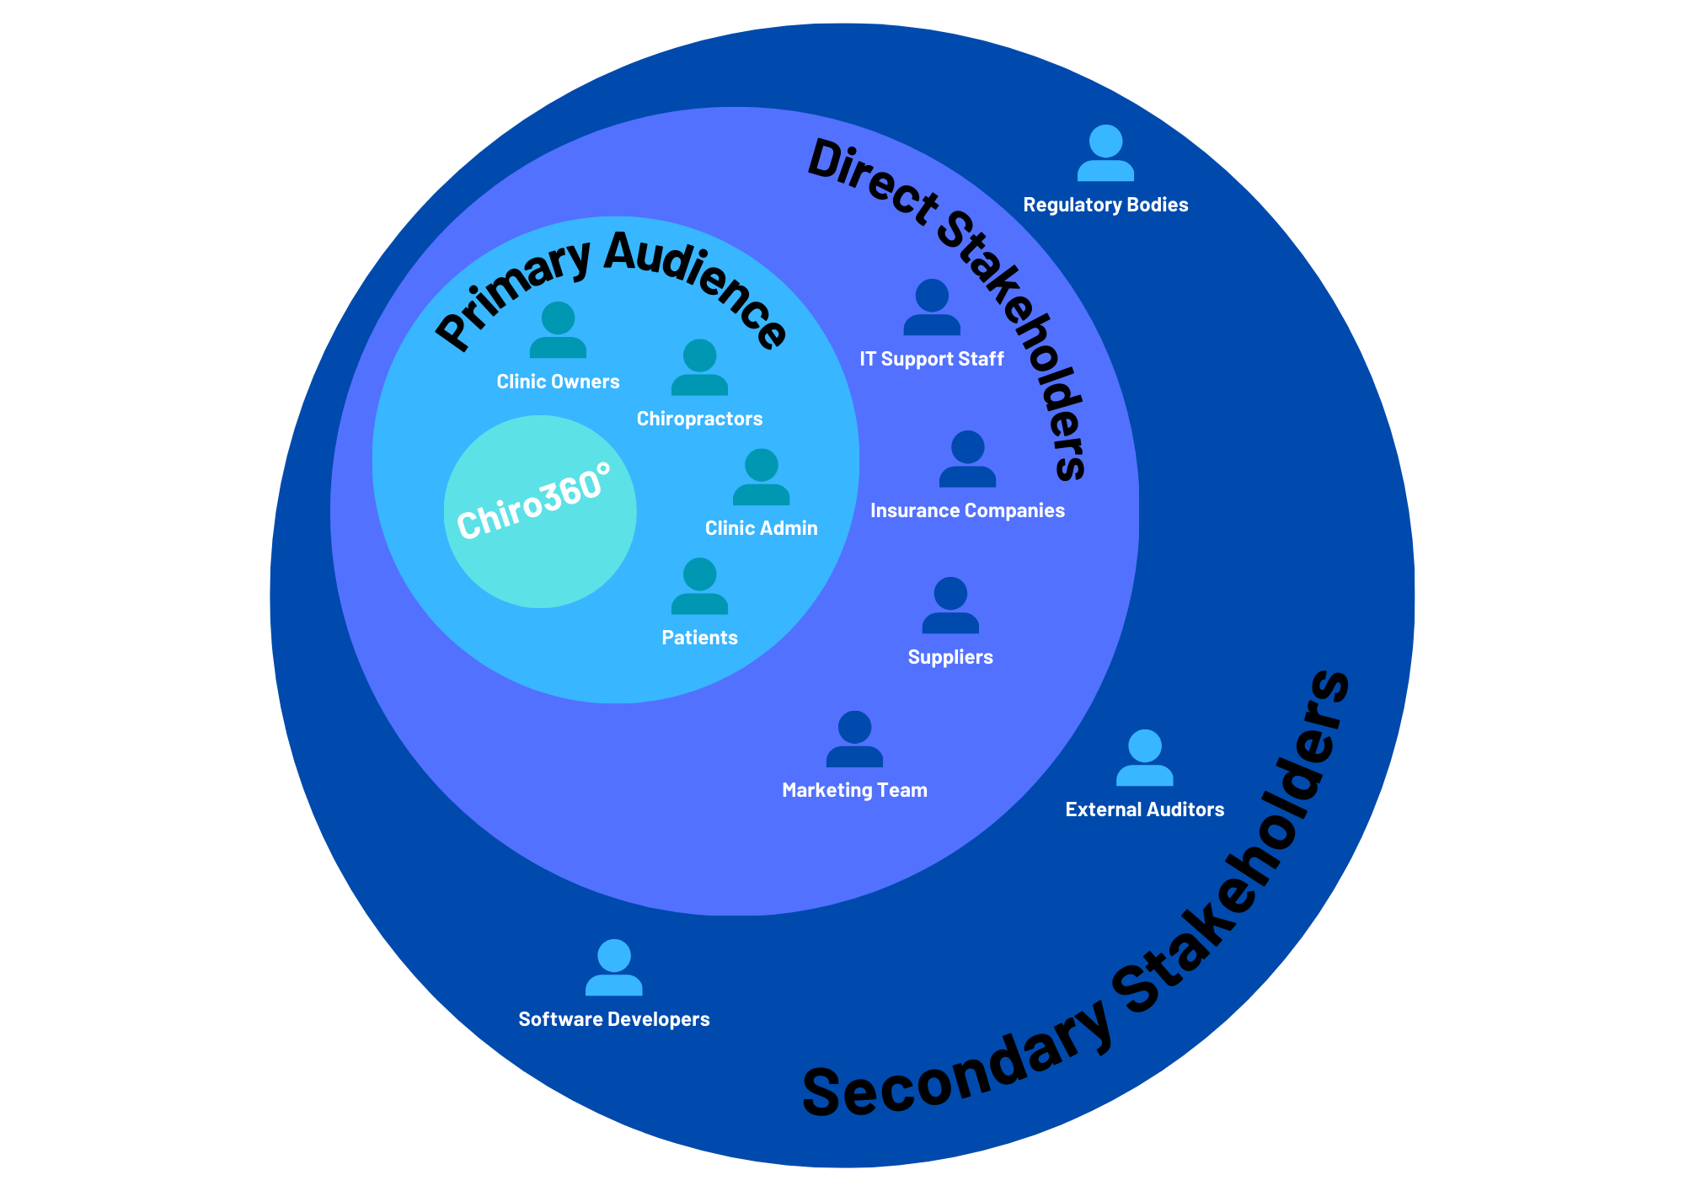

*Figure 3.1 Stakeholder Diagram*

### 3.2.1 Primary Stakeholders

Clinic owners, chiropractors, and medical staff are the primary users and decision-makers. Clinic owners focus on selecting and implementing a system that optimizes operations, supports multi-location management, and ensures compliance with regulations. Chiropractors and medical staff rely on the system daily for scheduling, EHR access, and patient care documentation, making usability and workflow integration crucial. Patients interact with the system to manage appointments, access health records, and refer new patients, requiring a user-friendly interface. Administrative staff manage daily operations, including scheduling, billing, and patient communication, and play a key role in onboarding new patients through application invites.

### 3.2.2 Secondary Stakeholders

The secondary stakeholders include IT support staff, insurance companies, suppliers, and the marketing team. IT support staff ensure the system's smooth operation, managing user accounts, access controls, and data security. Insurance companies use the system for processing claims, ensuring proper documentation and timely payments, while suppliers interact with the system's inventory management features to maintain an efficient supply chain. The marketing team utilizes the system's tools for patient acquisition and retention, leveraging analytics to optimize marketing efforts and contribute to the clinic’s growth.

### 3.2.3 Tertiary Stakeholders

Tertiary stakeholders involve regulatory bodies, external auditors, and software developers/vendors. Regulatory bodies and external auditors focus on ensuring the system complies with legal standards and maintains transparency in financial and operational practices. Software developers and vendors are responsible for designing, customizing, and maintaining the system, ensuring it meets the clinic's needs and stays current with industry standards. Their work ensures the system remains reliable, functional, and adaptable to the evolving needs of the clinic.

## 3.3 System Context

The context diagram below represents the chiropractic practice management system at the center, showing how it exchanges data with various external entities and stakeholders that directly interact with it. These include patients, clinic owners, medical staff, administrative staff, insurance companies, IT support staff, marketing teams, regulatory bodies, external auditors, and software developers/vendors.

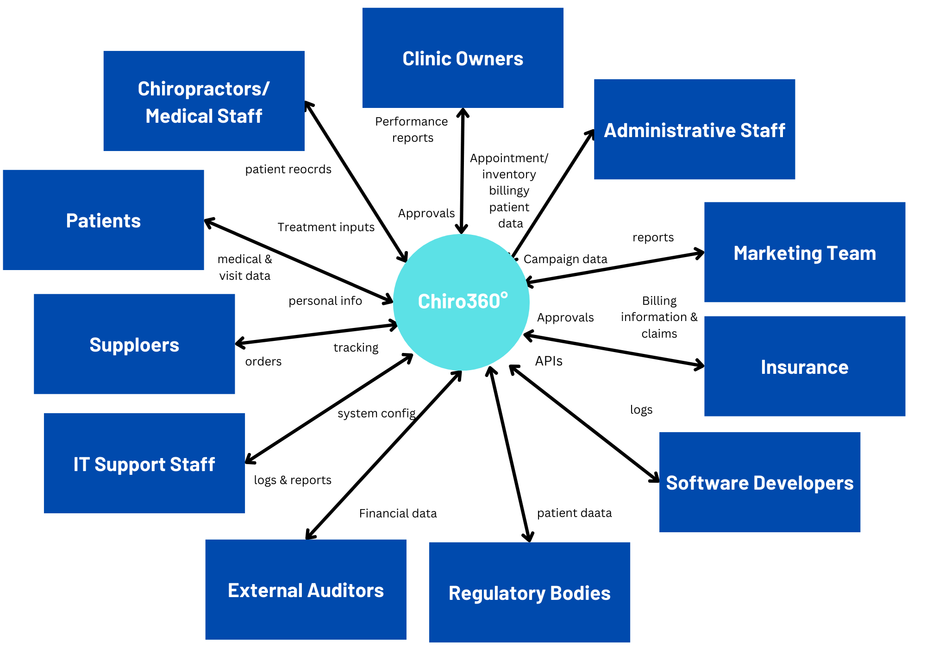

*Figure 3.2 Context Diagram*

### 3.3.1 Patients

Patients use the system to book, reschedule, or cancel appointments, access their electronic health records (EHR), communicate with clinic staff, and refer new patients. They provide personal and medical information, appointment requests, and feedback, while receiving confirmations, reminders, and access to their records.

### 3.3.2 Clinic Owners

Clinic owners interact with the system to monitor clinic performance, manage multi-location operations, and ensure that the clinic adheres to regulations. They access detailed reports, financial summaries, and operational metrics, and input strategic decisions, system settings, and financial approvals.

### 3.3.3 Chiropractors/Medical Staff

Chiropractors and medical staff rely on the system for managing patient records, documenting treatment sessions (SOAP notes), and scheduling follow-ups. They input clinical data, update patient progress, and access the system for daily patient management tasks.

### 3.3.4 Administrative Staff

Administrative staff handle scheduling, billing, insurance claims, and patient communication through the system. They input and manage appointment data, billing, and insurance details, and are responsible for sending out patient application invites and following up on patient inquiries.

### 3.3.5 Insurance Companies

Insurance companies receive billing and treatment data from the system to process insurance claims. They return claims approvals or denials, along with payment information, helping ensure timely reimbursement for services rendered.

### 3.3.6 IT Support Staff

IT support staff maintain the system, ensuring that it operates securely and efficiently. They manage user accounts, configure access controls, perform updates, and handle data security tasks like backups and recovery.

### 3.3.7 Marketing Teams

Marketing teams interact with the system’s marketing and patient acquisition tools to design and manage campaigns, track referrals, and analyse the effectiveness of marketing strategies. They input campaign data, manage patient communications, and utilize analytics to improve patient engagement and retention.

### 3.3.8 Regulatory Bodies

Regulatory bodies interact with the system through compliance checks and audits, ensuring that the system adheres to healthcare regulations and data protection laws. They access necessary records and reports to verify compliance with standards like HIPAA.

### 3.3.9 External Auditors

External auditors review the system’s financial and operational data to ensure accuracy and transparency. They access financial records, transaction histories, and system logs to conduct audits and provide feedback on regulatory compliance and financial integrity.

### 3.3.10 Software Developers/Vendors

Software developers and vendors are responsible for the ongoing development, customization, and maintenance of the system. They interact with the system to implement updates, introduce new features, fix bugs, and ensure the system remains aligned with the clinic’s needs and industry standards.

### 3.3.11 Suppliers

Suppliers of medical and office equipment interact with the system to provide and manage inventory, ensuring timely delivery of supplies and updating stock levels, which integrates with the system’s inventory management features to streamline clinic operations and prevent stockouts.

## 3.4 System Requirements

### 3.4.1 Functional Requirements

#### 3.4.1.1 Compulsory Functional Requirements

##### 3.4.1.1.1 Appointment Scheduling

* Schedule Appointments: Users must be able to easily add new appointments with patient details.
* Reschedule Appointments: Users should have the ability to modify existing appointments.
* Cancel Appointments: Users need to cancel appointments and notify patients.
* Calendar Views: Provide daily, weekly, and monthly calendar views.
* Real-Time Updates: Ensure that appointment changes are updated immediately to prevent double-booking.
* Patient Flow Management: Optimize scheduling to manage patient flow efficiently.

##### 3.4.1.1.2 Patient Electronic Health Record (EHR) Integration

* Patient Demographics: Store and retrieve patient demographic information.
* Medical History: Maintain comprehensive medical history for each patient.
* Treatment Plans: Document and update treatment plans.
* Visit Summaries: Generate summaries of each patient visit.
* Quick Access: Enable fast access and updating of patient records.

##### 3.4.1.1.3 SOAP Notes

* Create Notes: Allow users to create new SOAP notes for each patient visit.
* Store Notes: Store SOAP notes securely within the patient’s record.
* Retrieve Notes: Provide quick retrieval of SOAP notes for reference.
* Standardization: Ensure that the format follows standardized SOAP documentation practices.

##### 3.4.1.1.4 Reporting

* Generate Reports: Create reports on patient progress, financial performance, and appointment statistics.
* Real-Time Data Analysis: Provide real-time analysis and visualization of data.
* Insightful Metrics: Include key metrics to help in decision-making and practice management.

#### 3.4.1.2 Desirable Functional Requirements

##### 3.4.1.2.1 Appointment Scheduling

* Automated Reminders: Send email/SMS reminders to patients before their appointments.

##### 3.4.1.2.2 SOAP Notes

* Ease of Use: Design the note-taking interface to be user-friendly and efficient.

##### 3.4.1.2.3 Reporting

* Customizable Templates: Offer customizable report templates to meet various needs.

##### 3.4.1.2.4 Billing & Insurance Invoicing:

* Generate and manage invoices for patient services.
* Insurance Claims Processing: Process insurance claims and track their status.
* Payment Tracking: Track payments from patients and insurance companies.
* Financial Reporting: Produce financial reports detailing revenue, expenses, and payments.
* Adjustment Codes: Support for chiropractic-specific adjustment codes and integration with ICD/CPT codes.
* Multiple Payment Methods: Accept various payment methods, including credit cards and electronic payments.

##### 3.4.1.2.5 Inventory Management

* Track Supplies: Monitor levels of medical supplies, equipment, and consumables.
* Automated Reordering: Automate reordering processes to prevent stockouts.
* Supplier Management: Maintain information about suppliers and manage orders.
* Usage Analytics: Analyse usage patterns to optimize inventory management.
* Batch and Expiry Management: Track batch numbers and expiry dates to ensure timely use of products.
* Integration with Other Systems: Integrate with billing and EHR systems for seamless operation.

#### 3.4.1.3 Luxury Functional Requirements

##### 3.4.1.3.1 Appointment Scheduling

* Interactive Scheduling: Provide advanced features like drag-and-drop scheduling for easy adjustments.

##### 3.4.1.3.2 Reporting

* Export Options: Allow reports to be exported in multiple formats (e.g., PDF, Excel).

##### 3.4.1.3.3 Patient Portal

* Appointment Management: Allow patients to schedule, reschedule, or cancel their appointments online.
* Health Record Access: Provide access to personal health records and visit summaries.
* Communication: Enable secure messaging between patients and the clinic.
* Educational Materials: Offer access to educational resources and health information.
* Mobile Accessibility: Ensure the portal is accessible via mobile devices.

##### 3.4.1.3.4 Multi-Location Management

* Centralized Management: Manage multiple clinic locations from a single system.
* Consolidated Reporting: Generate reports that consolidate data from all locations.
* Staff Scheduling: Coordinate staff schedules across different locations.
* Unified Patient Records: Maintain consistent patient records across all locations.
* Administrative Efficiency: Streamline administrative tasks for multiple locations.

##### 3.4.1.3.5 Marketing Tools

* Email Campaigns: Create and manage email marketing campaigns.
* Social Media Management: Integrate with social media platforms for marketing purposes.
* Referral Tracking: Track patient referrals and manage referral programs.
* Campaign Analytics: Analyse the effectiveness of marketing campaigns and track performance metrics.
* Patient Acquisition: Use targeted marketing efforts to attract new patients.

### 3.4.2 Non-Functional Requirements

#### 3.4.2.1 Compulsory Non-Functional Requirements

##### 3.4.2.1.1 Security

* Access Controls: Implement role-based access controls to restrict user access to sensitive data.
* Authentication: Use secure authentication methods to verify user identities.

##### 3.4.2.1.2 Performance

* System Responsiveness: Ensure the system responds quickly to user inputs and operations.
* Load Handling: Handle high volumes of concurrent users and data efficiently.
* Latency: Minimize latency during peak usage times.

#### 3.4.2.2 Desirable Non-Functional Requirements

##### 3.4.2.2.1 Security

* Audit Trails: Maintain audit trails to track changes and access to sensitive data for accountability.

##### 3.4.2.2.2 Scalability

* User Scalability: Support an increasing number of users without performance degradation.
* Data Scalability: Handle growing amounts of data efficiently.
* Feature Expansion: Allow for the addition of new features and modules as needed.

#### 3.4.2.3 Luxury Non-Functional Requirements

##### 3.4.2.3.1 Security

* Data Encryption: Encrypt data both in transit and at rest to protect it from unauthorized access.

##### 3.4.2.3.2 Customization

* User Preferences: Allow users to customize settings, layouts, and functionalities.
* Workflow Personalization: Adapt workflows and interfaces to individual user needs.
* Flexible Reporting: Enable customization of report formats and content.

##### 3.4.2.3.3 Integration

* Third-Party Integration: Support integration with external applications and services.
* APIs: Provide APIs for custom integrations with other systems.
* Interoperability: Ensure smooth data exchange between different systems and platforms.

### 3.4.3 User Interface Requirements

#### 3.4.3.1 Compulsory User Interface Requirements

* Device Compatibility: Ensure the interface works well on desktops, tablets, and smartphones.
* Layout Adjustment: Automatically adjust layout based on screen size and resolution.
* Menu Organization: Organize menus and options clearly for easy access.
* Actionable Buttons: Ensure buttons and actions are clearly labelled and intuitive.

#### 3.4.3.2 Desirable User Interface Requirements

* Widget Placement: Allow users to add, remove, and rearrange widgets on their dashboards.
* Personalized Views: Provide options for users to personalize their dashboard view based on their role.
* Drag-and-Drop: Enable drag-and-drop functionality for scheduling and task management.
* Real-Time Updates: Provide real-time notifications and updates for user actions.

#### 3.4.3.3 Luxury User Interface Requirements

* Interactive Charts: Include interactive charts and graphs for data visualization.
* Filtering Options: Offer advanced filtering options for detailed data analysis.
* Custom Themes: Allow users to choose and customize themes and visual styles.
* Role-Based Customization: Enable different interface configurations based on user roles.
* Accessibly Inclusive Design: Ensure the system is accessible to users with disabilities, offering features like screen reader compatibility and keyboard navigation.

# Chapter 4 System Design

## 4.1 Introduction

This chapter presents the system design for the chiropractic practice management web application, beginning with a use case diagram and detailed scenarios that outline the primary user interactions with the system. Following this, an activity diagram illustrates the flow of activities and processes within the application. An Entity Relationship Diagram (ERD) is then provided to depict the database structure, ensuring that the application's data requirements are effectively met. The chapter concludes with the graphical user interface (GUI) design, showcasing wireframes of key screens and a screen flow diagram that maps out user navigation paths, ensuring a clear and user-friendly experience. This comprehensive design serves as a foundational guide for the development phase.

## A computer screen shot of a circuit board Description automatically generated4.2 Use Case Diagram

*Figure 4.1 Chiro360° Use Case Diagram*

### 4.2.1 Call Agent

#### 4.2.1.1 Simplified Call Agent Diagram

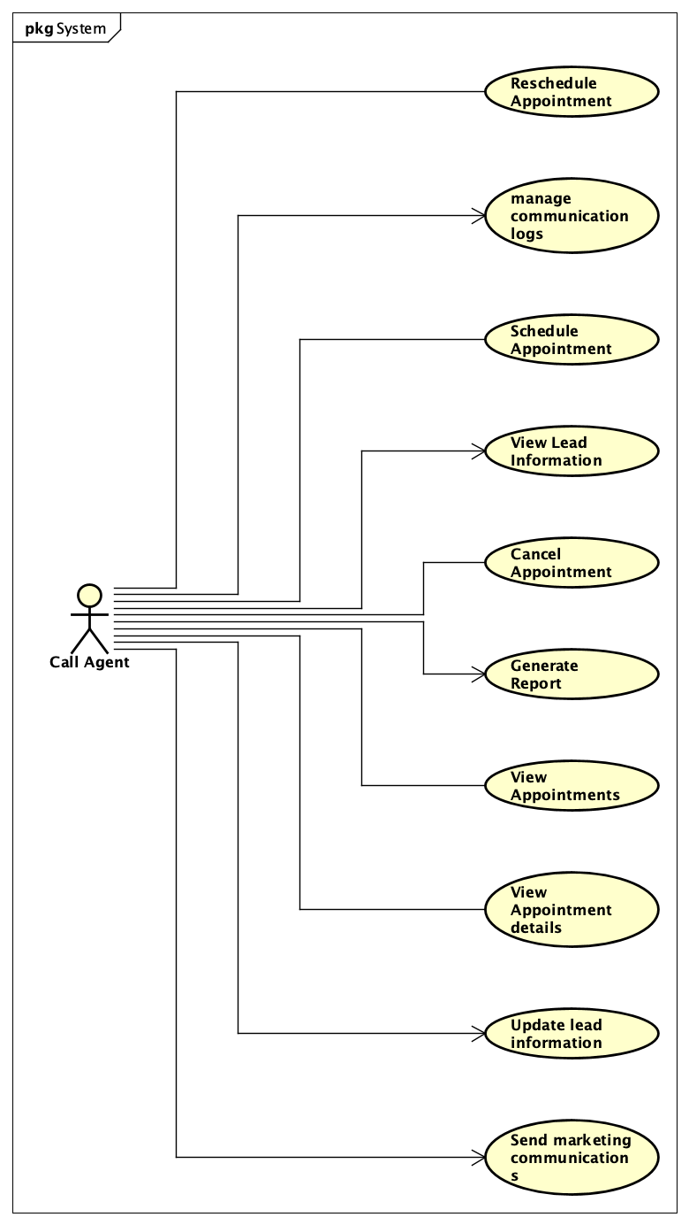

*Figure 4.2 Chiro360° Call Agent Simple Use Case Diagram*

#### 4.2.1.2 Call Agent Diagram with Relationships

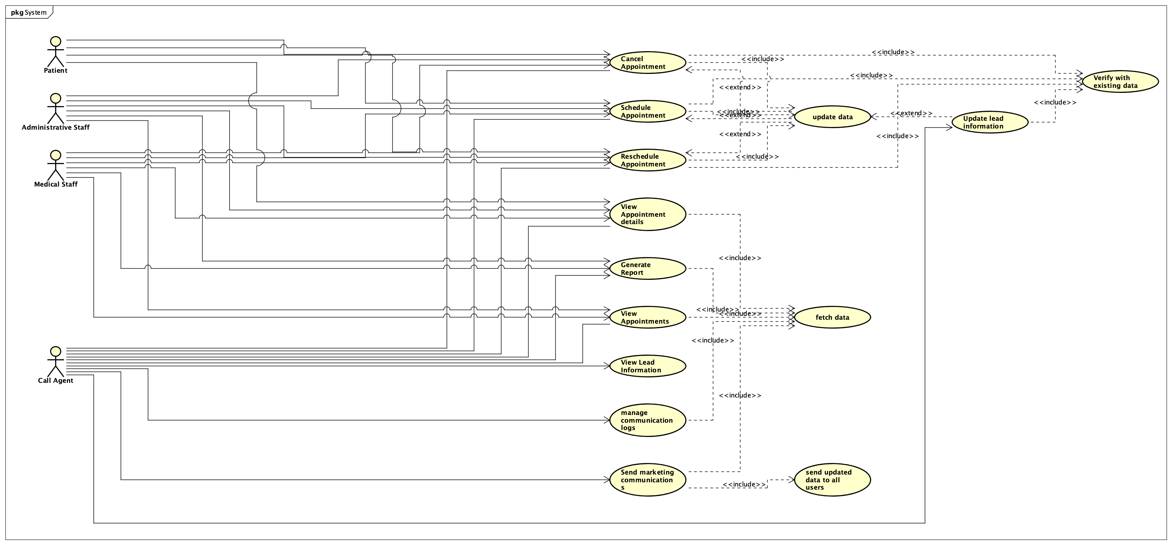

*Figure 4.3 Chiro360° Call Agent Use Case Diagram with Relationships*

### 4.2.2 Administrative Staff

#### 4.2.2.1 Simplified Administrative Staff Diagram

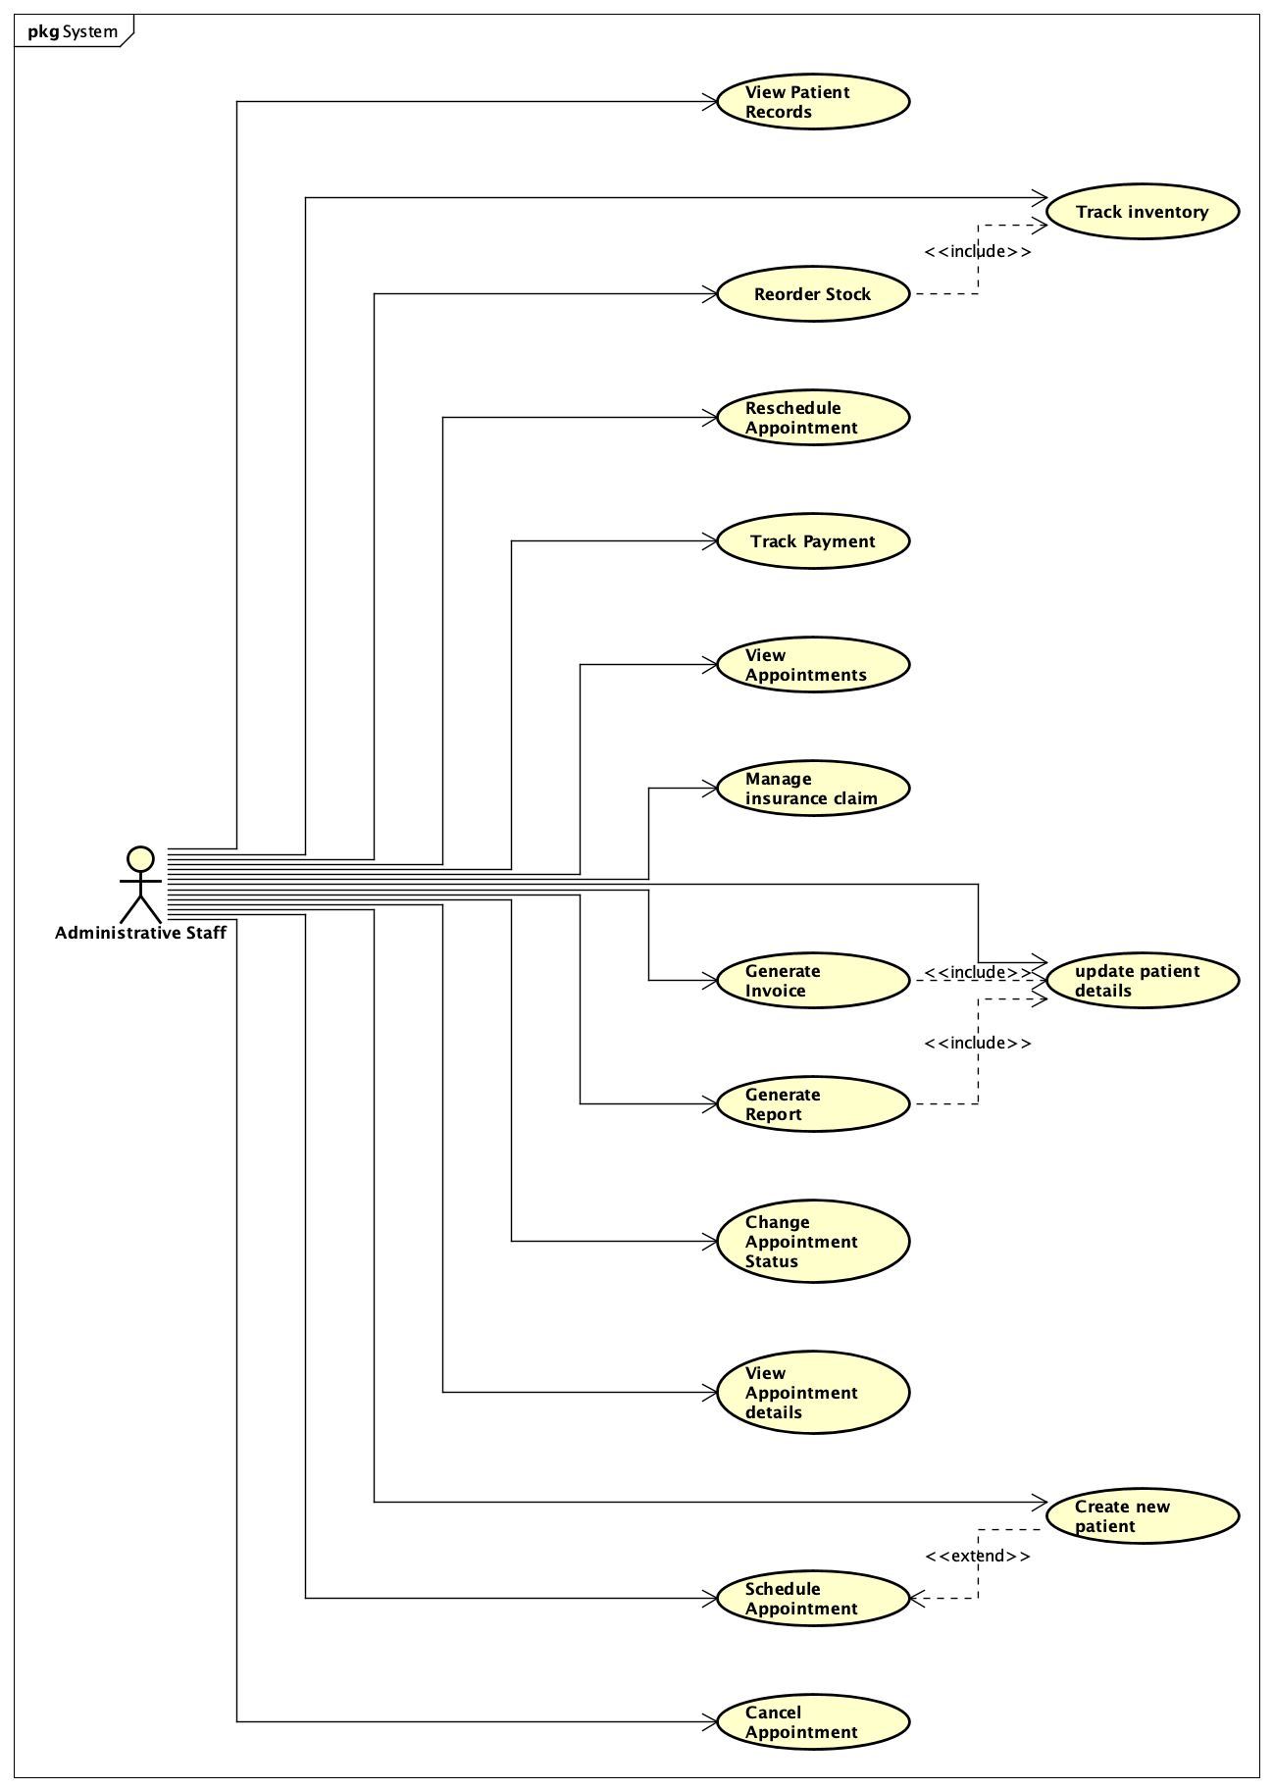

*Figure 4.4 Chiro360° Administrative Staff Simple Use Case Diagram*

#### 4.2.2.2 Administrative Staff Diagram with Relationships

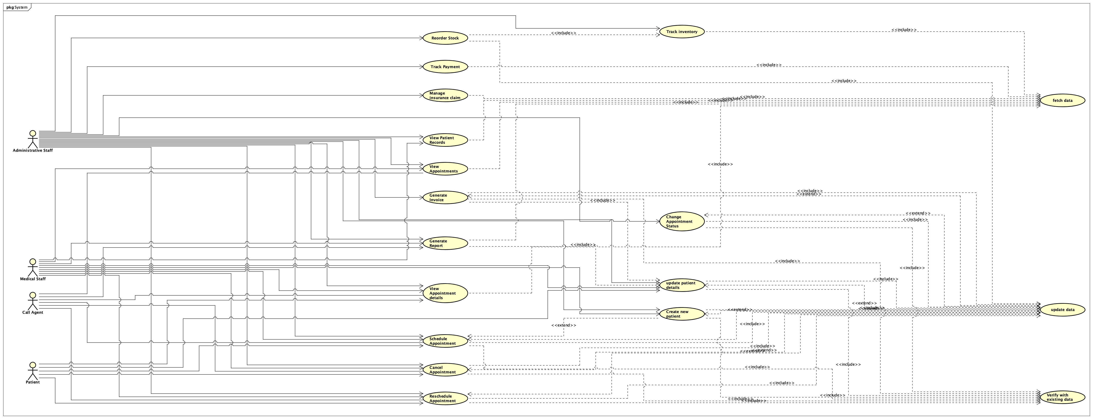

*Figure 4.5 Chiro360° Administrative Staff Use Case Diagram with Relationships*

### 4.2.3 Medical Staff

#### 4.2.3.1 Simplified Medical Staff Diagram

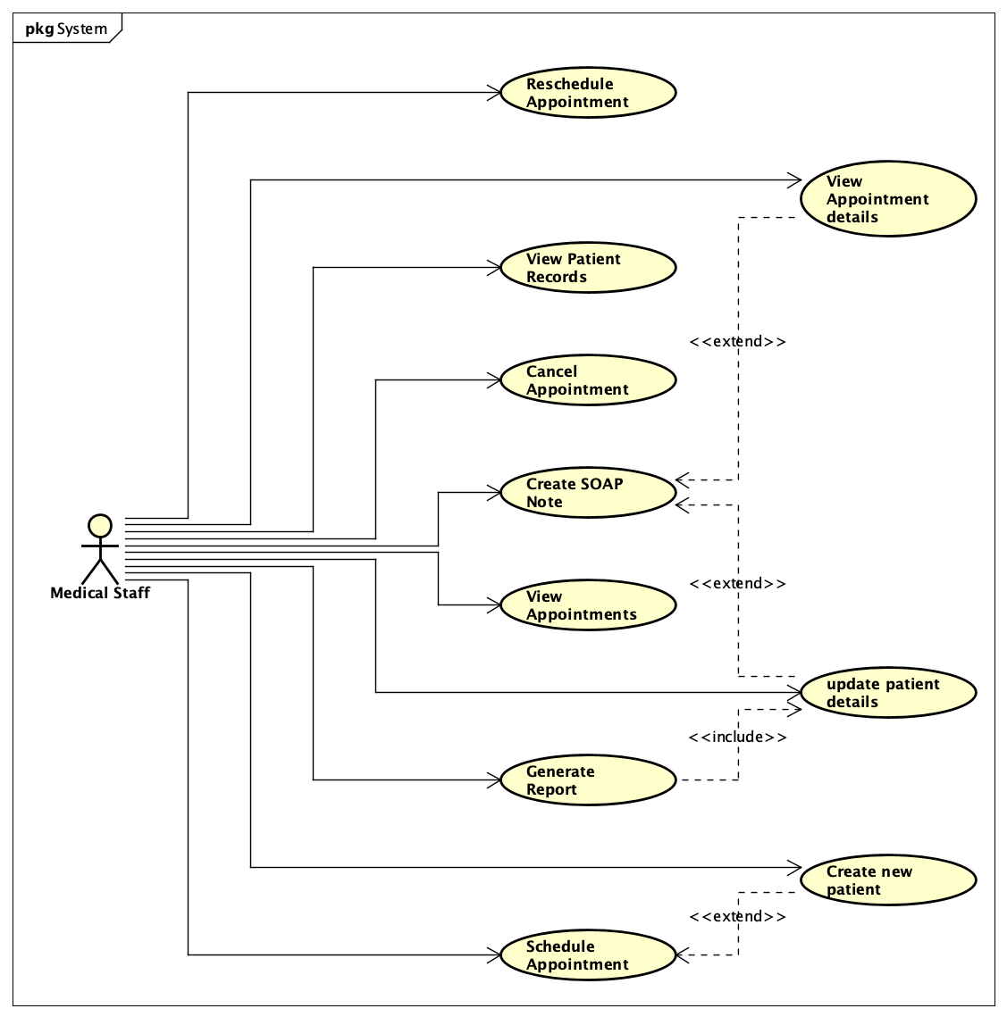

*Figure 4.6 Chiro360° Medical Staff Simple Use Case Diagram*

#### 4.2.3.2 Medical Staff Diagram with relationships

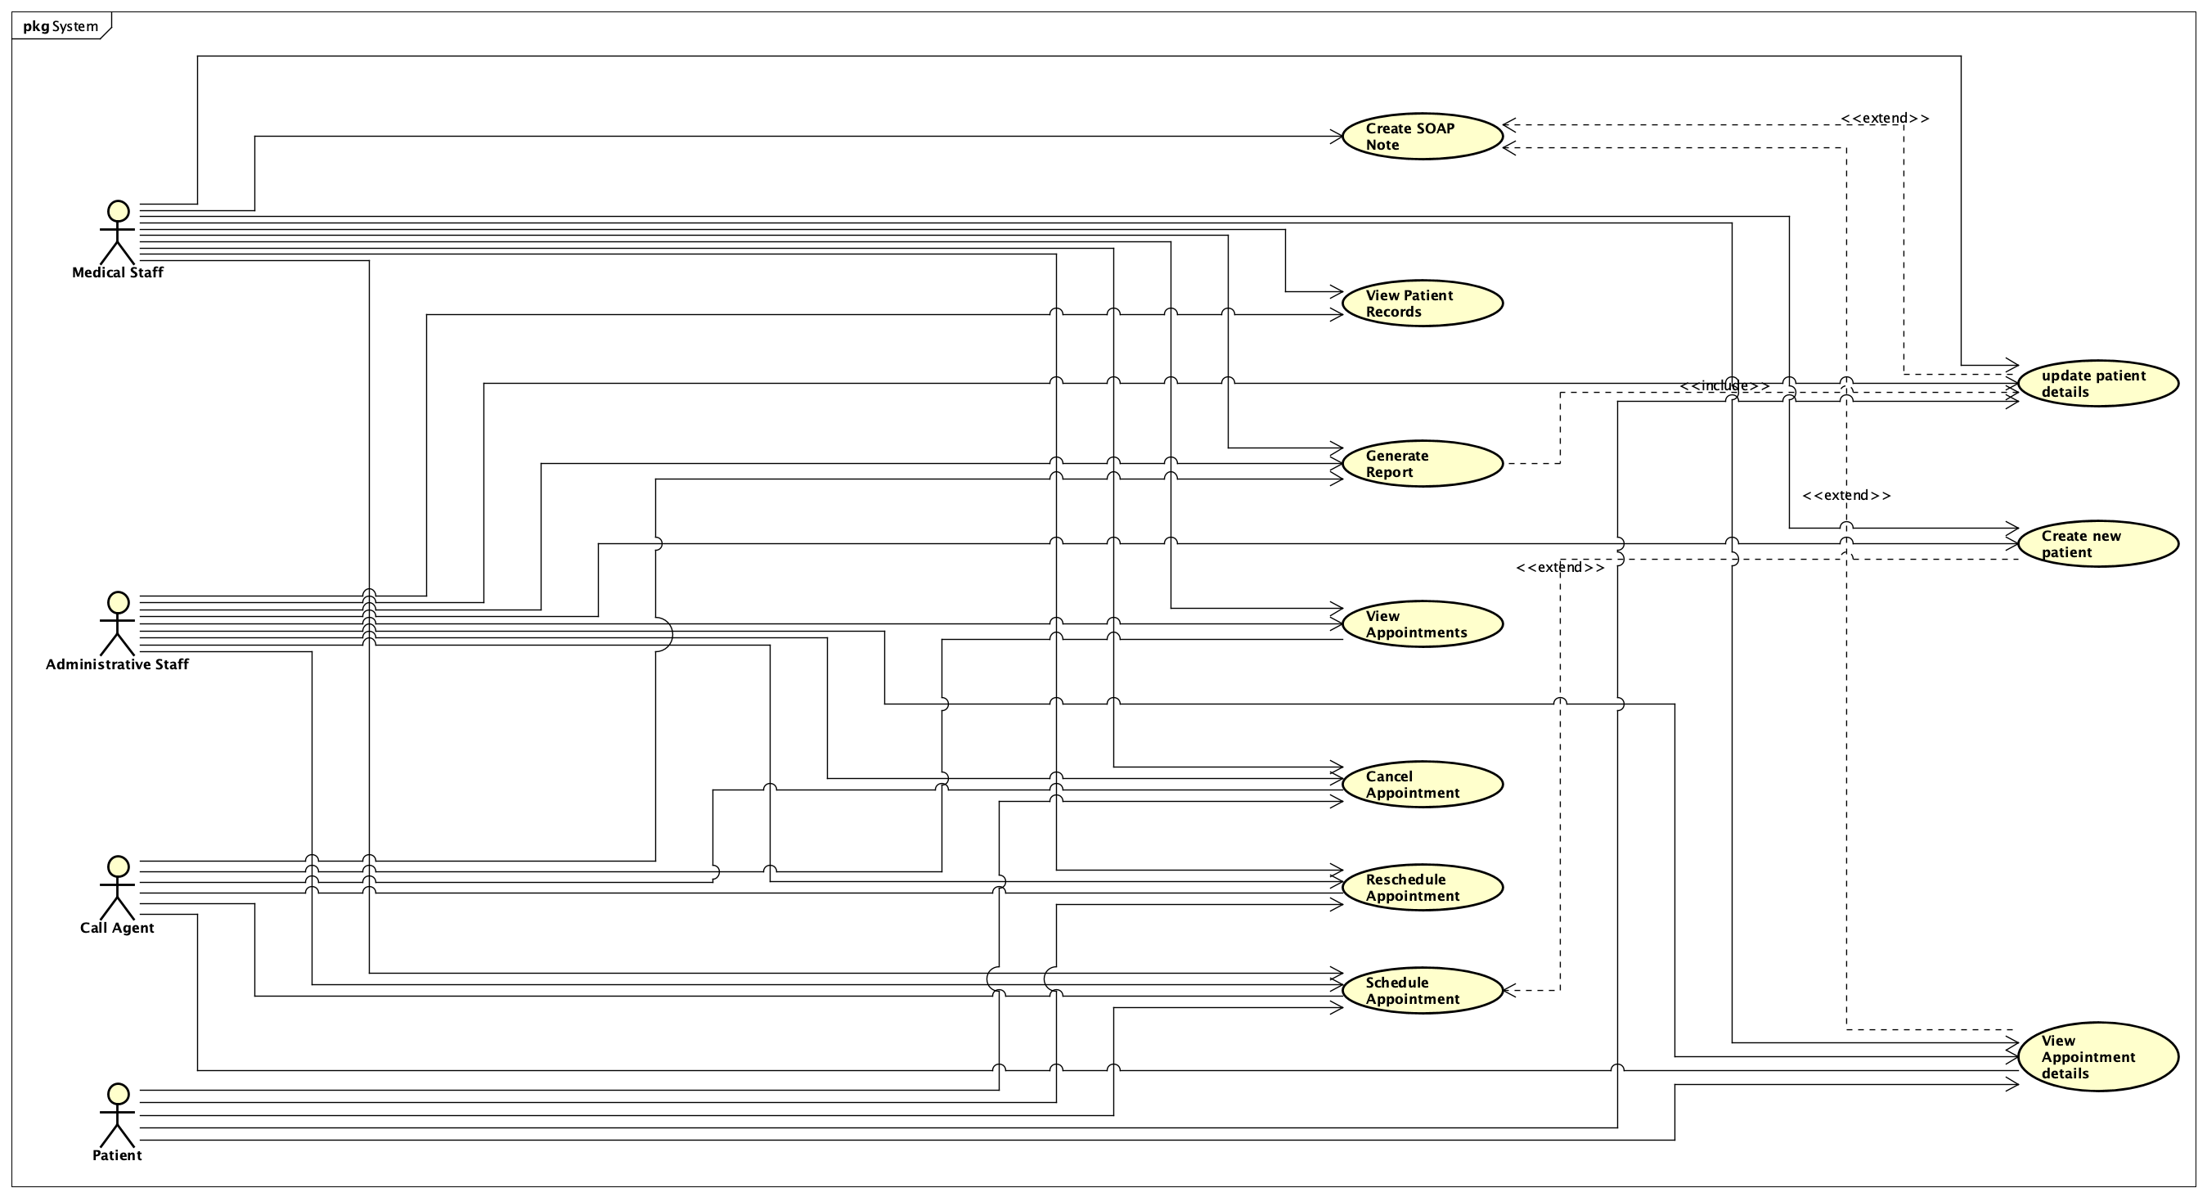

*Figure 4.7 Chiro360° Medical Staff Use Case Diagram with Relationships*

### 4.2.4 System Administrator

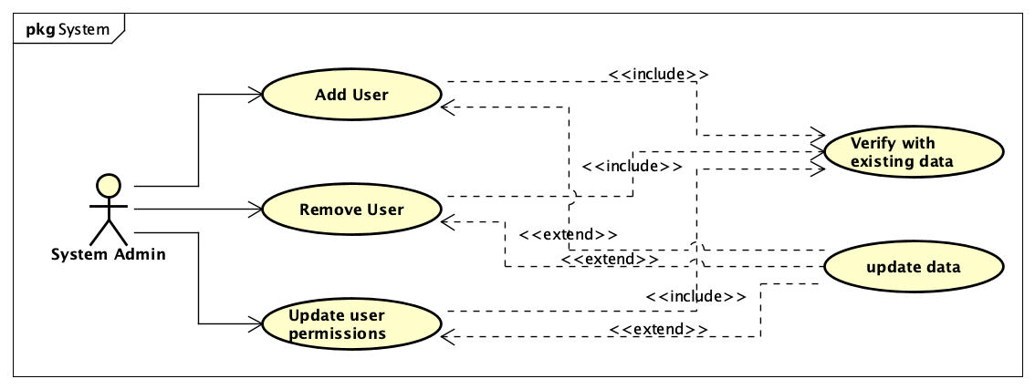

*Figure 4.8 Chiro360° System Administrator Use Case Diagram*

### 4.2.5 Patient

#### 4.2.5.1 Simplified Patient Diagram

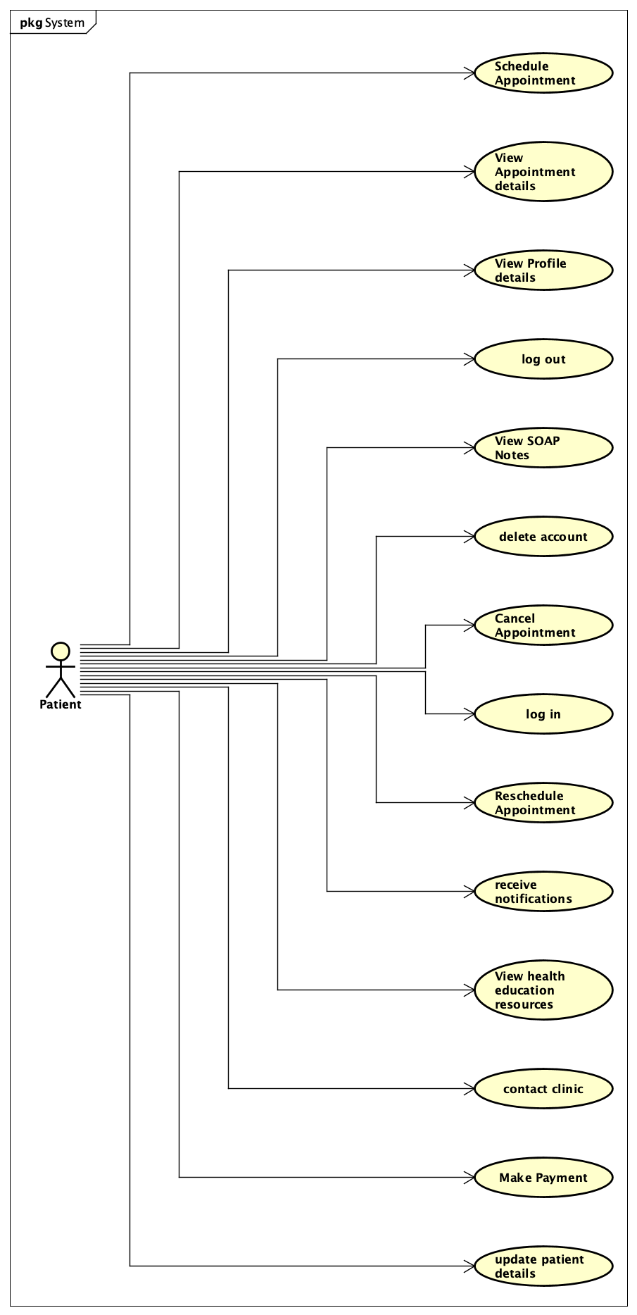

*Figure 4.9 Chiro360° Patient Simple Use Case Diagram*

#### 4.2.5.2 Patient Diagram with Relationships

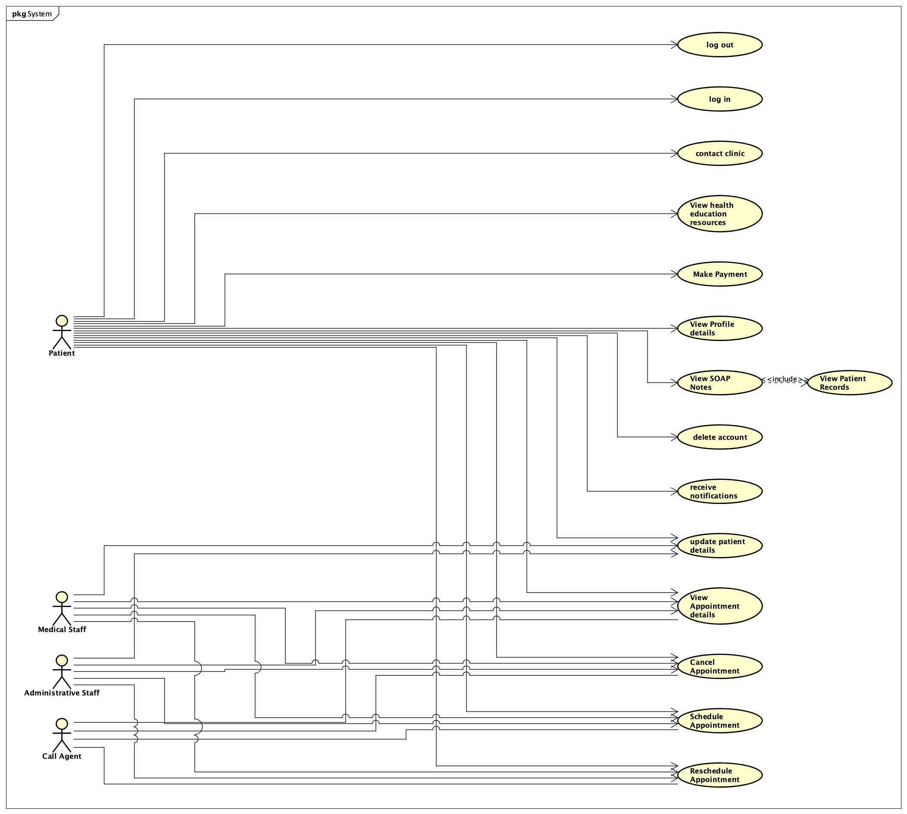

*Figure 4.10 Chiro360° Patient Use Case Diagram with Relationships*

## 4.3 Use Case Descriptions

### 4.3.1 Schedule Appointment

**Basic Flow:**

**Actor**: Patient/User

**Precondition**:

* The patient/user must be registered in the system.

**Steps**:

* The patient/user selects the option to schedule an appointment.
* The system prompts the patient/user to select a preferred date and time.
* The system checks for availability.
* If the selected date and time are available, the system reserves the slot.
* The system confirms the appointment and provides a summary to the patient/user.

**Postconditions**:

* The appointment is scheduled, and the details are saved in the system.

**Alternate Flow:**

* If the selected date and time are not available, the system suggests alternative dates and times. The patient/user can then select from these alternatives.

### 4.3.2 Reschedule Appointment

**Basic Flow:**

**Actor**: Patient/User

**Precondition**:

* An existing appointment must be in place.

**Steps**:

* The patient/user selects the option to reschedule an appointment.
* The system displays the details of the current appointment.
* The patient/user selects a new preferred date and time.
* The system checks for availability. If the new date and time are available,
* the system updates the appointment.
* The system confirms the rescheduled appointment and provides a summary.

**Postcondition**:

* The appointment is rescheduled, and the updated details are saved in the system.

**Alternate Flow:**

* If the new date and time are not available, the system suggests alternatives. The patient/user can select from these options.

### 4.3.3 Cancel Appointment

**Basic Flow:**

**Actor**: Patient/User

**Precondition**: An existing appointment must be in place.

**Steps**:

* The patient/user selects the option to cancel an appointment.
* The system displays the details of the current appointment.
* The patient/user confirms the cancellation.
* The system cancels the appointment and updates the system records.

**Postconditions**:

* The appointment is cancelled, and the details are updated in the system.

### 4.3.4 Create Patient

**Basic Flow:**

**Actor**: Admin/Healthcare Provider

**Precondition**:

* The admin/healthcare provider must have the necessary permissions.

**Steps**:

* The admin/healthcare provider selects the option to create a new patient.
* The system prompts the admin/healthcare provider to enter patient details (e.g., name, DOB, contact information).
* The system validates the entered information.
* The system creates the patient profile and saves the details.
* The system confirms the creation of the new patient profile.

**Postcondition**:

* The new patient profile is created and saved in the system.

### 4.3.5 Create SOAP Note

**Basic Flow:**

**Actor**: Healthcare Provider

**Precondition**:

* A patient appointment must be in place, and the healthcare provider must have the necessary permissions.

**Steps**:

* The healthcare provider selects the option to view appointment details.
* The system displays the details of the appointment, including patient information.
* The healthcare provider selects the option to create a SOAP note.
* The system prompts the healthcare provider to enter the Subjective, Objective, Assessment, and Plan (SOAP) details.
* The healthcare provider enters the required information.
* The system saves the SOAP note.
* The system confirms the creation of the SOAP note and associates it with the patient’s record.

**Postconditions**:

* The SOAP note is created and saved in the system, linked to the patient's appointment.

### 4.3.6 View Appointments

**Basic Flow:**

**Actors:** Medical Staff / Administrative Staff

**Preconditions:**

* The user is logged into the system. The user has the appropriate permissions to view appointments. The system has existing appointments recorded in the database.

**Steps:**

* The user navigates to the "Appointments" section from the dashboard.
* View Appointments (Medical Staff):
  + Medical Staff sees a list of their own appointments.
  + They can view appointments in two formats:
  + Calendar View: A visual calendar displaying appointments by date, with color-coded status indicators (e.g., Scheduled, Arrived, Complete).
  + Flow View: A detailed list view showing appointments for a selected day, categorized by status (Scheduled, Arrived, Drafted, Complete, Canceled).
  + Medical Staff can interact with their appointments by:
  + Viewing details of each appointment.
  + Changing the status of an appointment (e.g., from Scheduled to Arrived).
  + The changes are immediately reflected in the system.
* View Appointments (Administrative Staff):
  + Administrative Staff sees a list of all appointments for the Medical Staff within their branch.
  + They can view appointments similarly in:
  + Calendar View: A visual calendar displaying all appointments in the branch, with color-coded status indicators.
  + Flow View: A detailed list of appointments for a selected day, categorized by status, and further segmented by the assigned Medical Staff.
  + Administrative Staff can:
  + View details of all appointments.
  + Change the status of any appointment within their branch.
  + Schedule new appointments and assign them to specific Medical Staff.
  + The changes are immediately reflected in the system.
* Both Medical Staff and Administrative Staff have access to an Appointment Queue, medical Staff can see their own upcoming appointments, while admin staff can see upcoming appointments for all medical staff in the branch they are assigned to, segmented by provider
* Interaction with Appointments:
  + Users can interact with appointments by:
  + Viewing appointment details.
  + Changing the status of appointments directly from either the Calendar or Flow View.
  + Moving patients through different stages of the appointment process (e.g., from Scheduled to Complete).

**Postconditions:**

* The user successfully views and manages appointments according to their role. Any changes to appointment statuses are updated in the system and reflected for all relevant users.

**Alternate Flow:**

* No Appointments Available: If there are no appointments scheduled for the selected day, the system displays a message indicating no appointments are available.
* Role-Based Restrictions: If a Medical Staff member tries to view appointments assigned to other doctors, they are restricted from accessing those appointments. Administrative Staff, however, can view and manage all appointments within their branch.

## 4.4 Sequence Diagram

### 4.4.1 User Login and Dashboard Display

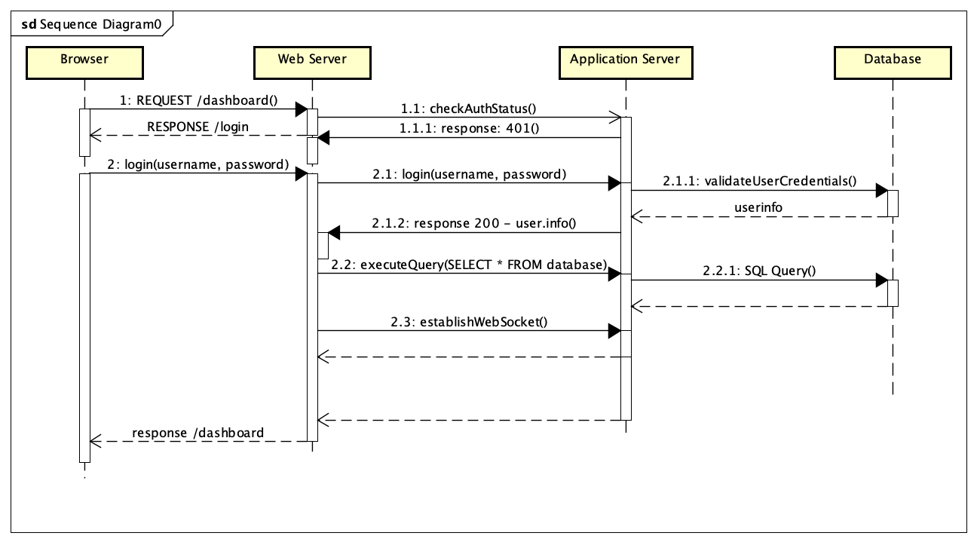

*Figure 4.11 Chiro360° User Login and Dashboard Display Sequence Diagram*

After the user enters their login credentials and clicks "Login," the web browser sends an authentication request to the web server (a React app), which forwards the request to the application server (built with Express.js). The application server validates the credentials by querying the database. If the credentials are valid, the application server starts a session, connects the user to the WebSocket server, and sends an authenticated response back to the web server along with a session token. The web server then loads the dashboard by making API calls to the application server, which retrieves data from the database for various components (e.g., Inventory, Branch, Users, Patients, Invoices, Appointments, SOAPs). Once the data is fetched, the web server updates the dashboard UI and sends it to the web browser. Simultaneously, the web browser establishes a WebSocket connection to the application server for real-time updates.

When a user clicks on a navigation link, such as "dashboard," the web server first checks if the required data is already in the local state. If the data isn't available, the web server sends an API call to the application server to retrieve it. The application server queries the database and sends the requested data back to the web server. The web server then updates the relevant component, and the web browser displays the updated component to the user.

### 4.4.2 Real-Time Data Update via Web Socket

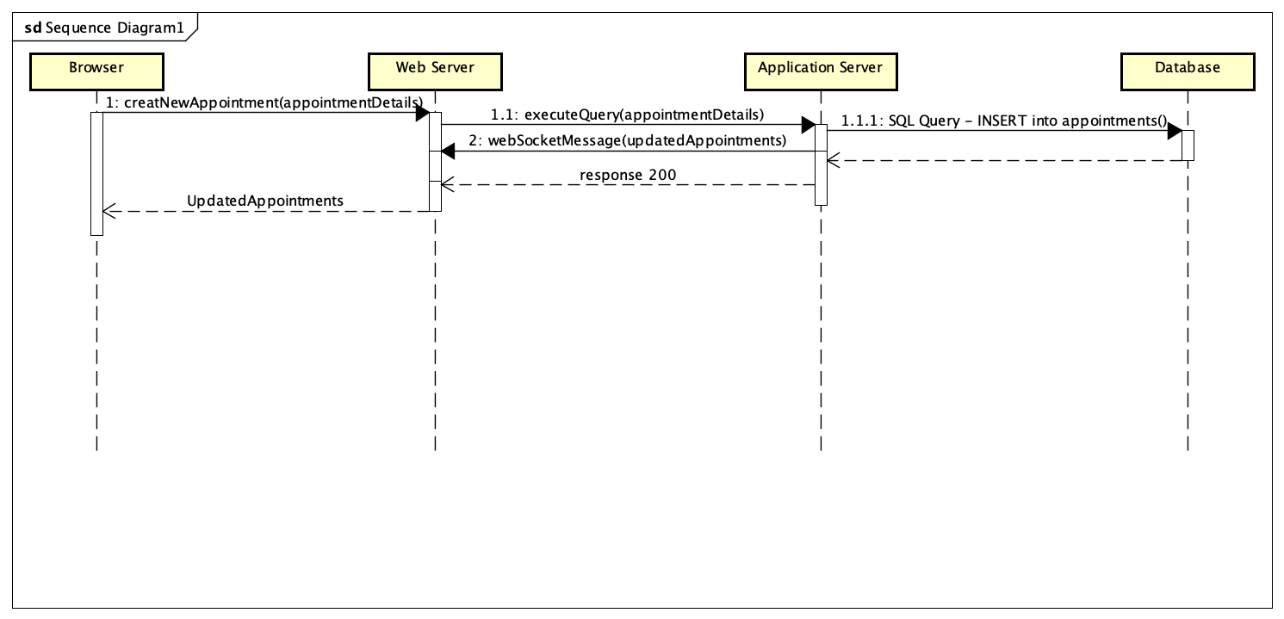

*Figure 4.12 Chiro360° Real-Time Data Update via Web Socket Sequence Diagram*

When a user updates data on the dashboard, such as patient information, the web server sends an API call to the application server to process the update. The application server executes the necessary query on the database, updates the data, and confirms the change. The application server then broadcasts the updated data to all connected WebSocket clients, including the current user. The web browser receives this WebSocket message, and the web server updates the local state to reflect the change. Finally, the web browser automatically refreshes the relevant part of the dashboard to display the updated data.

## 4.5 Entity Relationship Diagram

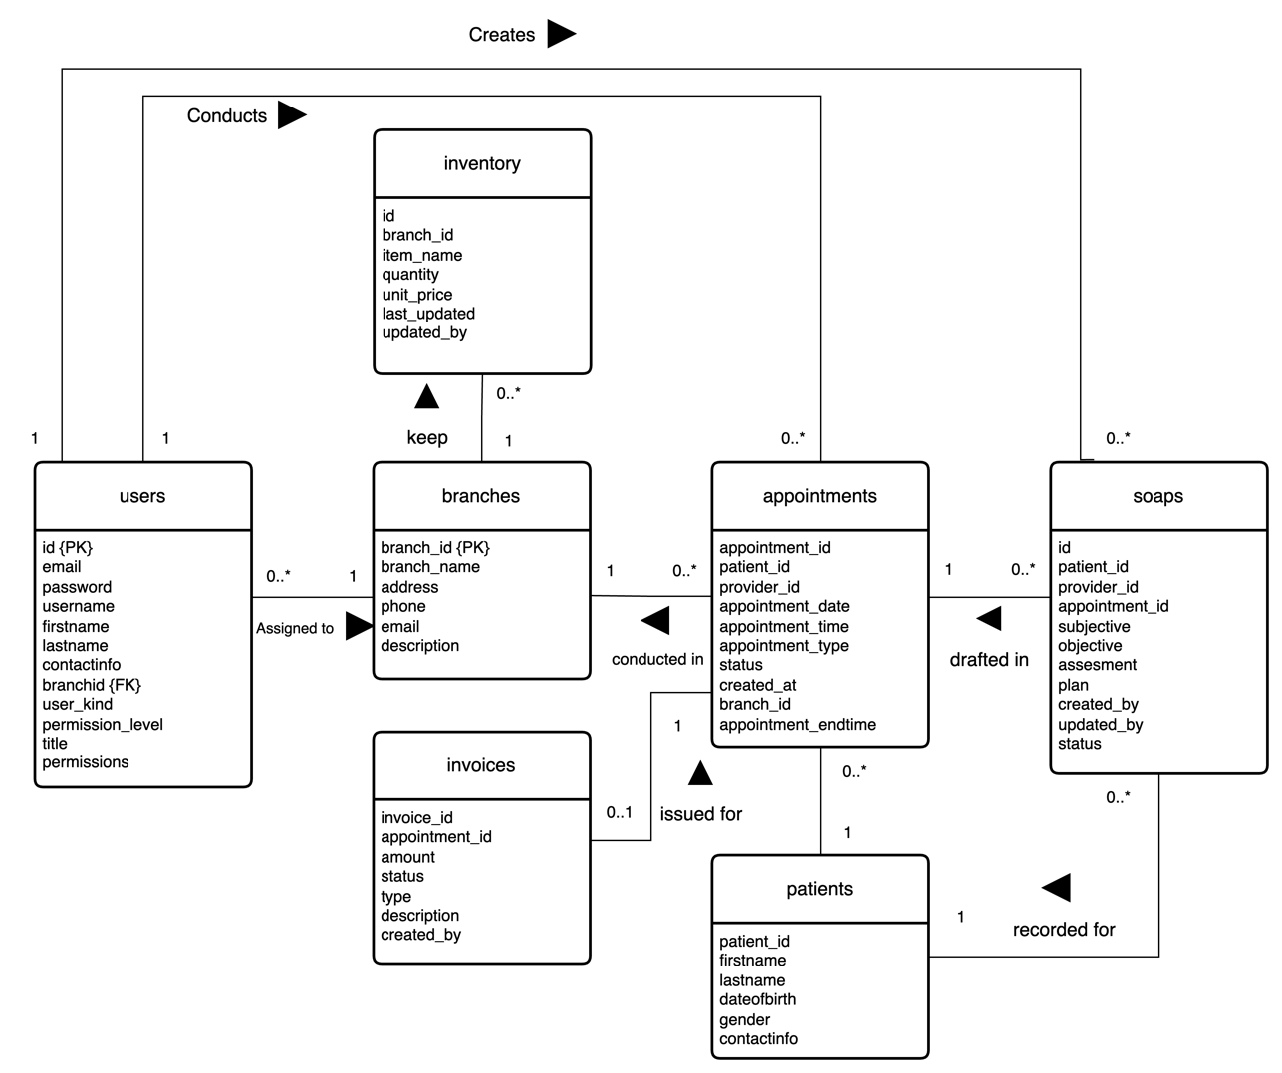

*Figure 4.13 Chiro360° Entity Relationship Diagram*

The diagram illustrates the relationships between various entities in the system. At the core of the system are branches, which are connected to multiple other entities. Each branch can have multiple users, appointments, SOAP notes (soaps), patients, invoices, and inventory items. This indicates that branches serve as the primary organizational units within the system, overseeing a range of activities and records.

Users, which represent clinic staff, within a branch can schedule multiple appointments and create multiple SOAP notes for those appointments. Appointments, in turn, are linked to both patients and SOAP notes, with each appointment corresponding to a specific patient and potentially having several associated SOAP notes, detailing different aspects of the patient's care. Patients have a direct relationship with both appointments. Each patient can have multiple appointments, and invoices are associated with a particular appointment, reflecting the financial transactions related to the care provided. Lastly, inventory is managed at the branch level, with each branch responsible for its own inventory items. However, inventory does not have direct relationships with other entities in this diagram, suggesting that it is managed independently of patient care processes.

Overall, the diagram presents a structured view of how the Chiropractic healthcare system organizes its operations, with branches as the central hubs connecting various aspects of patient care, administrative tasks, and inventory management.

## 4.6 GUI design

### 4.6.1 Login Page



*Figure 4.14 Chiro360° Login Wireframe*

### 4.6.2 Dashboard Home

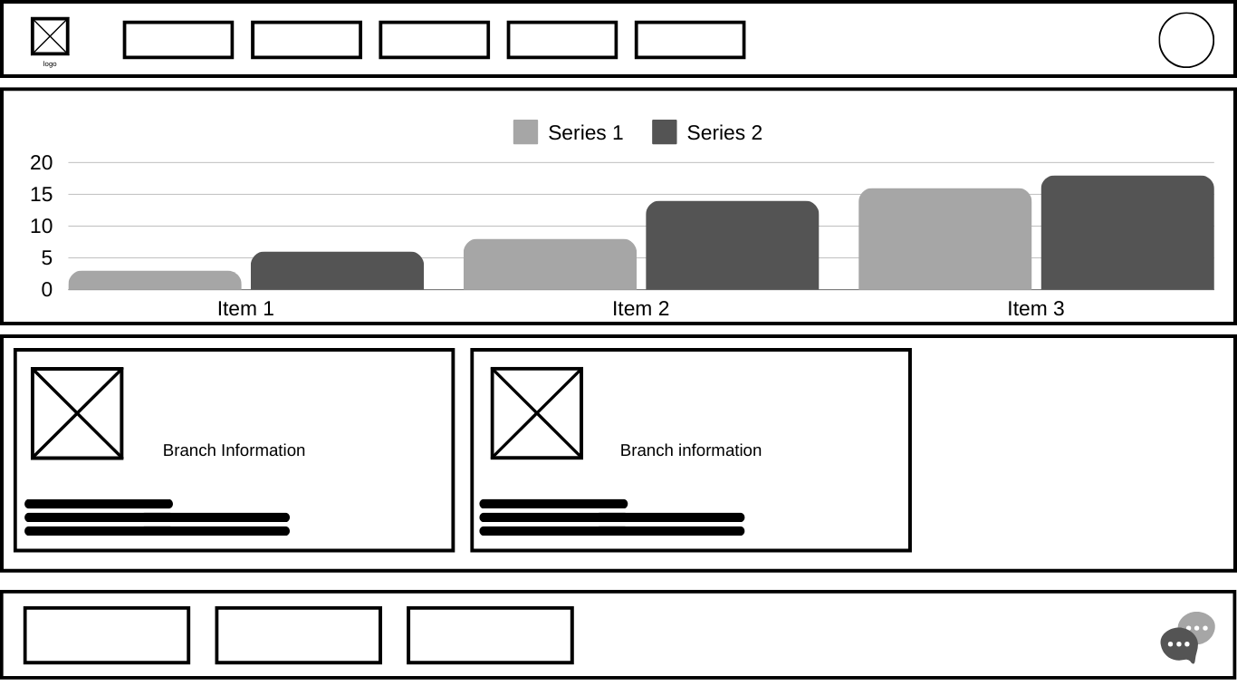

*Figure 4.15 Chiro360° Dashboard Wireframe*

### 4.6.3 Scheduling Page

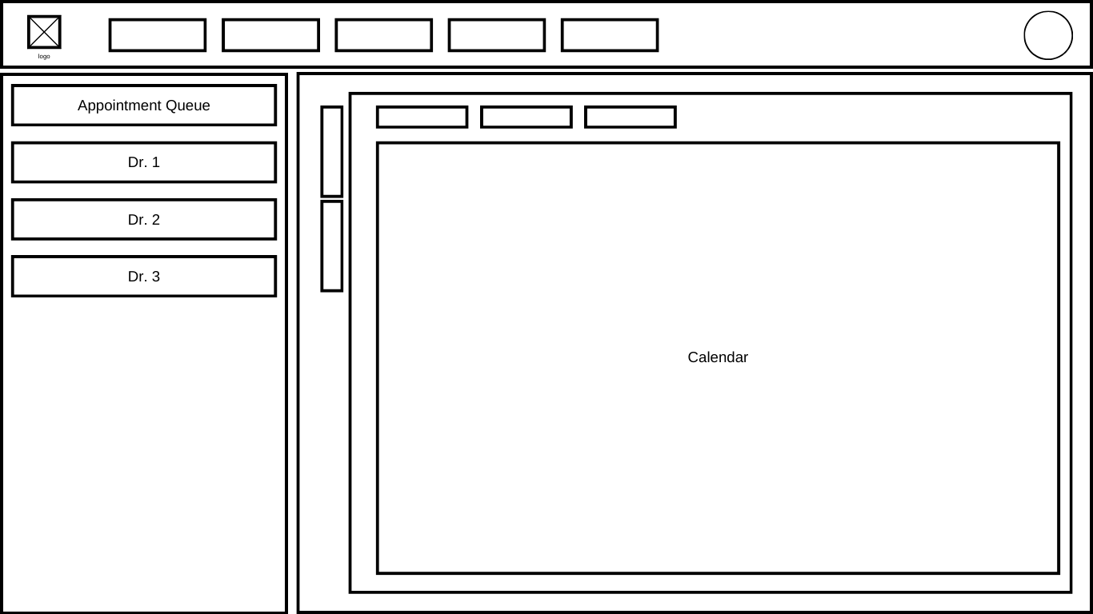

*Figure 4.16 Chiro360° Scheduling Wireframe*

### 4.6.4 SOAP Note Page

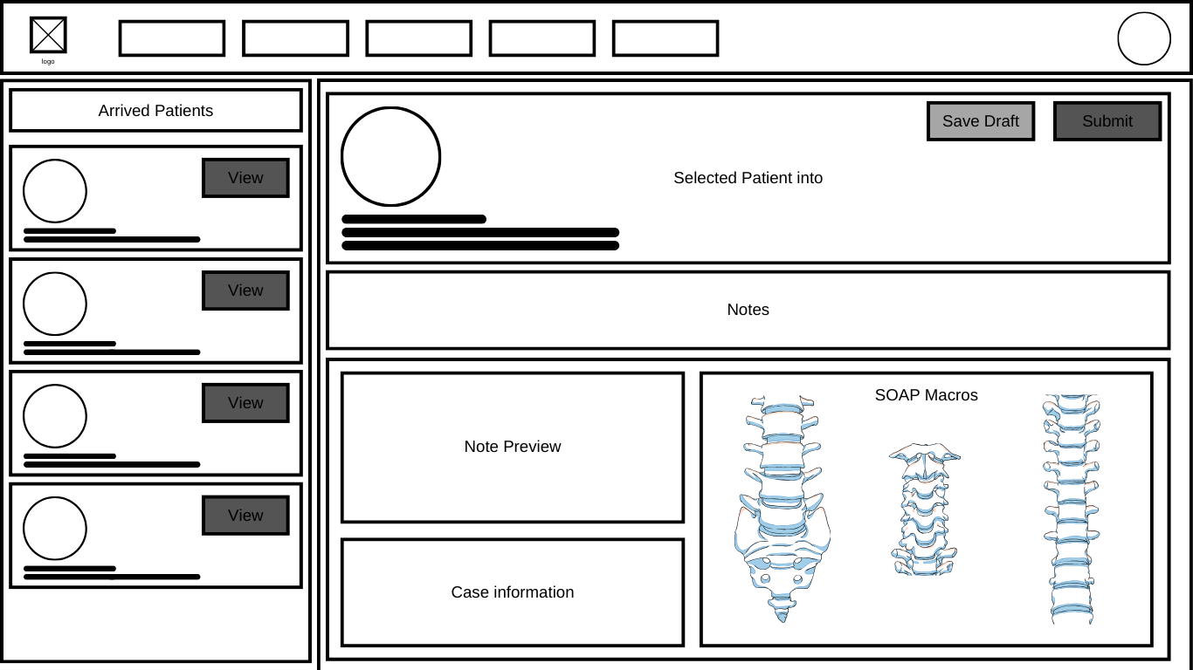

*Figure 4.17 Chiro360° SOAP Notes Wireframe*

### 4.6.5 Patient Profile Page

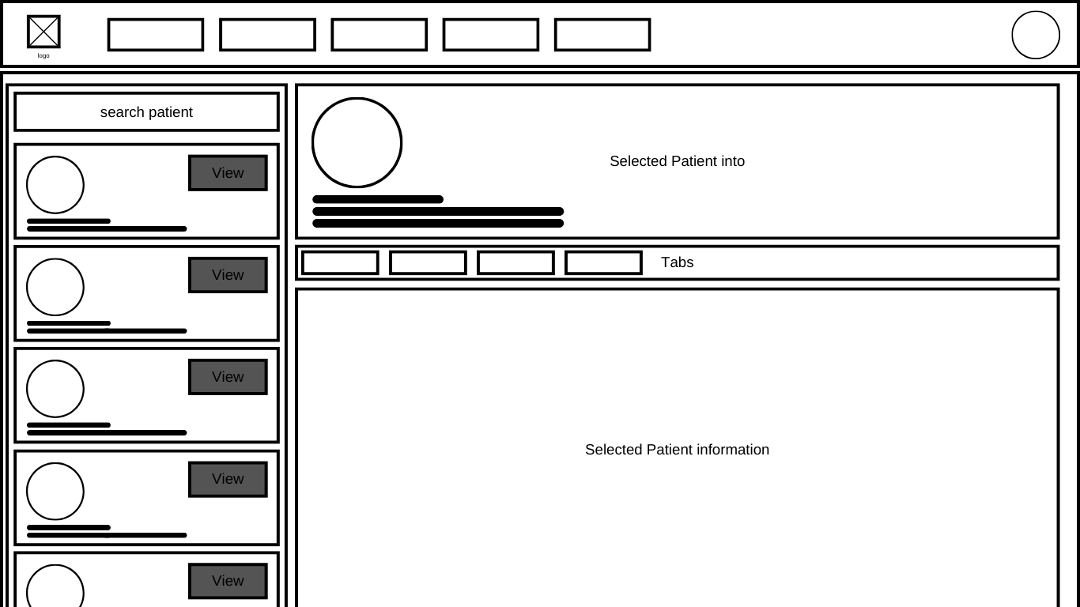

*Figure 4.18 Chiro360° Patient Profile Wireframe*

### 4.6.6 System Settings Page

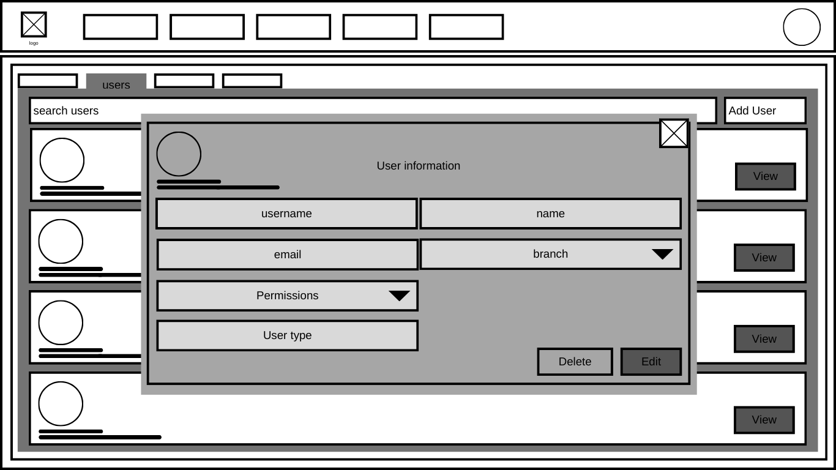

*Figure 4.19 Chiro360° System Settings Wireframe*

# Chapter 5 Implementation

## 5.1 Introduction

This chapter details the implementation phase of the project, focusing on the architectural design, selection of technologies, and the resolution of key implementation challenges. It begins with an overview of the system architecture, including a diagram that represents the structure and data flow of the application. The chapter then reviews the various technologies researched and selected for the project, with particular emphasis on the PERN stack (PostgreSQL, Express.js, React, Node.js), and the rationale behind these choices. Significant implementation issues, such as real-time data persistence, RESTful API design, and data management strategies, are discussed in detail, along with the solutions employed to address these challenges. Additionally, the chapter explores software components in depth, explaining how the various modules and services interact through the application of various libraries and frameworks to create a cohesive and scalable application, providing a comprehensive view of the implementation.

## A diagram of a software application Description automatically generated with medium confidence5.2 System Architecture

*Figure 5.1 Chiro360° System Architecture*

The architecture of the system is organized into three distinct layers, each with its specific responsibilities and technologies, ensuring a robust and maintainable application.

The frontend is built using React.js. Component-based architecture is utilized here to develop various modules of the application, each responsible for different functionalities. At the core of the frontend is the Dashboard component, which acts as the central hub, managing global data and orchestrating communication between the various modules. These modules include Scheduling, Patients, SOAPs, Analytics, Leads, Inventory, and Settings, each of which relies on the Dashboard to fetch or update data. The global data flow is managed such that the Dashboard passes data down to these individual components, which, in turn, make HTTP requests to the backend through the Dashboard by passing in the API executeQuery function as a prop to the individual components to perform necessary operations.

The backend is powered by Node.js and Express.js, which together provide a solid foundation for server-side logic. The backend is responsible for handling API requests, including user registration, login, and other operations through well-defined API routes. Authentication is a crucial aspect of the backend, utilizing Passport for authentication strategies, bcrypt for hashing passwords, and express.session for managing user sessions & tokens. Additionally, the backend features a WebSocket server that facilitates real-time communication, allowing the server to push updates to the frontend without requiring additional HTTP requests. The backend also manages database interactions through CRUD operations using the pg npm package, ensuring that data can be created, read, updated, or deleted as needed. The data flow from the backend to the frontend is managed by both the API routes and the WebSocket server, ensuring seamless data exchange.

The data layer utilizes PostgreSQL, a powerful relational database, to store and manage the application’s data. The database schema includes tables such as users, patients, branches, appointments, soaps, invoices, and inventory, each designed to handle specific types of information relevant to the application. The backend interacts with the PostgreSQL database to perform all necessary CRUD operations. Data from the database is retrieved and sent back to the frontend via the backends’ API routes or real-time updates from the WebSocket server.

In summary, this architecture outlines the responsibilities across the frontend, backend, and data layer. The frontend, constructed with React, focuses on user interaction and communicates with the backend. The backend, built with Node.js and Express.js, manages server-side logic, authentication, and data flow. PostgreSQL serves as the data layer, handling all data storage and retrieval. This separation of concerns ensures that the system is both scalable and maintainable, with each layer performing its designated role efficiently.

## 5.3 Review of Technologies

In selecting the appropriate software and hardware technologies for this project, careful consideration was given to both client-side and server-side technologies, ultimately leading to the adoption of the PERN stack. This stack was chosen for its robustness, scalability, and alignment with current industry demands.

The PERN stack, consisting of PostgreSQL, Express.js, React.js, and Node.js, was selected for its comprehensive capabilities in full-stack web development. Each component was chosen for specific reasons that align with the project’s requirements and industry best practices.

Node.js was selected as the runtime environment due to its ability to allow JavaScript to be used for both front-end and back-end development outside a browser environment. JavaScript is currently the most used programming language at 62.3%, in addition to Node being the most popular framework used by around 40.8% of respondents (Stack Overflow, 2024). Node.js enables non-blocking, asynchronous programming, which is essential for developing fast and scalable applications. Additionally, the extensive ecosystem of npm packages available with Node.js significantly reduces development time and complexity, making it a preferred choice among developers. According to GitHub’s annual reports, JavaScript remains the most used language, surpassing others such as Python, which, while growing in popularity, has not yet surpassed JavaScript’s dominance. Moreover, PHP, once a popular language, is becoming less relevant in modern web development (GitHub, 2022).

|  |  |
| --- | --- |
|  |  |
| *Figure 5.2 StackOverflow Top Programming Languages* | *Figure 5.3 StackOverflow Top Web Frameworks* |

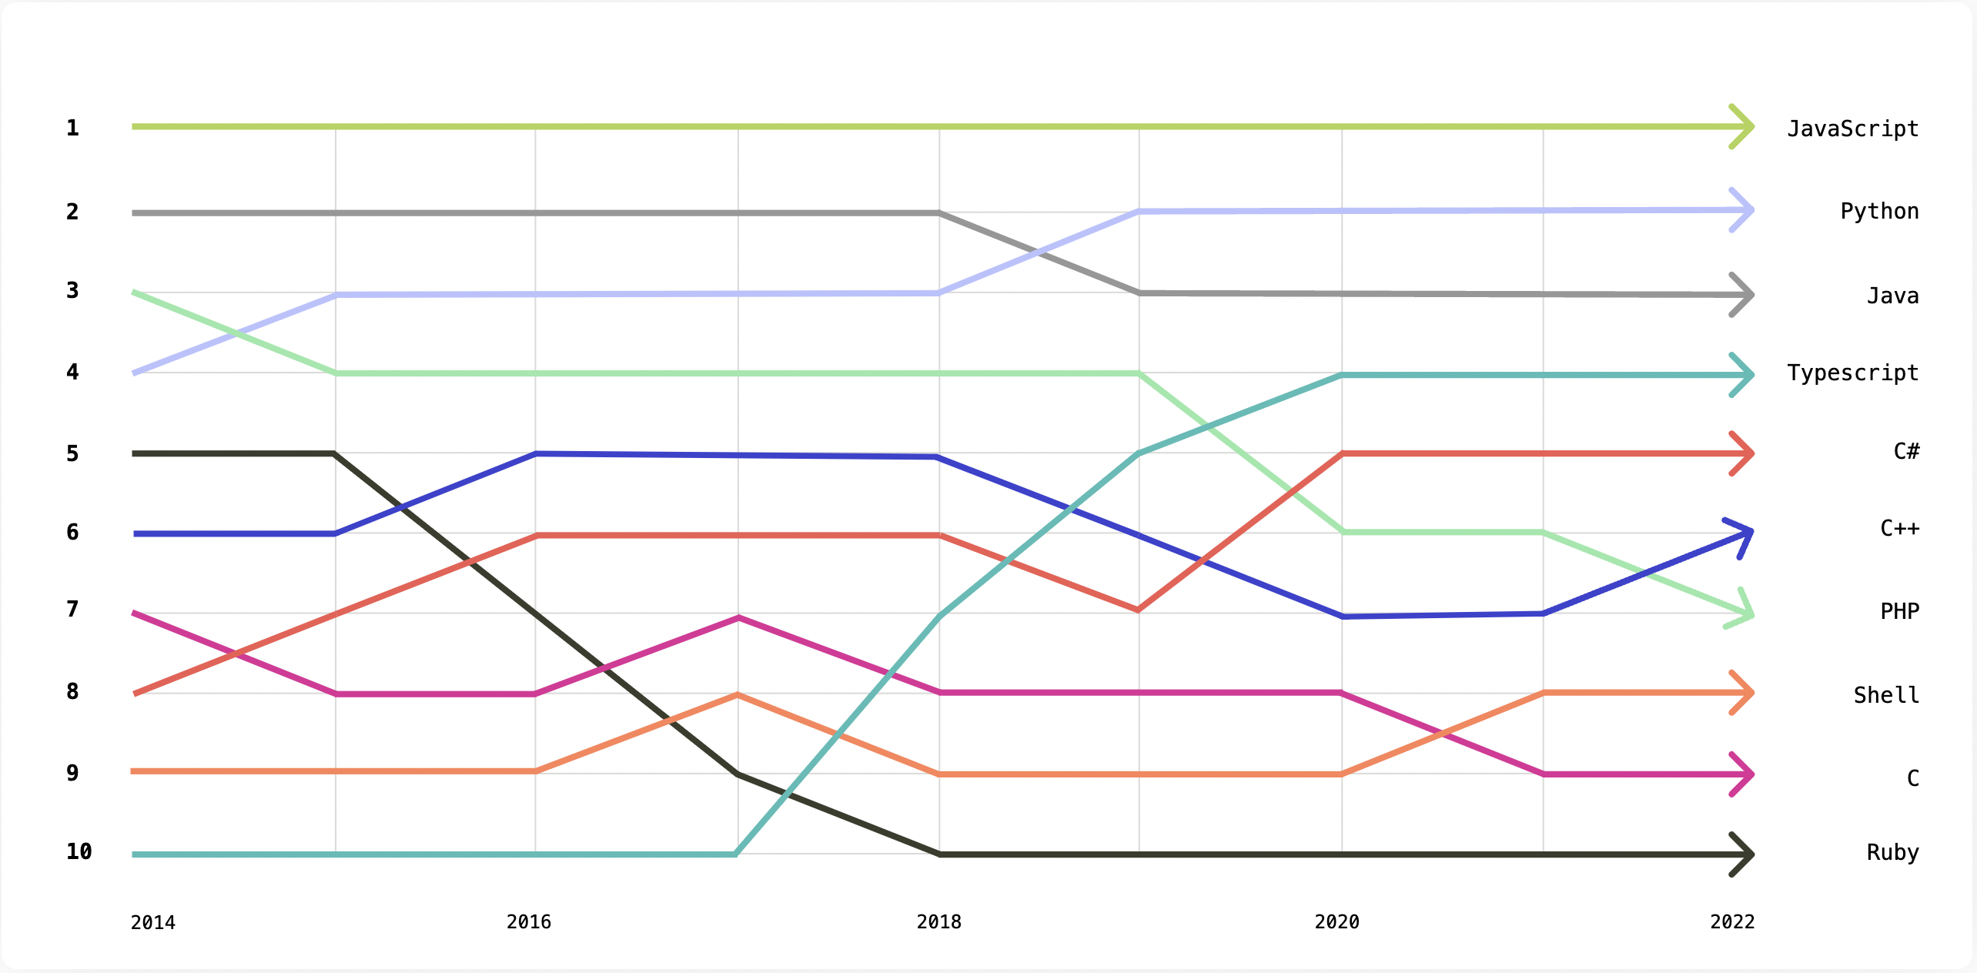

*Figure 5.4 GitHub Most Used Programming Langauges*

Express.js was chosen as the back-end framework because of its popularity and effectiveness in simplifying Node.js code. According to the 2023 Stack Overflow Developer Survey, Express.js is ranked among the most popular web frameworks, with 46.3% of professional developers favouring it. This framework’s modularity and simplicity complement Node.js perfectly, reinforcing the decision to use JavaScript for both server-side and client-side development (Stack Overflow, 2023).

For the database, SQL was chosen over NoSQL due to its advantages in managing relational data. SQL databases provide a structured format, which ensures data consistency and integrity, making it easier to build relationships between different data points. PostgreSQL was selected specifically because it is the most used SQL database among professional developers, according to Stack Overflow’s latest survey. PostgreSQL is known for its scalability, reliability, and robust community support, and it is open source, making it a viable choice for the project. Many companies rely on PostgreSQL, further attesting to its relevance and reliability in the industry (Stack Overflow, 2024).

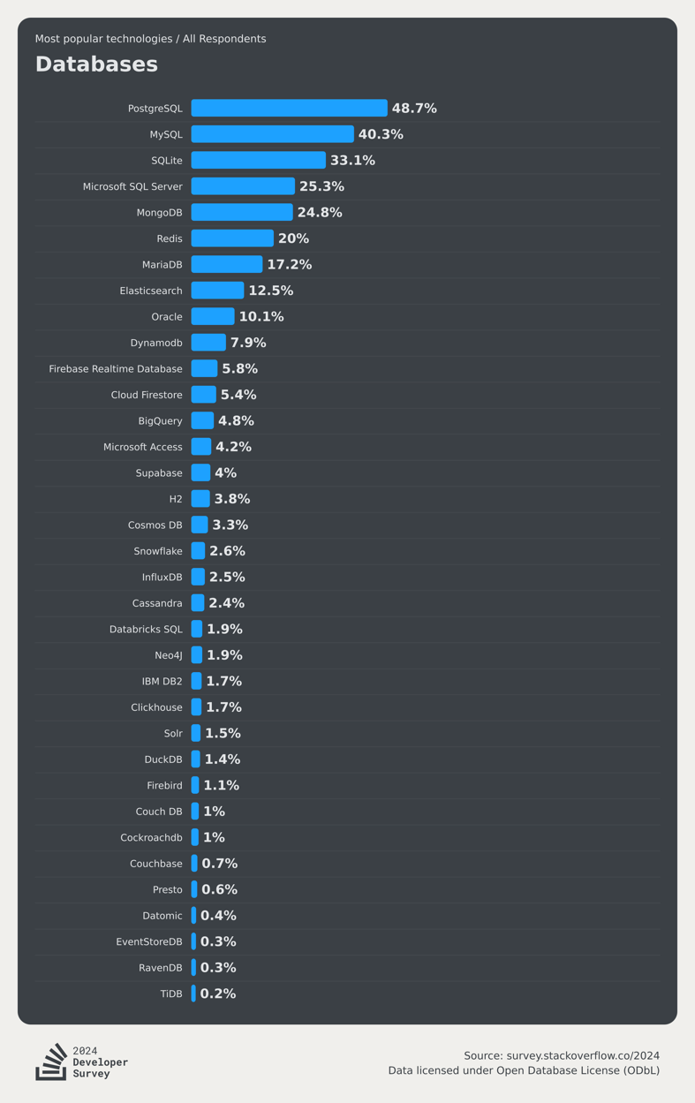

*Figure 5.5 StackOverflow Top Databases*

React.js was used as the front-end framework because it is the most favoured web framework among developers, as per the Stack Overflow Developer Survey 2023. React outperforms other popular frameworks such as Angular, Vue.js, Django, and ASP.NET in terms of developer preference. React’s component-based architecture and virtual DOM enhance the performance and scalability of web applications, making it ideal for building modern, dynamic user interfaces (Stack Overflow, 2024).

In conclusion, the PERN stack was chosen not only for its technical merits but also because it is highly demanded in the job market. By using these technologies, the project not only benefits from a robust and scalable architecture but also aligns with current industry trends, ensuring that the skills gained from this project are valuable and relevant.

## 5.4 Implementation Issues and Solutions

The implementation of this project presented numerous challenges that required in-depth research and creative problem-solving. Below, I discuss key issues encountered, including real-time data persistence, API development, and data capping, along with the strategies employed to address them effectively.

### 5.4.1 RESTful APIs for Frontend-Backend Communication

A significant aspect of the implementation was developing an effective communication bridge between the frontend and the backend. RESTful APIs were used to manage this interaction, allowing the frontend to execute queries, authenticate users, and manage sessions securely and efficiently (Fielding, 2000). The APIs facilitated CRUD (Create, Read, Update, Delete) operations, which were essential for dynamic web application functionality.

For instance, consider the route designed to manage database table operations:

//Database Table Management Route

app.post("/execute-query", async (req, res) => {

console.log("Session:", req.session);

console.log("User:", req.user);

if (req.isAuthenticated()) {

const { query, params, dataType } = req.body;

// Basic validation to prevent dangerous queries

if (

!query ||

typeof query !== "string" ||

query.includes(";--") ||

query.includes("DROP")

) {

return res.sendStatus(400); // Bad Request if query is invalid

}

try {

// Execute the provided query

await db.query(query, params || []);

// Now query the entire table

const result = await db.query(`SELECT * FROM ${dataType}`);

sendDataUpdate(dataType, `SELECT * FROM ${dataType}`); // Send update to all clients

return res.json(result.rows); // Return the entire table

} catch (err) {

console.error(err);

return res.sendStatus(500); // Internal Server Error

}

} else {

console.log("User is not authenticated");

return res.sendStatus(401); // Unauthorized if not authenticated

}

});

This route handles database queries, ensuring only authenticated users can execute them. It validates queries to prevent SQL injection attacks and other malicious activities. After a query is executed, the updated table is fetched, and the data is broadcast to all connected clients via WebSocket, ensuring that the frontend remains synchronized with the backend.

### 5.4.2 Real-Time Data Persistence: Web Sockets over Polling

One of the significant challenges faced was ensuring real-time data persistence on the web server, particularly when multiple users updated data simultaneously. The initial consideration was to use polling, where the frontend periodically requests updates from the server. However, polling is inefficient as it increases server load and latency, leading to a less responsive user experience (Fette & Melnikov, 2011).

To overcome this, WebSockets were employed to maintain a continuous connection between the client and the server, enabling instantaneous updates without the need for repeated HTTP requests. This full-duplex communication protocol significantly improved the responsiveness of the application, ensuring that all users received real-time updates as changes occurred on the server. For example, when a user creates an appointment, the WebSocket connection ensures that the appointment data is immediately synchronized across all connected clients, enhancing the user experience by providing seamless updates (Fette & Melnikov, 2011).

An example of this is when a user creates a new appointment, the appointment details are first sent from the frontend to the backend server. The backend processes this data by executing an SQL query to update the appointments table in the database, as explained above through an API call to the executeQuery route . Upon successful completion of this query, the server broadcasts the updated appointments table to all connected clients via WebSockets. The frontend WebSocket listener then updates the global state in React, specifically the variable storing the appointments data. As a result, all React components that rely on this data automatically re-render with the most current information.

import { WebSocketServer } from "ws";

//constants

const app = express();

const port = 8000;

const server = http.createServer(app);

const wss = new WebSocketServer({ server });

//Websocket connection and data exchange

wss.on("connection", (ws) => {

console.log("New WebSocket connection established");

ws.on("message", (message) => {

console.log("Received message:", message);

ws.send(JSON.stringify({ message: "Message received" }));

});

ws.on("error", (error) => {

console.error("WebSocket error:", error);

});

ws.on("close", () => {

console.log("WebSocket connection closed");

});

});

//Function to send data to all clients connected to web socket

const sendDataUpdate = async (eventType, query, params = []) => {

console.log("event " + eventType + " query: " + query + " params: " + params);

try {

// Execute the query to fetch data

const result = await db.query(query, params);

const data = result.rows;

// Prepare the message with the event type and data

const message = {

type: eventType,

data: data,

};

// Send data to all connected WebSocket clients

wss.clients.forEach((client) => {

if (client.readyState === 1) {

client.send(JSON.stringify(message));

}

});

} catch (err) {

console.error("Error fetching data:", err);

}

};

In this workflow, the sendDataUpdate function in the backend is responsible for broadcasting the updated data to all WebSocket-connected clients after executing the necessary SQL queries. On the frontend, the WebSocket listener (ws.onmessage) processes incoming messages and updates the application's state accordingly. This setup ensures that all components reflecting appointment data automatically re-render, presenting users with the most up-to-date information.

### 5.4.3 Data Capping and Permission Based Data Fetching

Managing data flow between the frontend and backend was another critical issue. Without proper handling, the application risked fetching large datasets unnecessarily, which could degrade performance and compromise user experience (Codd, 1970). To address this, a data capping strategy was implemented. This strategy limited the amount of data fetched from the database based on user permissions and roles, ensuring that each user only accessed data relevant to their needs.

For example, instead of fetching all data indiscriminately, the application only retrieved data specific to the user’s role. This was achieved by altering SQL queries dynamically based on the user’s permissions, which were determined during the authentication process. This approach not only improved performance by reducing the volume of data transferred but also enhanced security by restricting access to sensitive information.

if (userInfo.user_kind === "System Admin") {

// Fetch all users for System Admins

executeQuery("SELECT * FROM users", [], "users");

}

if (userInfo.user_kind === "Administrative Only") {

// Fetch all patients and appointments for the user's branch

executeQuery(

"SELECT * FROM patients WHERE branch_id = ?",

[userInfo.branch_id],

"patients"

);

executeQuery(

"SELECT * FROM appointments WHERE branch_id = ?",

[userInfo.branch_id],

"appointments"

);

} else {

// Fetch specific data based on user role

executeQuery(

"SELECT * FROM patients WHERE assigned_doctor = ?",

[userInfo.id],

"patients"

);

executeQuery(

"SELECT * FROM appointments WHERE provider_id = ?",

[userInfo.id],

"appointments"

);

executeQuery(

"SELECT * FROM soaps WHERE provider_id = ?",

[userInfo.id],

"soaps"

);

}

executeQuery(

"SELECT * FROM branches WHERE branch_id = ?",

[userInfo.branch_id],

"branches"

);

executeQuery("SELECT * FROM invoices", [], "invoices");

In this approach, SQL queries are tailored to each user's permissions, ensuring that only relevant data is fetched. This selective data fetching not only maintains application performance but also ensures that users interact with accurate, up-to-date data that is pertinent to their role within the system.

## 5.5 Overview of Software Components

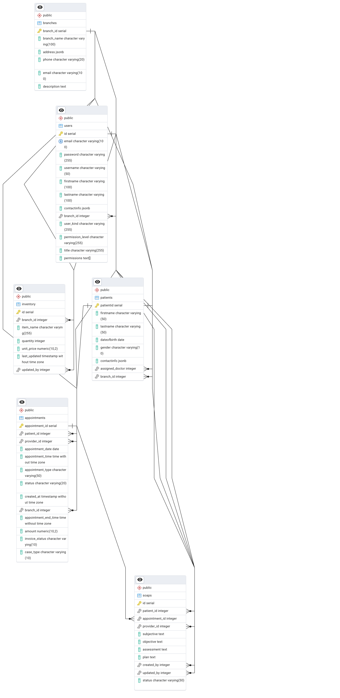

Provide an overview of each software component used, for example for OO code then for each class:

* purpose,
* data structures & methods,
* pseudo code of algorithms used.

## 5.6 Conclusions

# Chapter 6 Testing

In modern software development, testing is a fundamental practice to ensure the reliability, functionality, and performance of applications (Ammann & Offutt, 2016). This chapter explores several essential testing strategies applied during the development lifecycle. Unit Testing serves as the foundation, focusing on verifying individual components to ensure they function as intended in isolation (Royer, 2021). Next, Integration Testing is employed to evaluate the combined functionality of integrated modules, ensuring seamless interaction between different parts of the system (Pérez, 2020). End-to-End Testing goes beyond isolated components and integrated units, assessing the entire system from a user perspective to validate the overall workflow and business processes (Krishnan, 2022). Additionally, Black Box Testing is covered, a technique where the tester examines the software’s external behavior without consideration of the internal code (Moussa, 2021). Finally, this chapter identifies any Outstanding Bugs discovered during testing that require further resolution.

## 6.1 Unit Testing

|  |  |  |  |  |  |  |  |
| --- | --- | --- | --- | --- | --- | --- | --- |
| Test Number | Test Type | Description | Input Data | Expected Output | Output | Screenshot | Result |
|  |  |  |  |  |  |  |  |

## 6.2 Integration Testing

|  |  |  |  |  |  |  |  |
| --- | --- | --- | --- | --- | --- | --- | --- |
| Test Number | Test Type | Description | Input Data | Expected Output | Output | Screenshot | Result |
|  |  |  |  |  |  |  |  |

## 6.3 End to End Testing

|  |  |  |  |  |  |  |  |
| --- | --- | --- | --- | --- | --- | --- | --- |
| Test Number | Test Type | Description | Input Data | Expected Output | Output | Screenshot | Result |
|  |  |  |  |  |  |  |  |

## 6.4 Black Box Testing

|  |  |  |  |  |  |  |  |
| --- | --- | --- | --- | --- | --- | --- | --- |
| Test Number | Test Type | Description | Input Data | Expected Output | Output | Screenshot | Result |
|  |  |  |  |  |  |  |  |

## 6.5 Outstanding Bugs

# Chapter 7 Conclusions

**[4 - 6 pages]**

## 7.1 Introduction and Summary

## 7.2 Review of Project Aims and Objectives

* Explain how you have achieved each of the project aims (PA1), (PA2), etc.
* Similarly for the project objectives (OBJ1.1), (OBJ1.2), etc.

## 7.3 Review of Requirements

### 7.3.1 Functional Requirements

* Which of the Essential ones have been met, not met, why not?, etc
* Which of the Desirable & Luxury ones have been met, not met, etc

### 7.3.2 Non-Functional Requirements

As above

### 7.3.3 User Interface Requirements

As above

### Review of Project Delivery

Areas undervalued , less time spent, what I would’ve don’t differently (design, requiremets, iteratively)

### Reflection on skills development

Skills learnt during project

## 7.4 Further Work and Improvements

## 7.5 Conclusion

Final conclusions to include at least a discussion of:

* the success or failure of the project's outcomes,
* lessons learnt from doing it,
* problems encountered and how overcome or not.
* anything else you want to say about it.

# Bibliography

Ammann, P., & Offutt, J. (2016). Introduction to Software Testing (2nd ed.). Cambridge University Press.

Boehm, B. (1988) 'A Spiral Model of Software Development and Enhancement', ACM SIGSOFT Software Engineering Notes, 11(4), pp. 14-24.

ChiroHD. (2024). *Features*. Retrieved from <https://www.chirohd.com/web/features>

ChiroSpring. (2024). *Product overview*. Retrieved from <https://www.chirospring.com/product>

ChiroTouch. (2024). *Practice management software*. Retrieved from <https://www.chirotouch.com/practice-management-software>

Christensen, M.G. & Kollasch, M.W. (2005). *Job analysis of chiropractic: a project report, survey analysis, and summary of the practice of chiropractic within the United States*. National Board of Chiropractic Examiners.

Codd, E.F. (1970) 'A Relational Model of Data for Large Shared Data Banks', Communications of the ACM, 13(6), pp. 377-387.

EZBIS. (2024). *EZBIS products*. Retrieved from <https://ezbis.com/products/>

Fette, I. and Melnikov, A. (2011) 'The WebSocket Protocol', RFC 6455. Available at: https://datatracker.ietf.org/doc/html/rfc6455 (Accessed: 13 August 2024).

Fielding, R.T. (2000) 'Architectural Styles and the Design of Network-based Software Architectures', Doctoral dissertation, University of California, Irvine. Available at: <https://www.ics.uci.edu/~fielding/pubs/dissertation/rest_arch_style.htm> (Accessed: 13 August 2024).

GitHub. (2022). The 2022 State of the Octoverse: Top Programming Languages. Retrieved from <https://octoverse.github.com/2022/top-programming-languages>

Jane. (2024). *Features*. Retrieved from <https://jane.app/features>

Krishnan, M. (2022). End-to-End Testing with Cypress: A Practical Guide. Apress.

Moussa, A. (2021). Practical Guide to Black Box Testing. Springer.

Leach, R.A., Langley, M., Heffron, C. & Fernandez, J. (2013). *Chiropractic SOAP notes and case management*. Journal of Manipulative and Physiological Therapeutics, 36(1), pp. 15-24.

Mior, S.A. & Barnsley, J. (2010). *Utilization patterns and outcomes of chiropractic care for musculoskeletal conditions*. Journal of the Canadian Chiropractic Association, 54(4), pp. 226-233.

Pérez, A. M. (2020). Modern Integration Testing Strategies: A Hands-On Approach. O'Reilly Media.

Richardson, L. and Ruby, S. (2007) RESTful Web Services. O'Reilly Media, Inc.

Wieruch, R. (2018) The Road to React. Leanpub.

Royer, J. (2021). Unit Testing Principles, Practices, and Patterns. Manning Publications.

Stack Overflow. (2024, July 24). Developers want more, more, more! The 2024 results from Stack Overflow’s annual developer survey. Stack Overflow Blog. Retrieved from <https://stackoverflow.blog/2024/07/24/developers-want-more-more-more-the-2024-results-from-stack-overflow-s-annual-developer-survey/>

Stack Overflow. (2024). 2024 Stack Overflow Developer Survey: Technology. Retrieved from <https://survey.stackoverflow.co/2024/technology>

Testsigma. (2023). Software evaluation: Criteria, process, and best practices. Retrieved from <https://testsigma.com/blog/software-evaluation/>

Walker, B.F., French, S.D., Grant, W., Green, S. & Roush, J. (2018). *Chiropractic health care in the United States: Literature review and update*. Journal of Chiropractic Medicine, 17(2), pp. 69-80.

Whedon, J.M., Toler, A.W., Goel, V. & Kazal, L.A. (2015). *Association between utilization of chiropractic services for treatment of low back pain and use of prescription opioids*. Journal of Alternative and Complementary Medicine, 21(10), pp. 656-662.

**Appendices Notes**

* How many & what they contain is project dependent, and should but I would expect that all projects would have at least the following two: overflow of (UML) design diagrams, & optionally your program code. See examples below.
* Other possible appendices could contain results data from surveys, additional test data results, etc.
* Appendices are numbers using **A, B, C,** …, with a title. Sections are numbered as follows, A.3.1, etc
* Each appendix starts on a new page.
* All appendices pages must have page numbers, that follow on from the main report page numbering.

**Appendix A. Additional Design Material**

* This could be the "extra" UML tables, diagrams etc. that you are not putting in the Chapter 4.
* UC descriptions, Sequence diagrams, etc

**Appendix B. Program Code**

Discuss with your supervisor if and how your software code should be included in the report.

If you are told to include your code then you should present it as follows.

**B.1 Code Index**

* A list of all the code units, i.e. classes, XML, JSON, SQL, etc, **all with page numbers**, i.e. a code contents page.

**B.2 Program Code**

* **The code must be included as “PLAIN TEXT”.**
* **NOT as “SCREEN IMAGES” of the code, as this may be seen as an attempt to avoid detection by Blackboard's plagiarism detection software.**